

The Seven Signs of a Changing Economy™

“What to look for, where to find it and what to do when you see trends changing!”
As of October 2021

Summary

If you are like most investors, you might agree that the last few months have been a pretty intense period for fear versus greed!

Below is a graph of the Fear & Greed Index dated 10/6/2021:

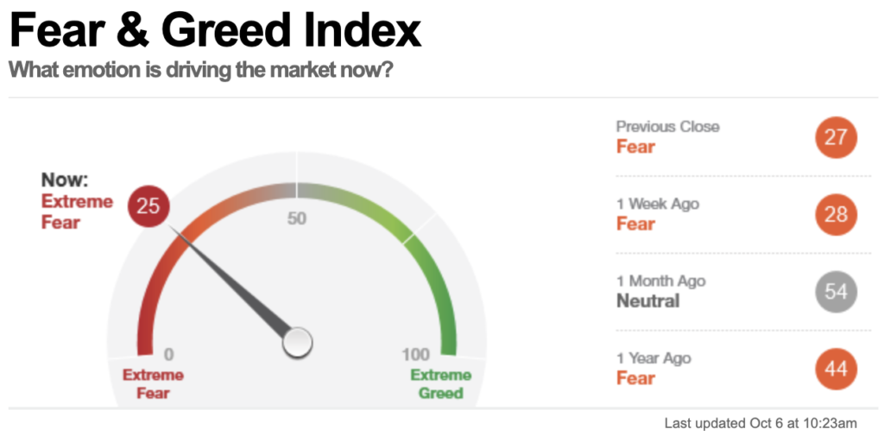
25 is extreme fear. But, consider the flipside of this index, which is implying 75% of investors are already out of investments, or close to it.

If you go back and review the WSG Weekly Update I write and post to our website every Friday, except for that one time, you will see I was suggesting exactly this would unfold. Labor Day is the unofficial end of summer and trading volume drops as the “B” team takes over the big money desks, thus adding volatility to most asset categories!

I will now once again say we are about to enter the best six months of market performance, which is November 1st through April 30th, hence the old saying “Sell in May and go away”. With 11/1/2021 just days away we also leave the two worst performing months of the twelve in our rearview mirror. As a side note, there are many trade desks with trillions under their oversight that will simply buy on 11/1/XXXX of any year and sell on 4/30/XXXX.

On top of all the fear and angst grinding out to the end of October you will read in Sign #2, Money Flow, that $19.677 trillion remains in cash and short-term securities, according to The St. Louis Federal Reserve. Just FYI, that is the most money in history looking for a return above 0 – 1%, which is where it is now resting, i.e., think “rocket fuel”.

I hear you! “Jim, the broader markets have gone nowhere since last April” (re-read “Sell in May and go away” in the above paragraph.) How many times have you heard me say “markets don’t tend to trade sideways, a trading range, and then go down. Instead, they just go down. With the NYSE Composite Index chart below, provided by my friend of over a third of a century, Mike Williams over at Truvestments, you will see the purple box covering the trade range we are in.

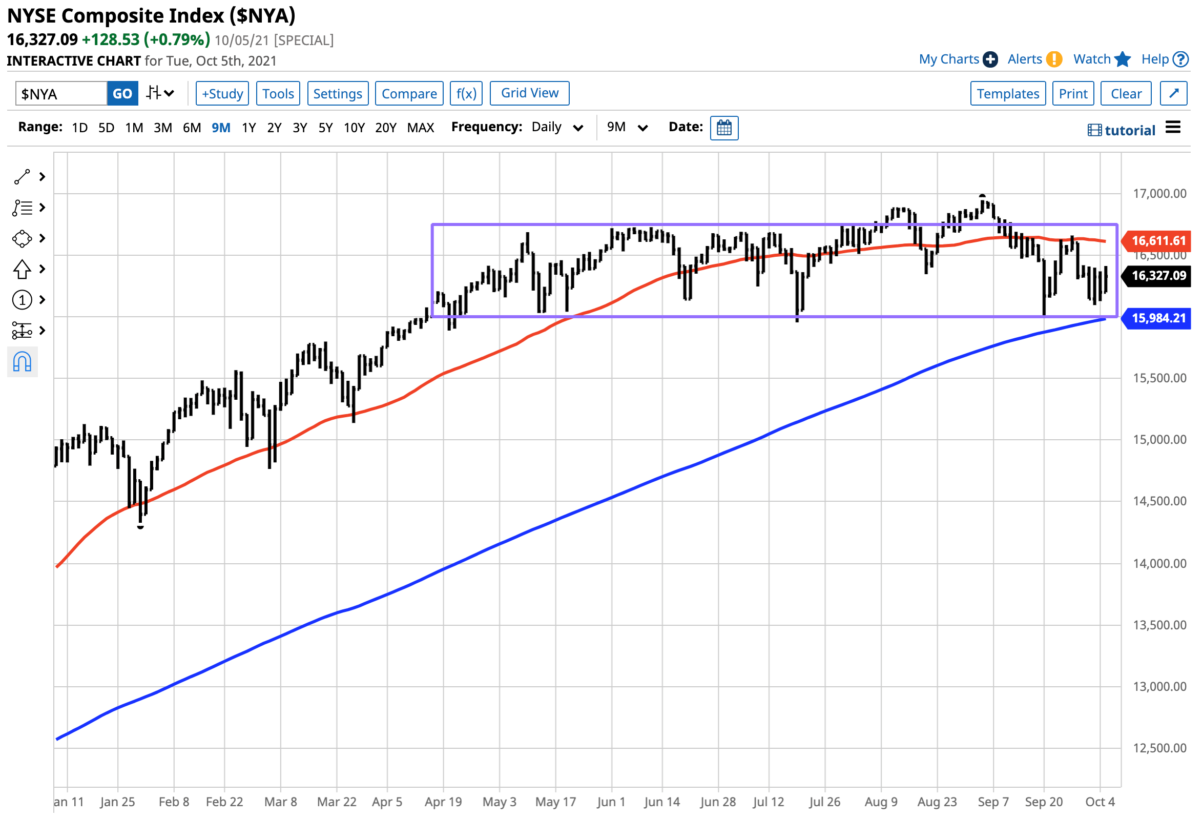

With this trade range, I suggest you are looking more at a launchpad than a high dive board. The Seven Signs of a Changing Economy™ below is chockfull of detail that supports this comment.

Back to my long-time friend, Mike Williams, for a moment. In a recent conversation, Mike said, “Jim, you and I have seen this uptrend before. In fact, for every decade since we both started in the business in 1981.” Mike then sent me the charts below that I am sharing with you for perspective.

This is the Decade of the 80’s:

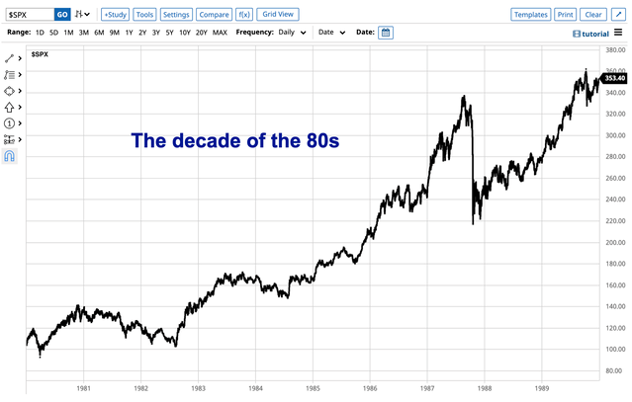

This is the Decade of the 90’s:

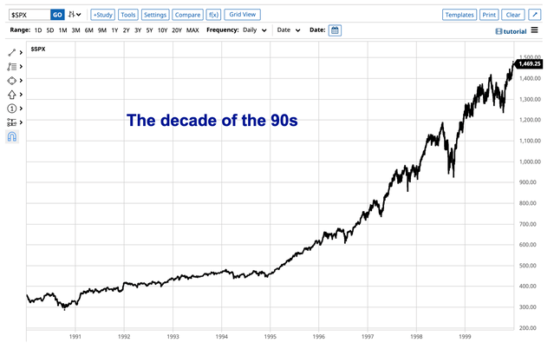

This is the Decade of the 2010’s:
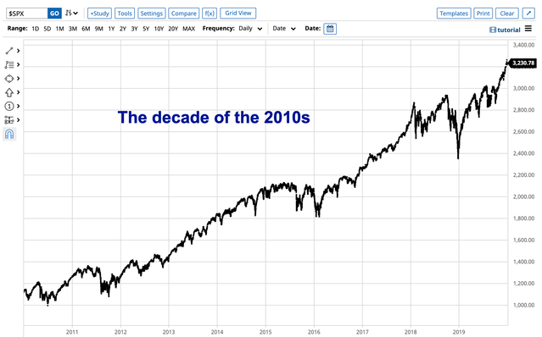

We are only one year into the 2020’s and it looks much like the other three decades.

It might be a fun exercise for each reader to search online for the top 10 negative headlines for each decade just to reminisce about how the end of the world was right around the corner. Yet, here we are in 2021 within 2% of an all-time high in the valuations of Corporate America, as measured by the S&P 500.

As a side note, each of the above decades returned an average of over 300%. Not combined, each one alone! Bad news does not stop America, it just offers more opportunity to those who understand that corrections happen. They are part of investing. Embrace the idea, pray for one and buy into it.

This last chart is from our Broker/Dealer, LPL Financial. It was in our 10/6/2021 research piece and I am adding this because, once again, it offers a sense of perspective and reality.

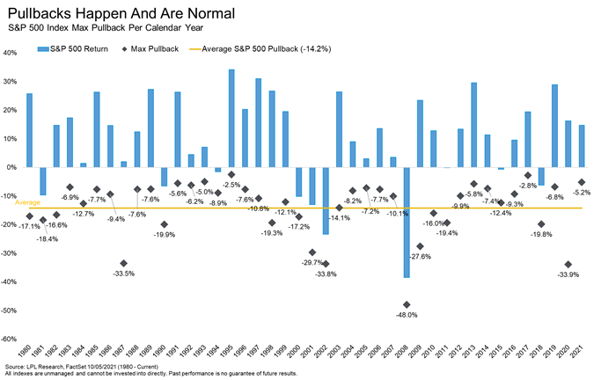

Please observe this chart closely, as I have. If you squint, there “might be” one correction period that lasted as long as five years in the last 32 that offered a negative return. That is why our WSG advisors suggest you only invest money you don’t need to touch for at least five years.

The basics:

- Have no debt wherever possible, even on your home
- Have enough cash on hand that you drift off to sleep at night and know you are good
- Know your expenses each month
- Know where your money is coming from each month to cover #3 above

And only then invest and systematically add to your investments with a minimum of a five-year timeline.

This month’s Seven Signs are updated below. As always, I have added some unique insight with my comments. Just scroll down to view these now.

Your thoughts, comments and discussion are welcome. Please call me at 303-933-2107 or e-mail me at Jlunney@wealthstratgroup.com.

Respectfully,

James O. Lunney, CFP®
CERTIFIED FINANCIAL PLANNER™ Professional

The Wealth Strategies Group was founded by James O. Lunney under the guiding principle that comprehensive wealth counseling combined with independent investment advice will provide high net worth clients with complete trust in our competence, execution and integrity.

P.S. Please join me for our monthly conference call on The Seven Signs of a Changing Economy. You have the option of calling in or listening live for free from your computer. To call in, simply dial 516-387-1595. There is no access code needed. To listen live from your computer, go to our website, www.wealthstratgroup.com, and click on the “LISTEN LIVE” button on the home page. You will be sent directly to our page on the Blog Talk Radio website and you can click on the link there. Instead of having a live Q & A session at the end of the call, you can now e-mail your question to me prior to the call at JLunney@wealthstratgroup.com and I will address them after my commentary on The Seven Signs of Economic Change.

The call is usually on the second Thursday of each month at 1:00 p.m. MST/3:00 p.m. EST, unless otherwise noted. Please mark your calendar to join me for the next call on Thursday, 11/18/2021.

We encourage you to invite people from your family, work and social circle to join in the call. Just forward my e-mail notification to your e-mail list. It is very timely information and in the volatile investment environment a second opinion may be greatly appreciated in these uncertain times.

1) | Indicator: | Personal Consumption Expenditure (PCE)
 | Where to find it: | www.bea.gov
 | What to look for: | Consumer spending increases or decreases for three consecutive months

(Positive) For the first time since December 2020!

Back in 2020 I referred to Covid as the “black hole” in our economic donut and if we were to make it through the black hole, Consumer Spending would be the how. Why? Long-time readers already know that 69.10% of our entire economy is Personal Consumption Expenditures (PCE) (Source: J.P. Morgan Guide to the Markets, August 31, 2021). That is why it is Sign #1!

We are a nation of spenders and we are “locked and loaded”! Household net worth is at a record high for both absolute level and growth trajectory. In addition, the household debt levels have dropped to the lowest levels since tracking started in 1980 (Source: Blackstone Private Wealth, October 2021). J.P. Morgan Chase surveyed 1.7 million families who have active checking accounts in their organization and reported that more than 50% have higher balances than the same period in 2019!

These points combined with low interest rates, people once again getting out, dining, traveling, etc., combined with herd immunity to Covid has caused the most recent Personal Consumption Expenditures (PCE) to come in at +.40% for the month, annualizing at +5.76%!

For perspective:

Full year 2016: +3.43%
2017: +2.45%
2018: +2.40%
2019: +2.80%
2020: -2.20% (Covid impacted)
YTD annualized 2021: +5.76%

Yes, I could get into the weeds and discuss that the velocity of money is flat, TSA checkpoint travel numbers dropped a touch, or that $144 billion “hit” our economy from increased energy costs. But, just like the law of lift supersedes the law of gravity, PCE supersedes those points!

Last month I closed off the Sign #1 update with this: “Keeping with my rule of trend changes, I am leaving Sign #1 neutral, yet with a touch of positive in PCE, next month should turn positive.”

We are there! This key sign of a changing economy has flipped to positive!

2) | Indicator: | Institutional Money Flow
 | Where to find it: | www.wordenbrothers.com or www.barrons.com/convictionoftraders
 | What to look for: | Increasing or decreasing prices on high volume of large block trades

(Positive)
This is a key sign of change! Money flowing to where it is expected to get the highest returns matters a lot!

As the world started to learn what Covid-19 meant, the amount of money in our economy was $3.989 trillion (Source: St. Louis Federal Reserve 2/17/2020).

To prevent an economic meltdown, and to propel our economy to the other side of the “black hole” in our economic donut, the Federal Reserve and U.S. Treasury increased this by 493% to the highest level ever, $19.677 trillion, as of 9/28/2021.

That is a ton of cash sloshing around looking to be invested in anything that might return more than 0 – 1%! But, as they say in late night television, “that’s not all!” As we left 3Q2021, Corporate America has issued $1.1 trillion of new bonds (debt), and we have 4Q2021 to add more (Source: LPL Financial Research September 2021).

For perspective, that is more new debt than 2010, 2011 and 2012 combined! This is brilliant! Big companies, like Microsoft, have issued over $1 billion in debt this year. Rough, back of the napkin arithmetic suggests a cost of 1% per year for 30 years with a cost after tax benefits of say .60%.

Let’s assume they chose to buy back some of their own shares out in the marketplace. Well, their current return on equity (ROE) is over 15%. Billions again! If something costs you .60 cents and returns you $15.00, wouldn’t you do that all day long? Yes, and Corporate America is! Thus, more “rocket fuel” to propel the value of Corporate America higher.

That is even more money looking for a home! Meanwhile, back in Mr. and Mrs. 401(k) land, the Fear versus Greed Index, dated 10/6/2021 dropped to 25. 1 is total fear and 100 is complete greed. For perspective, one year ago during the pandemic the index rested at 44.

The American Association of Individual Investor (AAII) survey, dated 10/6/2021, survey of members for their six-month outlook on the capital markets came in 25.5% bullish (positive), 30.9% neutral and 43.6% bearish (negative). In other words, 75% of AAII members are not positive on the investment outlook for the next six months. Most have already sold and are part of that $19.677 trillion in cash.

It would be reasonable to suggest that with the fearful investors have already left the building and that is very likely that with $19.677 trillion looking for a home, it is not a set up for a crash. Again, a 5%, 10%, 15%, perhaps even a 20% pullback can happen anytime for any wildcard reason, but that, too, is usually a set up for higher highs ahead.

Sign #2 is positive.

3) | Indicator: | Leading Economic Index (LEI)
 | Where to find it: | www.businesscycle.com or www.newyorkfed.org/research/global-economy/globalindicators.html
 | What to look for: | Trends up or down for three to four months

(Positive)
The Conference Board is the creator and tracker of the Leading Economic Index (LEI). The LEI is made up of ten components that combined offer a pretty clear picture as to how strong, or weak, the economy Corporate America will be operating in six to nine months in the future.

Thus, Sign #3 is our “peek around the corner” and it is suggesting a very broad-based, robust and strong backdrop. This month the only negative contributor of the ten components was “consumer expectations for business conditions”. That data point is, in my opinion, a nothing burger. The big three that matter are:

- ISM New Orders Index
- Manufacturers’ new orders for consumer goods and materials…think supplying the PCE in Sign #1 above
- Manufacturers’ new orders for non-defense capital goods

I underlined new in each as there are a ton of inputs needed, including jobs/labor to create anything new. These are key drivers to the future economy and all are strong, solid and growing.

We remain in the middle of a robust economic recovery with a solid outlook, which is clearly supportive of ownership in Corporate America.

This month the LEI was +.90% and annualizing near +13.10% versus the prior six months. This is a positive peek around the corner to mid-April 2022 to July 2022.

Sign #3 remains positive.

4) | Indicator: | Employment rate and after-tax personal income
 | Where to find it: | www.bls.gov
 | What to look for: | A flattening, then downward trend in non-farm employment with a flattening to decreasing after-tax income would be a negative indicator. The appropriate trend would, of course, be a positive trend indication

(Positive)
The Bureau of Labor Statistics (BLS) released this month’s Job Openings and Labor Turnover Summary, or JOLT’s Report, reporting there are over 10,000,000 job openings available, the highest ever recorded!

There was also another record in this month’s report and that was the highest number of Americans quit their jobs last month. You usually don’t quit unless you have secured a better, higher paying job, or that are very confident that you will be able to.

Which makes sense, as the NFIB Small Business Jobs Report reported a record high 50% of all small business owners had job openings they could not fill. The near 50-year average is 22%!

This begs the question of how could our robust economy only create 194,000 jobs last month (Source: Bureau of Labor Statistics, 10/8/2021), while expectations were for 500,000? Well, this is where Covid comes in, again! School districts lost 140,000 jobs and we are in the seasonality period of changing from summer employment to retail seasonal hiring, but there is a 30 – 60-day window in between.

Note to self: 1) The jobs creation number is a survey of businesses and they are understaffed and overwhelmed, suggesting sloppy data in the report. 2) The unemployment rate is the result of a household survey. Those folks at home are more inclined to have a chat about who is getting a new job in the household. This month the unemployment rate dropped from 5.2% down to 4.8%. We are not down to the pre-Covid level of 3.5% but have dropped from the Covid peak of 14.80% and that is positive, as is Sign #4.

5) | Indicator: | Durable goods spending
 | Where to find it: | www.census.gov/indicator/www/m3
 | What to look for: | An increasing or decreasing trend, especially a trend of four to five months out of six would be a positive or negative sign

(Positive)
These long shelf-life items like non-perishable, non-fashion items are usually the first to show signs of a slowing economy. Remember, these are items we can do without, if need be.

This month new orders increased +1.80% and have been up fifteen of the last sixteen months. Shipments were down following three up months and are at -.50%. Inventories increased a modest +.80%.

Unfilled orders is one of my favorite data points, as it suggests manufacturing is not keeping up with demand (a very good recovery sign), was up +1.00% and is up for the seventh consecutive month.

Conclusion: The orders are coming in hot, shipments are affected by supply chain impacts, the “back room” inventories are normal and unfilled orders suggest more good news to follow. Remember, this Sign is our “canary in the coal mine”! Since these are items we can live without, it is a perfect window to see if people have money and are spending it. This month it is both and positive.

As noted above, shipments were down this month after three strong months of increases. The American Trucking Association (ATA) Chief Economist, Bob Costello, wrote in his monthly economic report that “tonnage has not recovered to pre-pandemic levels for two main reasons; broader supply chain issues, like semiconductor shortages, as well as industry specific difficulties, including the truck driver shortage and lack of equipment.”

I believe that sums it up very concisely. The new orders are there, inventory is in the warehouse awaiting the soon to be largest holiday shopping season ever experienced on earth and manufacturers can’t keep up with the unfilled orders growing.

The Covid caused disruption to worldwide manufacturing will take care of itself, but likely not much before summer 2022. As we saw above in Sign #1, PCE, consumers have the desire to spend, have the cash to spend and also have the borrowing power to buy big ticket items like cars and homes.

Sign #5 suggests our canary in the coal mine is full of oxygen and few worries ahead.

6) | Indicator: | S&P 500 Earnings per Share growth
 | Where to find it: | www.standardandpoors.com
 | What to look for: | Two quarters of S&P 500 earnings per-share growth, up being a positive trend and down being a negative trend

(Positive)
As we rang in the New Year 2021, Refinitiv Research estimated the full-year earnings for Corporate America, as measured by the S&P 500, to be $159.02. As our economy has bounced back bigger, better and faster, the economists in our midst could not revise upward fast enough. As of 9/27/2021 Yardini Research has estimated the earnings for Corporate America, as measured by the S&P 500 to be $214.78. Just a cool +35.06% higher than Refinitiv Research’s $159.02 on 12/31/2020.

In just a few short months we will ring in 2022. As of 9/27/2021 Yardini Research is estimating earnings of $220.39 for next year.

So, let’s plug into our Fair Market Value (FMV) calculator using “The Rule of 20” to get both FMV and the price to earnings, or P/E ratio (a measure of risk).

To use “The Rule of 20” you just subtract the inflation rate from 20. I will use the same inflation rate the BEA used in calculating the Gross Domestic Product (GDP) for the 2Q2021 “third estimate” released October 1, 2021 of +2.10%.

The result becomes your multiplier and is multiplied by the respective year’s earnings per share to calculate the Fair Market Value (FMV).

- 20 – 2.10 = 17.90
- 2021 S&P 500 earnings estimate $214.78 (Source: Yardini Research, 9/21/2021)
- 2021 S&P 500 Fair Market Value estimate $214.78 x 17.90 = S&P 500 (FMV) 3,844.56

As of 10/8/2021, the S&P 500 trades at 4,391.34, or a 12.45% premium to 2021 FMV.

With Corporate America hitting all-time highs for profits and interest rates hitting close to zero, it is normal for investors to look just 75 days forward to 2022 earnings. Let’s also look at FMV for 2022.

- 20 – 2.10 = 17.90
- 2022 S&P 500 earnings estimate $220.39 (Source: Yardini Research, 9/27/2021)
- 2022 S&P 500 Fair Market Value estimate $220.39 x 17.90 = S&P 500 (FMV) 3,944.98. Thus, the S&P 500 is trading at an 11.31% premium to 2022 earnings estimates.

A research piece I recently read was titled “Daily Wealth” by Dr. Steve Sjuggerud. In this issue, Dr. Sjuggerud presented research that added the price/earnings (P/E ratio to the 90-day T-bill.

This is a tool that accounts for the cost associated with borrowing money, i.e., accounts for the impact of low interest rates on a company’s ability to earn profits. The research quantifiably showed than when the total is above 22, we are in the danger zone. Below 20 represents quantifiable value.

Based on this, I did some quick math to see the 2021 projected price/earnings (P/E) ratio is 20.44 + .05 (the yield on the 90-day T-bill) = 20.49.

So, based on 2021, not in the danger zone, but not inexpensive either.

Based on 2022, the P/E ratio is 19.92 +.05 (the yield on the 90-day T-bill) = 19.97 and in the “quantifiable value” zone.

Current valuations for Corporate America are reasonable and 2022 are in the “quantifiable value” area. With earnings momentum in a strong upward trend and with Sign #3, LEI, suggesting a positive economic backdrop for the next six to nine months, Sign #6 remains positive.

7) | Indicator: | Inflation/deflation numbers
 | Where to find it: | www.bls.gov/ppi/ or www.bls.gov/cpi/
 | What to look for: | An interruption to the consistent but modest increase in the cost we all pay for goods and services

(Positive)
On September 10, 2021, The Producer Price Index (PPI), which measures the inflation rate at the manufacturing level, reported in at 8.30% annualized for his month. As energy prices increase and labor costs spiral up it is likely we will continue to see input costs go up.

The companies who manufacture all the stuff we are buying hand over fist are incurring costs to make the stuff. Raw materials, energy and labor for sure, but copper, lumber and shipping are all also up…a lot. It is likely the supply chain will loosen up until next summer, but the cost points are likely staying higher for a long time. You are already seeing what that has meant in your own home. Inflation is like a tax, as you have less disposable income as a result of paying higher prices.

On 9/14/2021, the Consumer Price Index (CPI), which measures the inflation rate at the household level, reported in at +5.30% annualized (highest since 2008) for this month. CPI has increased from .30% in April 2020. That is a large percentage increase, and the shot over the bow of inflation entering the households of America that I have been writing to you about, talking with you about and investing in front of since last summer.

It has been happening for the last few years, but now we are seeing very real price increases in all the core needs of our lives, medicine, energy, food, cars if you can find one, etc.

All the goods and services we produce as a country are measured as our Gross Domestic Product, or GDP. When the GDP data is released, it is made “real” to adjust for the effect of inflation. As I wrote above in Sign #6, the “deflator”, as it is called, to make GDP “real” was 2.10%.

Think out loud with me here, but let’s suppose the inflation rate is more like the CPI we just posted above at 5.30%. Well, then our GDP released on 10/1/2021 would not be 6.70%, but more like 3.50%.

My point is simply to say +3.50% growth on a near $22 trillion economy is pretty darn good and still distanced from all those stagflation headlines!

Sign #7 remains neutral but with a moderation in the increasing inflation could turn positive soon.

*The Rule of 20 is in this calculation implying, and using, a price/earnings ratio, which is the valuation ratio of a company’s current share price compared to its per-share earnings. Thus, 17.90x the expected Earnings per Share. Both EPS and the multiple of 17.90 could drop. The earnings could be reduced due to the consumers spending less. The multiplier of 17.90 could drop to, say 8 for example, if investors were to get scared and become risk adverse. All of a sudden 8 x $214.78 turns the 3,844.56 2021 FMV into 1,718.24 and even worse if earnings were to drop below the example of $214.78/share! This is the multiplier risk and earnings risk I personally worry about. It may never occur, but what an unfortunate event it would be if it did and we had not prepared for it as a possibility. Thus, I am glad we have!

The opinions voiced in this material are for general information only and are not intended to provide specific advice for every client.

All performance referenced is historical and is no guarantee of future results. All indices are unmanaged and cannot be invested into directly.

•The economic forecasts set forth in the presentation may not develop as predicted and there can be no guarantee that strategies promoted will be successful.
•Stock investing involves risk including potential loss of principal
•Government bonds and Treasury bills are guaranteed by the US government as to the timely payment of principal and interest and, if held to maturity, offer a fixed rate of return and fixed principal value.
•The Dow Jones Industrial Average is comprised of 30 stocks that are major factors in their industries and widely held by individuals and institutional investors.
•The Standard & Poor’s 500 Index is a capitalization weighted index of 500 stocks designed to measure performance of the broad domestic economy through changes in the aggregate market value of 500 stocks representing all major industries.

Copyright © 2008. The Wealth Strategies Group. All rights reserved.

