In this week’s recap: the S&P 500 loses 1% for the week after investors assess mixed economic data and hear that limits might be placed on U.S. investment in Chinese companies.
Weekly Economic Update

Presented by Serge Mallat, CLTC, September 30, 2019

THE WEEK ON WALL STREET
Stocks retreated last week. Traders worried that the formal impeachment inquiry of President Donald Trump might distract White House officials from their pursuit of a trade deal with China and shift the focus of Congress away from consideration of the United States-Mexico-Canada Agreement (USMCA). Also, news broke Friday that the White House was considering restricting levels of U.S. investment in Chinese firms.
The Dow Jones Industrial Average lost less than the Nasdaq Composite and S&P 500. Blue chips declined 0.43% week-over-week, while the S&P fell 1.01%, and the Nasdaq dipped 2.19%. The MSCI EAFE index, tracking developed overseas stock markets, lost 0.89%.^{1,2,3}

Incomes Grow, Spending Slows
Data released Friday by the Bureau of Economic Analysis (BEA) showed household incomes rising 0.4% in August. Consumer spending improved just 0.1% last month, however; that was the smallest advance in six months.
Another BEA report noted that “real” consumer spending (that is, consumer spending adjusted for inflation) rose 4.6% during the second quarter.^{4,5}

A Slip in Consumer Confidence
The Conference Board’s Consumer Confidence Index fell to 125.1 for September. That compares to a reading of 134.2 in August. Lynn Franco, the CB’s director of economic indicators, wrote that “the escalation in trade and tariff tensions in late August appears to have rattled consumers. However, this pattern of uncertainty and volatility has persisted for much of the year and it appears confidence is plateauing.”
In contrast, the University of Michigan’s Consumer Sentiment Index ended September at 93.2, an improvement from a final August mark of 89.8.^{6,7}

WHAT’S AHEAD
On October 10, the Social Security Administration is scheduled to announce the 2020 cost of living adjustment (COLA) for Social Security retirement benefits. Earlier this month, Bureau of Labor Statistics yearly inflation data pointed to a possible 2020 COLA in the range of 1.6%-1.7%.⁸

T I P O F T H E W E E K
When one or both spouses come into a marriage with considerable individual assets, a separate property trust may be worth considering, if only as a mechanism to try and insulate assets of one spouse from creditors of the other.

THE WEEK AHEAD: KEY ECONOMIC DATA
Tuesday: The Institute for Supply Management (ISM) presents its September Purchasing Managers Index (PMI) for the factory sector, a barometer of U.S. manufacturing health.
Wednesday: ADP, the payroll processor, releases its September National Employment Report.
Thursday: ISM’s non-manufacturing PMI arrives, reporting on the state of the U.S. service sector.
Friday: The Department of Labor’s September jobs report appears, and Federal Reserve Chairman Jerome Powell gives a keynote speech at a Fed event in Washington D.C.
Source: Econoday, September 27, 2019
The Econoday economic calendar lists upcoming U.S. economic data releases (including key economic indicators), Federal Reserve policy meetings, and speaking engagements of Federal Reserve officials. The content is developed from sources believed to be providing accurate information. The forecasts or forward-looking statements are based on assumptions and may not materialize. The forecasts also are subject to revision.

THE WEEK AHEAD: COMPANIES REPORTING EARNINGS
Wednesday: Lennar (LEN), Paychex (PAYX)
Thursday: Constellation Brands (STZ), Costco (COST), PepsiCo (PEP)
Source: Zacks, September 27, 2019
Companies mentioned are for informational purposes only. It should not be considered a solicitation for the purchase or sale of the securities. Any investment should be consistent with your objectives, time frame, and risk tolerance. The return and principal value of investments will fluctuate as market conditions change. When sold, investments may be worth more or less than their original cost. Companies may reschedule when they report earnings without notice.

Q U O T E O F T H E W E E K

“Each of us is full of too many wheels, screws, and valves to permit us to judge one another on a first impression or by two or three external signs.”
ANTON CHEKHOV

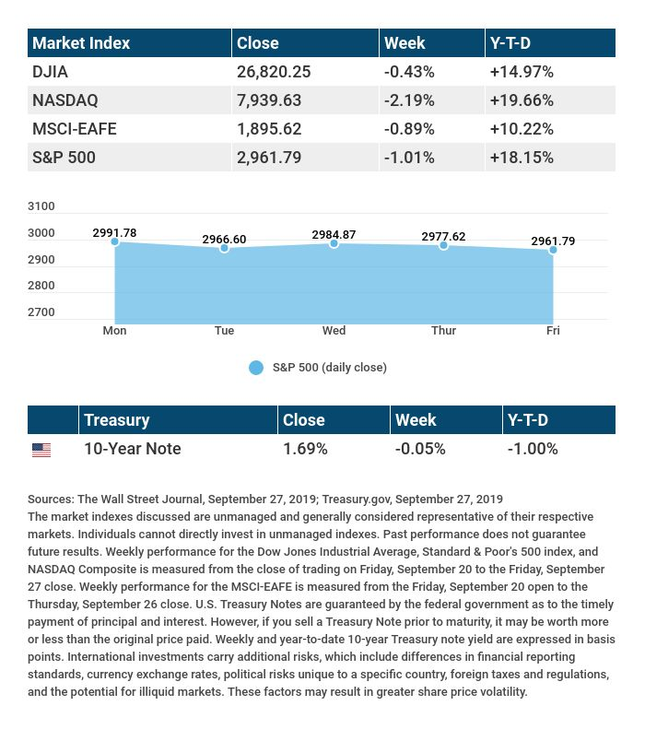

T H E W E E K L Y R I D D L E

Which is heavier, a pound of lead or a pound of silver?

LAST WEEK’S RIDDLE: Up and down the stairs it goes, without moving any toes. It is found upstairs, downstairs, even in the hall; alas, it cannot move at all. What is it?
ANSWER: Carpet.

Serge Mallat, CLTC | 954-445-8222 | smallat@onesouthfloridawa.com
www.onesouthfloridawa.com
Know someone who could use information like this?
Please feel free to send us their contact information via phone or email. (Don’t worry – we’ll request their permission before adding them to our mailing list.)

Registered Representative and Investment Advisor Representative of and securities offered through OneAmerica Securities, Inc., a Registered Investment Advisor, Member FINRA, SIPC. OneSouth Florida Wealth Advisors is not an affiliate of OneAmerica Securities and is not a broker dealer or Registered Investment Advisor.
Do not transmit orders regarding your OneAmerica Securities, Inc. account via e-mail. OneAmerica Securities, Inc. and OneSouth Florida Wealth Advisors will not be responsible for carrying out orders and or instructions.
This message is intended only for the use of the individual or entity to which the transmission is addressed. Any interception may be a violation of law. If you are not the intended recipient, any dissemination, distribution or copying of this message is strictly prohibited. If you are not the intended recipient, please contact the sender and destroy all copies of the document.
Provided content is for overview and informational purposes only and is not intended and should not be relied upon as individualized tax, legal, fiduciary, or investment advice. Neither the companies of OneAmerica nor their representatives provide tax or legal advice. For answers to specific questions and before making any decisions, please consult a qualified attorney or tax advisor.
Not affiliated with or endorsed by the Social Security Administration, the Centers for Medicare & Medicaid Services, or any governmental agency.
This material was prepared by MarketingPro, Inc., and does not necessarily represent the views of the presenting party, nor their affiliates. The information herein has been derived from sources believed to be accurate. Please note - investing involves risk, and past performance is no guarantee of future results. Investments will fluctuate and when redeemed may be worth more or less than when originally invested. This information should not be construed as investment, tax or legal advice and may not be relied on for the purpose of avoiding any Federal tax penalty. This is neither a solicitation nor recommendation to purchase or sell any investment or insurance product or service, and should not be relied upon as such. All market indices discussed are unmanaged and are not illustrative of any particular investment. Indices do not incur management fees, costs and expenses, and cannot be invested into directly. All economic and performance data is historical and not indicative of future results. The Dow Jones Industrial Average is a price-weighted index of 30 actively traded blue-chip stocks. The NASDAQ Composite Index is a market-weighted index of all over-the-counter common stocks traded on the National Association of Securities Dealers Automated Quotation System. The Standard & Poor's 500 (S&P 500) is a market-cap weighted index composed of the common stocks of 500 leading companies in leading industries of the U.S. economy. NYSE Group, Inc. (NYSE:NYX) operates two securities exchanges: the New York Stock Exchange (the “NYSE”) and NYSE Arca (formerly known as the Archipelago Exchange, or ArcaEx®, and the Pacific Exchange). NYSE Group is a leading provider of securities listing, trading and market data products and services. The New York Mercantile Exchange, Inc. (NYMEX) is the world's largest physical commodity futures exchange and the preeminent trading forum for energy and precious metals, with trading conducted through two divisions – the NYMEX Division, home to the energy, platinum, and palladium markets, and the COMEX Division, on which all other metals trade. Additional risks are associated with international investing, such as currency fluctuations, political and economic instability and differences in accounting standards. This material represents an assessment of the market environment at a specific point in time and is not intended to be a forecast of future events, or a guarantee of future results. MarketingPro, Inc. is not affiliated with any person or firm that may be providing this information to you. The publisher is not engaged in rendering legal, accounting or other professional services. If assistance is needed, the reader is advised to engage the services of a competent professional.
CITATIONS:
1 - cnn.com/2019/09/27/investing/dow-stock-market-today-oil/index.html [9/27/19]
2 - wsj.com/market-data [9/27/19]
3 - quotes.wsj.com/index/XX/990300/historical-prices [9/27/19]
4 - marketwatch.com/story/consumer-spending-barely-rises-in-august-as-americans-save-more-2019-09-27 [9/27/19]
5 - investing.com/economic-calendar [9/27/19]
6 - conference-board.org/data/consumerconfidence.cfm [9/24/19]
7 - marketwatch.com/story/consumer-sentiment-rebounds-in-september-but-americans-more-anxious-2019-09-27 [9/27/19]
8 - tinyurl.com/y2n8uvng [9/8/19]

CHART CITATIONS:
wsj.com/market-data [9/27/19]
quotes.wsj.com/index/XX/990300/historical-prices [9/27/19]
quotes.wsj.com/index/SPX/historical-prices [9/27/19]
treasury.gov/resource-center/data-chart-center/interest-rates/Pages/TextView.aspx?data=yield [9/27/19]
treasury.gov/resource-center/data-chart-center/interest-rates/Pages/TextView.aspx?data=yieldAll [9/27/19]

