Please join us for the Taxing Times and Plan Health discussion for CPA's.
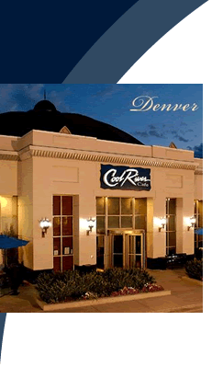

Date: Tuesday, December 9, 2014
Time: 11:00 a.m. — 1:00 p.m.
Location: Cool River Café - 8000 E. Belleview Ave - Greenwood Village, CO 80111

Space is limited. Registration is required.
Please RSVP by Monday, December 8, 2014. Reply to Diana Larson at dianalarson@cccandc.com.
Topics of Discussion:
• How Taxes, Healthcare and Retirement Readiness are related
• New Tax laws you may not have anticipated
• Ways to improve your business owners' retirement plans through tax efficiency
• How a local TPA can help you prepare for discussions with prospects
• How Pending Laws and Regulations may affect the future of retirement plans
Keynote Speaker:
Thomas Foster, ESQ — Vice President & National Spokesperson - MassMutual Retirement Services
Presented by:
Pat Alfano — Regional Sales Director - MassMutual Retirement Services
Craig Ciarlelli* — Financial Advisor, AIFA, ChFC, CLU - CC Coaching and Consulting
Mike Staples — Vice President, Senior Retirement Consultant Oppenheimer Funds

We Hope to See You There!!

* Craig Ciarlelli, is an Investment Adviser Representative offering securities and advisory services through Cetera Advisor Networks LLC, member FINRA/SIPC. Cetera Advisor Networks LLC, is not affiliated with any other named entity.
This event paid for in whole or in part by MassMutual Retirement Services.
© 2014 MassMutual Financial Group is the fleet name for Massachusetts Mutual Life Insurance Company (MassMutual)
[Of which Retirement Services is a division] and its affiliated companies and sales representatives. RS-19834-00.

