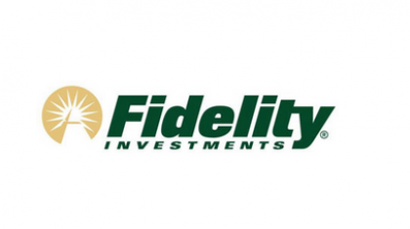
Great seeing everyone this morning and looking forward to spending time with some of you tonight during dinner. To follow up on today’s conversation, below is an overview of the items I referenced. To access the rollover over service, please contact Katharine Yenke and she would be happy to coordinate the
I’ve attached the following pieces:

- Value Stack Presentation
- Portfolio Quick Check Tool: www.portfolioquickcheck.fidelity.com
- FA Multi Asset Income (FAYZX) Flyer & Presentation (see page 11 for the asymmetric risk profile, and page 17 which highlights the process in action)
- Fidelity 401k Rollover Concierge Service
- Money Funds:
- Prime, FNSXX, 2.37%
- Government, FRGXX, 2.06%
Thank you for your time and consideration!

Gus Engel
Regional Director
Fidelity InstitutionalSM
500 Salem Street, OS3N
Smithfield RI 02917
gus.engel@fmr.com
Mobile: 412.480.8054
Faxmail: 401.292.0591

For immediate assistance, please call Katharine Yenke at 401.757.5076 or Katharine.Yenke@fmr.com

