May 2019

wealth maximization strategies*

Creative





A picture containing outdoor object, parachute

Description generated with very high confidence

**How   
Savings Protect Your Investments**

**W**ant to improve your chances for long-term financial success? You might want to focus on maintaining healthy cash reserves.

Recent studies suggest one of the reasons many Americans struggle to accumulate enough to retire is because they don’t take a “protection-first” approach by establishing a foundation of cash reserves.

A 2017 working paper* from the Harvard School of Business, co-authored by six professors from various disciplines, found that the lack of cash reserves – secure, liquid savings available for unexpected financial events – was one of the biggest deterrents to successful long-term accumulation.

Because of inadequate cash reserves, many households end up tapping the balances in their long-term accumulation accounts, particularly their employer-sponsored 401(k)s.

These early withdrawals hurt long-term accumulation in several ways:

* Pre-retirement withdrawals not only reduce the account balance, but also forfeit the earnings or appreciation that could accrue if these funds remained invested.



**In This Issue…**

**HOW SAVINGS PROTECT YOUR INVESTMENTS** Page 1

**THE CHART OF   
THE CENTURY** Page 3

**SPENDING: THE HOUSE   
DRIVES EVERYTHING** Page 4

**MORE MONEY OR   
MORE TIME?** Page 5

* The title of this newsletter should in no way be construed that the strategies/information in these articles are guaranteed to be successful. The reader should discuss any financial strategies presented in this newsletter with a licensed financial professional.

* Early withdrawals often incur additional costs in the form of tax penalties or loan repayments.
* Many retirement accounts are invested in assets whose values fluctuate daily. Early withdrawals may mean liquidating investments at inopportune times, possibly at a loss (or selling strongly-performing assets and ending their potential for above-average gain).

This “leakage” from retirement accounts is significant. The Harvard report noted that in the past decade approximately one in seven taxpayers under the age of 55 made taxable withdrawals from retirement plans in any given year. Over the same period, data from the Federal Reserve and Internal Revenue Service estimated that between 30 and 40 cents of every dollar deposited into retirement accounts by participants under the age of 55 had been withdrawn before retirement.

Instead of systematically building substantial nest eggs through a steady stream of deposits to investments that perform best when held for long time periods, the retirement plans of many Americans are constantly hindered by withdrawals that diminish balances and sabotage optimal returns.

Connecting the dots, Brigitte Madrian, one of the study’s co-authors, and business school dean at Brigham Young University, says retirement savers should really have ***two*** nest eggs, “one that’s hard to access, and one that can be tapped almost at will.”

Sounds perfectly logical, and in fact, that’s pretty much what a lot of financial professionals recommend. But many Americans don’t do it.

**Why Don’t Americans Build Cash Reserves?**

A close up of a device

Description generated with high confidence

A bunch of issues, large and small, conspire against saving.

One of the problems is semantics. “Saving” and “investing” are often seen as interchangeable terms. But while both words connote setting aside money for the future, “savings” (i.e., cash reserves) are for unforeseen needs or opportunities, while “investments” are typically connected to specific future objectives, like retirement or college funding.

With two distinctly different accumulation objectives, saving and investing should probably have separate accounts. “If you only have one account, then it de facto becomes the ‘everything’ account, so people no longer think of it as a retirement account because it’s serving multiple purposes,” says Madrian,

The problem isn’t just fuzzy definitions; current economic policy discourages saving. To soften the fallout from the 2009 recession, central bankers deliberately lowered interest rates, and have kept them down. This may have averted a global financial crisis, but when a year’s worth of interest from a $1,000 deposit barely pays for a latte at your local café, many consumers are ambivalent about building cash reserves. A 1% yield (or less) on savings is de-motivating.

Some retirement experts blame the structure of qualified retirement plans in the US; compared to formats used in other countries, “It’s too easy for people to access their money right now, and lots and lots of people are doing it,” says Ms. Madrian.

But imposing tighter restrictions on early withdrawals to stop leakage is problematic. Defined contribution retirement plans like 401(k)s are primarily funded by voluntary employee deferrals on income already earned. Further restricting access to money that’s already been earned might decrease long-term accumulation, because employees may feel that without some options for emergency withdrawals, they can’t commit to long-term investing.

And there’s the psychological quirk financial behaviorists call “present bias”; consumers tend to excuse overspending in the present while planning to be more responsible in the future. They rationalize going over budget this month, but simultaneously commit to substantial 401(k) withholdings to show they are serious about getting back on track. When their overspending and lack of savings catches up to them, they have to dip into their long-term investments.

**The Employer-Sponsored Rainy-Day Account**

To resolve the saving dilemma, the Harvard paper proposes employer-sponsored programs that pair a qualified retirement plan with a rainy-day account, from which workers could withdraw limited amounts of money to meet emergencies. Employees would commit to a single deduction amount from each paycheck, which would be divided between the two accounts, according to pre-established criteria.

**If you have to tap your long-term investment accounts for short-term needs, maybe your saving ought to be re-evaluated.**

**A review with your financial professionals could be the “nudge” that puts you on the track to steady long-term accumulation.**

The less an employee has in rainy-day savings, the greater the percentage of contributions go to this account. As cash reserves build, the amount invested in the retirement plan increases. When a withdrawal is made from the rainy-day account, deductions are recalibrated until the cash reserve balance returns to a previously agreed-upon level.

The concept is simple, but the devil is in the details. Combining an accessible rainy-day account with a qualified retirement plan would require different standards for accounting, contribution limits, taxation, withdrawals, and product options. That’s more work – and responsibility – for employers. But the study’s authors think the benefits would be significant: “(W)e believe that automatically enrolling workers into an employer-sponsored payroll deduction ‘rainy day’ or ‘emergency’ savings account could be a cost-effective means of helping households accumulate liquid savings to meet possible urgent pre-retirement expenditure needs.”

**A Validation of the Protection-First Approach**

The only novelty in the rainy-day account idea is having an employer “nudge” you toward doing it. Perhaps the real news here is retirement experts acknowledging the essential nature of cash reserves. This validates the “protection-first” approach to personal finance, which is embodied in the phrase: “Tomorrows come next, todays come first.”

Consumers might associate the protection-first philosophy with life and disability insurance, a will, and other policies or legal devices, and those items are essential components of financial protection. But saving for today’s unforeseen events is equally important in keeping your plans for tomorrow from being derailed.

Retirement accumulation is often presented as a stand-alone issue, with experts of various stripes trying to boost either deposits or returns through new platforms or products. But unless retirement accumulation is integrated into the bigger picture of your financial life, you may always struggle to achieve your long-term objectives. While some see protection-first as just one opinion about how to order your financial life, these new studies say it’s an approach that sets the stage for long-term success. ❖

* "Building Emergency Savings Through Employer-Sponsored Rainy Day Savings Accounts"byJohn Beshears, James J. Choi, J. Mark Iwry, David C. John, David Laibson, and Brigitte Madrian, October 2017.

A person posing for the camera

Description generated with high confidence

**The Chart   
of the Century**

**I**f a picture is worth a thousand words, how much can be said about the “chart of the century?” It depends on what you see.

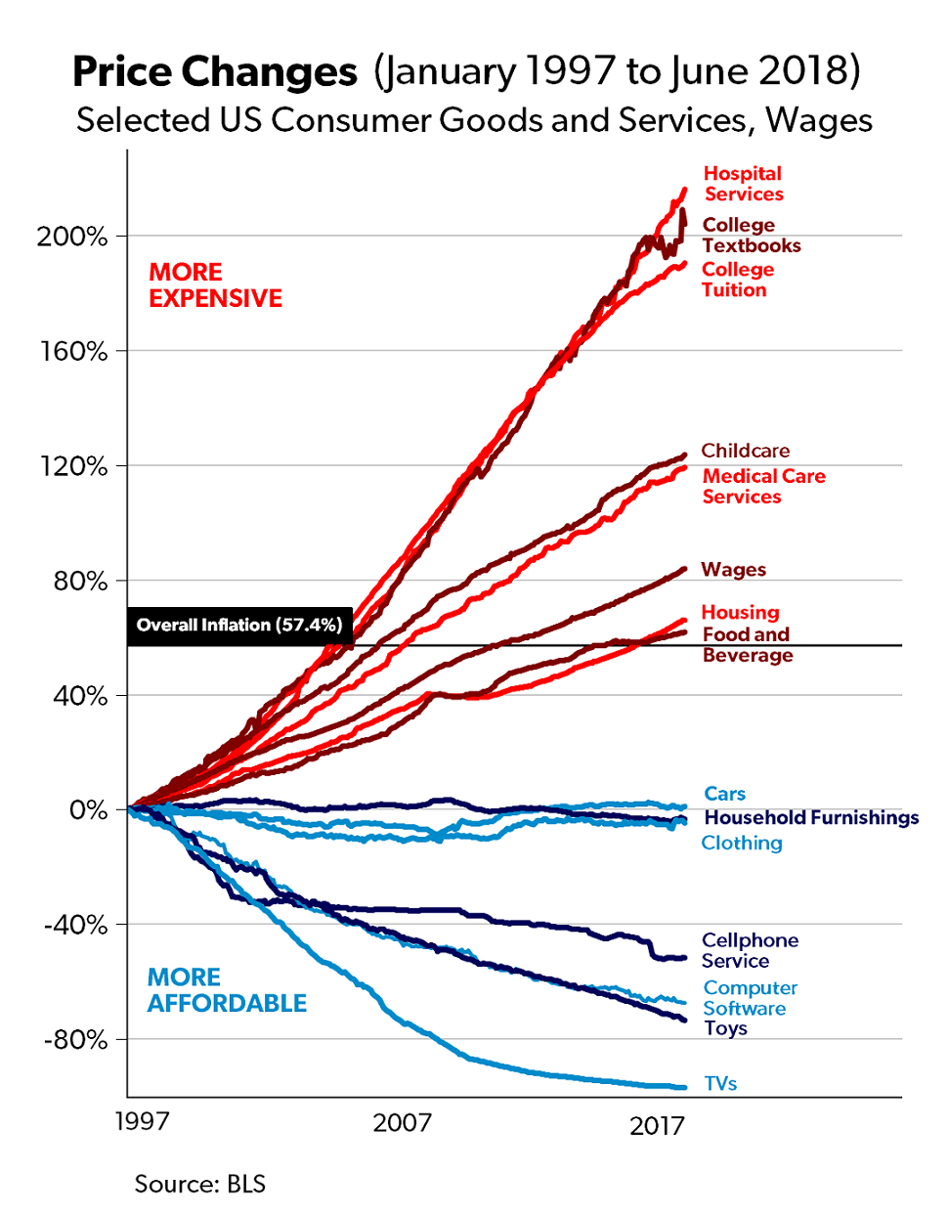Mark Perry is an economics and finance professor at the University of Michigan who constructed, and regularly updates, what some publications have dubbed “one of the most important charts about the economy this century”. Here’s what it looks like:

Perry uses Consumer Price Index data from the Bureau of Labor and Statistics to track the overall rate of inflation (as measured by the price changes of all goods and services included in the CPI), then breaks out 15 select categories to see how their prices have changed compared to the average.

Since 1997, the cumulative rate of inflation is 57.4%, which is indicated by the black horizontal line on the chart. Items that have increased more than the average rate are indicated by red lines, while the categories whose prices have either fallen or risen less than inflation are shown in blue. Relatively speaking, the items in blue have become more affordable, while those in red have become more expensive.

**Cool Graphics. But…?**

This chart has generated a lot of buzz, from academics and policymakers, to financial publications and social media (a February 2019 article mentioned that the chart was a topic of discussion by Federal Reserve Board members during a recent policy session). But while a lot of people may be talking about it, the political, economic, and investment conclusions drawn from it are all over the place. A sampling:

**It illustrates the difference between local and global markets.** A cell phone, TV, or toy can be manufactured anywhere, and sold anywhere. When a market is global, the lowest price often prevails; this competition usually results in more goods and services available at ever-lower costs.

Conversely, some things are uniquely local, such as where you live, eat and earn a living. Which could explain why the markets for housing, food and jobs, while competitive, more closely align with the national rate of inflation instead of global economic conditions.

**It shows the impact of government involvement.** Some commenters see the outsized price increases for education and healthcare as a result of government intervention. In healthcare, it’s regulatory oversight that imposes a bureaucratic layer and adds costs. For higher education, it’s subsidies (like loans, grants, and taxpayer funding) that artificially stimulate demand and drive up prices.

In categories where prices have declined the most compared to inflation, government involvement is either absent or behind the curve of innovation. For example, 5G, the next iteration of connectivity, might make political arguments about net neutrality irrelevant.

**It oversimplifies and obscures the real issues.** The chart implies that wages have kept pace with inflation. But a deeper dive shows uneven wage growth: a small group of Americans have seen their wages outpace inflation by significant percentages, while the vast majority have experienced wage stagnation or deflation. The average disguises a growing income inequality in America. This contention parallels another view of the chart…

**It means we live in a Bread-and-Circuses Economy**, where everyone can afford diversions, but most find it harder to pay for the essentials, especially quality-of-life-changing essentials, like education and health care. The more cynical observers view this as a deliberate strategy of the wealthy to appease the masses while pricing everyone else out of the most valuable goods and services.

**What Can I Learn from This Chart?**

To maximize your personal economy, the data is clear: You should write a college textbook and buy a TV. Joking aside, there are some insights for personal finance.

The chart emphasizes the economic value of maintaining a healthy lifestyle; every dollar not spent on healthcare effectively yields an inflation-beating return. Likewise, options to obtain a higher education at below-market prices (like online programs, community colleges, or employer-subsidized tuition) also deliver maximum economic value.

But going forward, categories which out-pace inflation will require a larger percentage of your personal economy to maintain. If you’re saving for college education, the only sure way to keep pace with price increases is to set aside more money – which means less to spend on leisure or invest in retirement.

The same goes for retirement planning. The more savings that must be kept in reserve for medical expenses, the less there is to generate monthly income.

Perhaps the biggest takeaway: the chart dramatically illustrates the cumulative impact of inflation; modest annual increases add up. While it is impossible to accurately project the rate of inflation, it is essential that consumers keep it in mind when planning for the future. ❖

A yellow sign hanging from a pole

Description generated with very high confidence

**Does your economy seem like Bread and Circuses? Utilizing the expertise of a financial professional can help you cut through the clutter and identify the real threats to your money.**

A picture containing floor, wall, indoor

Description generated with very high confidence

**The House Drives Everything**

**Spending:**

**A fundamental principle of personal finance:** The more you spend, the less you have to save and invest.

**A unique financial insight:** One of the biggest determiners of how much you spend is the size of your home and the neighborhood in which it is located.

When you buy a home, you also buy the lifestyle standards that prevail in its neighborhood. This inevitably exerts a strong influence on all other spending: the type of car you drive, theclothes you wear, the extra-curricular activities of your kids, everything. In an homage to the real estate maxim of “location, location, location,” personal finance columnist Jarred Dillian puts it succinctly:

**“The house drives everything. The house drives everything. The house drives everything.”**

This insight isn’t new. Here’s an excerpt from the *Millionaire Next Door*, a 1996 bestseller by Thomas Stanley and William Danko that chronicled the defining behaviors and lifestyles of American millionaires, particularly those identified as Prodigious Accumulators of Wealth:

**Nothing has a greater impact on your wealth and your consumption than your choices of house and neighborhood.** If you live in a high-price home in an exclusive community, you will spend more than you should and your ability to save and build wealth will be compromised…. [P]eople who live in million-dollar homes are not millionaires. They may be high-income producers but, by trying to emulate glittering rich millionaires, they are living a treadmill existence.

Two decades later, Stanley’s daughter, Sarah Stanley Fallaw, coauthored [*The Next Millionaire Next Door: Enduring Strategies for Building Wealth*](https://www.amazon.com/Next-Millionaire-Door-Enduring-Strategies/dp/1493035355?tag=bisafetynet2-20), in which she surveyed more than 600 millionaires in America. Fallaw wrote:

**“The key to wealth building is to live in a home that one can easily afford.”**

These general statements are exemplified by an interesting personal anecdote: Legendary investor Warren Buffett still lives in the Omaha, Nebraska home he bought in 1958 for $31,000 (approximately $267,000 in today's dollars). Buffett’s net worth is currently estimated at $82 billion, making him the third-richest person in the world; his home represents ***one thousandth of one percent*** (.001%) of his net worth.

**“Yeah, But…”**

There are two counter-arguments that might convince you to ignore the connection between your home and spending. The first, and probably most compelling, is the benefits it may offer your children. A bigger house in a better community often means greater safety, better schools, and more opportunities for your kids. That’s a premium many parents are willing to pay. And you might be able to justify any negative impact on your saving if you think you’ll eventually recoup the money when you sell. Because another real-estate adage says “Buy a little bit more than you can afford right now – you’ll grow into it.”

Okay. Maybe. Except…

A regular perusal of the *Wall Street Journal’s* Friday “Real Estate” section usually features sales involving mammoth homes in exclusive neighborhoods, that were either bought or sold at a discount. As investments, many are breathtaking money pits; costly to renovate and maintain, and often sold at a loss.

And a March 21, 2019, *WSJ* article (“A Growing Problem in Real Estate: Too Many Too Big Houses”) notes this isn’t just a characteristic of multi-million-dollar properties in ultra-affluent neighborhoods. Homeowners in McMansion subdivisions built two decades ago are finding the market for their large homes aren’t what they anticipated:

Many baby boomers poured millions into these spacious homes, planning to live out their golden years in houses with all the bells and whistles.

Now, many boomers are discovering that these large, high-maintenance houses no longer fit their needs as they grow older, but younger people aren’t buying them.

**To Save More, Downsize**

It might sound radical, but if you’re in your 50s and 60s and behind in retirement accumulation, Dillian says you should downsize now, rather than wait until retirement. Because one of the easiest ways to save more is by spending less. And when it comes to spending, remember: **the house drives everything.**

Even in retirement, your spending is connected to your residence. The larger your home, the nicer the neighborhood, the more retirement income you’ll need. Why? Because **the house drives everything. ❖**

This isn’t to imply that the best financial decision for housing is to live “in a van down by the river.” But if your saving isn’t where it should be, you might want to consider how your home impacts this deficiency.   
 If you want to save more, keep in mind that *the**house drives everything*.

A clock hanging on the wall

Description generated with very high confidence

**MORE MONEY   
OR MORE TIME?**

***Would your life be better if you had more money?***

**S**urveys show that in the United States, almost everyone, even those with very high incomes, believes their lives would be better if they had more money. But maybe what we really need is more time.

**Americans Work More Than Anyone Else (And Some of the Richest Work the Most)**

Among developed nations, Americans have a unique affinity for work. According to the UN’s International Labor Organization, “Americans work 137 more hours per year than Japanese workers, 260 more hours per year than British workers, and 499 more hours per year than French workers.”

Why do Americans work so much? Some attribute it to deficient social policy. Americans have to work more because they don’t have the job security or economic safety nets enjoyed by workers in other countries. Japanese corporations are known for lifetime employment, and many western European governments provide generous benefits and entitlements.

That’s an intriguing conclusion. But here’s one statistic that refutes it: Unlike almost any other country, **the people working the most hours in America are those with the highest incomes.** To be more specific, it is college-educated married men who are working more than anyone else. Derek Thompson, in a February 2019 article in *The Atlantic*, summarizes this curious cultural twist:

In 1980, the highest-earning men actually worked fewer hours per week than middle-class and low-income men…By 2005, the richest 10 percent of married men had the *longest*average workweek. In that same time, college-educated men reduced their leisure time [more than any other group](https://www.theatlantic.com/business/archive/2016/09/the-free-time-paradox-in-america/499826/). Today, it is fair to say that elite American men have transformed themselves into [the world’s premier workaholics](https://www.theatlantic.com/business/archive/2016/04/too-many-elite-american-men-are-obsessed-with-work/479940/), toiling longer hours than both poorer men in the U.S. and rich men in similarly rich countries.

This shift defies economic logic—and economic history. The rich have always worked less than the poor, because they could afford to…Today’s rich American men can afford vastly more downtime. But they have used their wealth to buy the strangest of prizes: more work!

And more work, even with more money, is not a path to contentment. In a February 2019 paper titled “Time for Happiness,” Ashley Whillans, a behavioral science researcher, reported:

We consistently find that people who are willing to give up money to gain more free time – by say, working fewer hours or paying to outsource disliked tasks – experience more fulfilling social relationships, more satisfying careers, and overall, live happier lives.

Drawing from a survey of 2.5 million Americans, Whillans found that “a preponderance of evidence shows that the feeling of having enough time – ‘time affluence’ – is now at a record low in the United States. The situation is so severe it could even be described as a ‘famine’ – a collective cultural failure to effectively manage our most precious resource, time.

**Time Poverty: Is It a Planning Problem?**

The primary cause of time poverty for high-earners, according to Whillans, is a curious mix of wealth and financial insecurity. Commodity theory is an economic concept which says that when any resource is considered valuable, it is also perceived as being scarce. Applied to the time-vs-money issue, the more someone gets paid for work, the more they value it, and the more intensely they fear losing it. Someone who feels unsure about their finances, especially someone with a high income, is more likely to prioritize working more – to have more money – at the expense of having more time. This condition of earning a lot but never being sure if it is enough, makes us reluctant to work less, or to pay someone else to do some of the work for us.

Yet studies repeatedly show that people who value their time enough to buy more of it, whether through labor-saving

devices or paying for outside assistance, are happier, healthier, tend to socialize more, and end up building more-rewarding careers.

A picture containing object, clock

Description generated with very high confidence

If we believe in the benefits of buying time, one of the best ways to ensure that we do it is to plan for it. We may think we want our free time to be spontaneous and open-ended, but research suggests that *planned* free time – an exercise class at the same time each week, a vacation that’s on the calendar, a regular date night – actually makes us happier. In a similar way, a deliberate decision to buy time, like contracting a yard service to mow the lawn, delivers a bigger benefit than an impulse purchase.

The time poverty issue also suggests an unbalanced emphasis on retirement. Whillans calls it “future time slack”: we don’t value our time today because we believe we will have plenty of it in the future – when we retire. When a future retirement is our only financial objective, we may not ever learn to value time, or be comfortable buying it. Many retirees suffer from a “spending gap”; they have money, but won’t spend it.

**Instead of trading your valuable time for more money, should you give some thought to trading money for more time?**

**The next time you meet with a financial professional, perhaps that’s a topic for discussion.**

A segment of the financial services industry is beginning to address the time poverty issue. You see commercials where a father uses savings to install a swimming pool for his family, an

architect starts her own firm, or a father takes a consulting job to spend less time traveling – all with the assistance of a financial professional. These are examples of money buying time – before retirement. ❖

(PAS disclosure goes here)

**Name**

**Company**

**Address**

**Phone**

**Email**

This newsletter is prepared by an independent third party for distribution by your Representative(s). Material discussed is meant for general illustration and/or informational purposes only and it is not to be construed as tax, legal or investment advice. Although the information has been gathered from sources believed reliable, please note that individual situations can vary, therefore the information should be relied upon when coordinated with individual professional advice. Links to other sites are for your convenience in locating related information and services. The Representative(s) does not maintain these other sites and has no control over the organizations that maintain the sites or the information, products or services these organizations provide. The Representative(s) expressly disclaims any responsibility for the content, the accuracy of the information or the quality of products or services provided by the organizations that maintain these sites.   
The Representative(s) does not recommend or endorse these organizations or their products or services in any way. We have not reviewed or approved the above referenced publications nor recommend or endorse them in any way.   
The title of this newsletter should in no way be construed that the strategies/information in these articles are guaranteed to be successful. The reader should discuss any financial strategies presented in this newsletter with   
a licensed financial professional.  
  
