Valley News - People in Business:
http://www.vnews.com/People-in-Business-for-Sunday-May-27-2018-17742702

May 27, 2018 Saturday
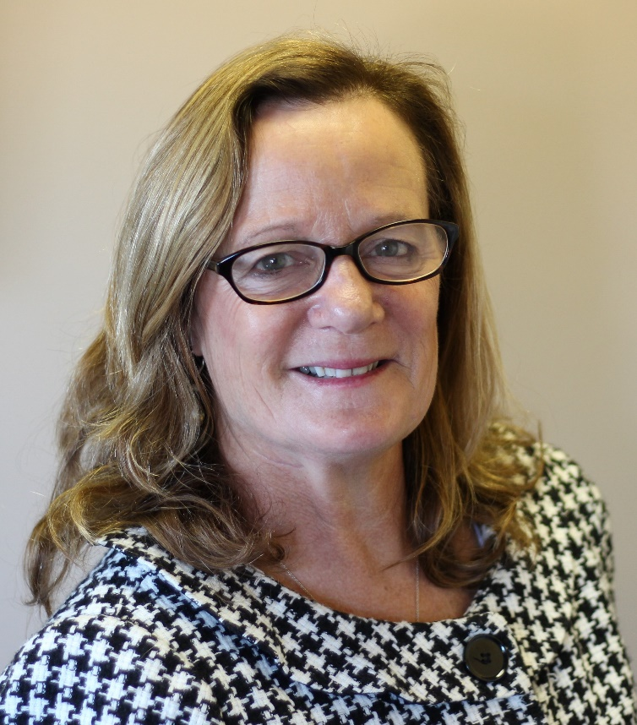
The MNE Group adviser Maureen Meehan, of Quechee and Andover, Mass., has received one of Boston Magazine’s 2018 Five Star Wealth Manager awards. The award was announced in the February issue of Boston, according to a news release from The MNE Group.
Meehan and her partner at the firm, Kristin Nordahl, both were recipients of the award. The women were nominated through a survey of more than 3,000 registered financial services professionals and financial services companies. Together the pair has more than 70 years of combined financial advising experience and an “unwavering commitment to their clients and to their sustainable success,” the release said.
“It’s wonderful that Maureen and Kristin have been recognized for their tremendous commitment to people who need help planning their financial futures. They have a knack for designing financial plans that meet the individual needs of their clients as well as explaining them clearly so their clients feel engaged and empowered in their financial lives,” said Dave Porter, managing partner at Baystate Financial, with which The MNE Group is aligned.

