**Join Us for a Complimentary Lunch and a Special Presentation!**

**CC Coaching and Consulting, Inc. Presents:**

***“Working With Women: Surprising Secrets to Build Loyalty & Long-Term Clients”***

***Presented by*: Ann Hughes – President/Founder of The Female Affect**

**National Spokesperson for WomensJobList**

The Female Affect adds a new twist to traditional presentations regarding women and investing by sharing personal experiences,

preferences and a fresh perspective through real life examples of how women and couples work with their financial professionals.

Let us help you grow your business by attending this informational event! Want to know more about Ann Hughes and The Female Affect?

[Click here](http://www.thefemaleaffect.com/) for more information!

**Topics of Discussion:**

* Learn simple and effective strategies to acquire new female clients and couples.
* How to deepen your relationship with existing clients.
* Grow sales and improve business functions.

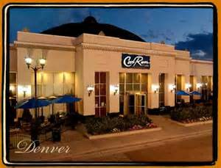

**Date: May 19th, 2015**

**Time: 11:00am – 12:30pm**

**Location: Cool River Café - 8000 East Belleview Avenue – Greenwood Village, CO 80111**

**\*Registration is required!\***

**Please RSVP to Diana Larson at dianalarson@cccandc.com by May 15th**

* Craig Ciarlelli, is an Investment Adviser Representative offering securities and advisory services through Cetera Advisor Networks LLC, member FINRA/SIPC. Cetera Advisor Networks LLC, is not affiliated with any other named entity.

*This event paid for in whole or in part by Sammons Retirement Solutions.

