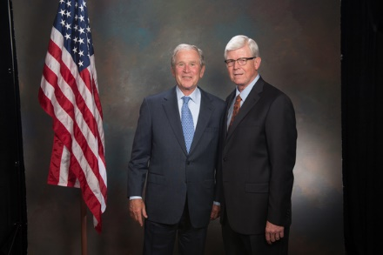
As a recognized top advisor, Danny Cochran also had the opportunity to meet
President George W. Bush during CONNECT2015 in Dallas.

Danny Cochran, Danny Cochran Certified Financial Planner ®and CPA located in Stillwater, Shawnee, and Oklahoma City attended CONNECT2015, HD Vest’s annual national conference. HD Vest Investment ServicesSM, the leading independent broker-dealer empowering holistic wealth management-based investment services, hosted over 1,600 participants as part of CONNECT2015, which took place in Dallas, TX, from June 16-19, and featured HD Vest’s unique focus on supporting independent advisors who integrate tax solutions with financial planning services.

CONNECT2015 included a thought-provoking line-up of speakers, highlighted by industry experts and noted commentators such as President George W. Bush, and provided one-of-a-kind opportunities to network with thought leaders from across the industry. The event included interactive educational workshops and breakout sessions, as well as the opportunity to meet with 125 financial product firms and exhibitors to discuss some of the latest ideas encompassing a wide range of practice management and wealth management solutions.

“It was an honor to attend CONNECT2015. The entire Financial Services team of my practice attended. We all found the event to be an invaluable resource for networking with peers from around the country and, perhaps most importantly, to learn firsthand from HD Vest executives and industry experts regarding best practices related to the successful integration of sound tax and investment advice into one wealth management solution aimed at helping our clients to pursue their long-term financial goals,” said Cochran.

Learn more: www.dannycochran.com

Danny Cochran is a Registered Representative. Securities offered through H.D.Vest Investment Services^{sm} Member SIPC Advisory Services offered through H.D.Vest Advisory Services^{sm} 6333 N. State Highway 161 Fourth Floor, Irving, TX 75038 972.870.6000

Danny Cochran Certified Financial Planner and CPA is not a registered broker/dealer or independent investment advisory firm

