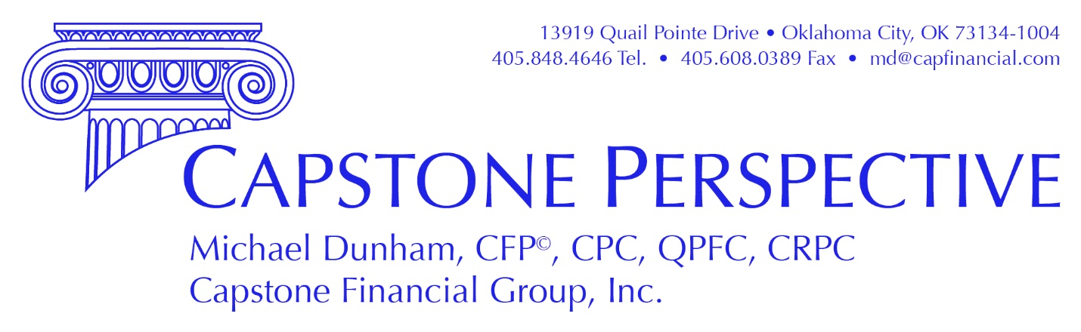

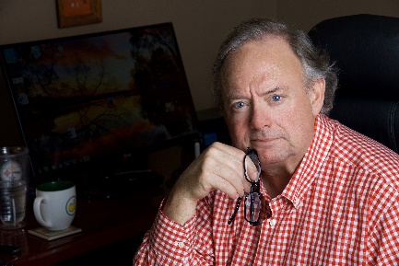
2020 will forever be linked to the global pandemic. I hope you and your families are well and are coping with the current shutdown. Fortunately, Capstone operations are business as usual other than staff is working remotely and the face-to-face meetings I treasure are on hold. We’ve all probably seen enough images of the virus and read lots about it, so I am not going to share things like that. I do encourage you to follow the directions of healthcare professionals and to listen to them rather than politicians.
Stocks entered bear market territory with a total loss of $12.1 trillion from February 19 through March 20. Since then, stocks are up 25% as of April 9th. The bond market turned a little frosty with some forced selling early in the event but now is operating more normally. New jobless claims set new records. The economy has largely shut down and we will see a GDP contraction of at least 20% this quarter. Corporate earnings will vary by industry. Most commentators expect earnings declines averaging 25%.
Saudi Arabia, Russia and other producers added to our angst in Oklahoma by taking advantage of the pandemic to attempt to put American energy companies out of business with low oil prices. The lowest gasoline prices in a decade are nice but our local economy is still significantly affected by the fortunes of players in the energy exploration, production, and transportation industries. I hope politicians and the American public remember these actions by these players.
It is possible the stock market bottom was reached in March. I certainly hope so. However, I am preparing for further declines before this bear stock cycle is over. The stock market is forward looking so the bottom will be put in before the economy has recovered. The nature of this recovery will depend on many factors.
Science will be our salvation and will determine how quickly the economy is reopened. Hopefully, scientists will come up with an absolute cure that can be mass produced and administered quickly. Short of this, it seems the re-opening will be in fits and starts and will not be a green light moment we initially hoped for. Bill Gates told the press this morning he expects an effective treatment within four to six months. This is encouraging and he should know. If you have not read about the things he is doing, Google it up. There is no doubt he is someone making a real difference in the world.
I am completely certain the markets and the economy will recover over time. I expect the recovery to be strong and certainly hope it will be rapid. There is already tremendous pent up demand to do the things we previously took for granted. Americans will be going out to eat, going to concerts and movies, going to the gym, etc. at much higher levels than they were before the pandemic once we can do these things. The United States is a consumer driven economy and will lead the world out of this mess economically.
The Capstone Client Portal and Reports
Our client portal provides more robust, easier to understand and more timely information about your assets than Schwab. If you have not yet set yourself up to login, please e-mail Mara Scott at mara@capfinancial.com to send you a login e-mail. We can also set up to send you a PDF report periodically if you would prefer that to going online. The system includes a document vault which allows you to securely save any type of document and contains your Schwab statements You can also download an App on your iPhone or other device to access information as well.

Risk and Opportunities
The Chinese symbols for crisis and opportunity are the same. “Crisis is opportunity riding the restless winds” I feel there will be great opportunities to buy companies and fixed income investments as there always are during bear markets. Rather than chasing airlines, cruise lines, restaurants and other hard-hit industries or companies that have done well during this period, because of the unusual circumstances, I plan to buy my favorite companies with solid balance sheets and strong business positions instead.
The CAREs ACT

Congress passed the Coronavirus Aid, Relief, and Economic Security Act of 2020 on March 27, 2020. Please don’t hesitate to contact me if you have any questions about how provisions of the CAREs Act might affect you or your family. The following are several of the important provisions.

Coronavirus-Related Retirement Plan Distributions. Participants and account owners of 401(k), IRA and 403(b) plans (not defined benefit plans) who have suffered financially due to the pandemic may take distributions of up to $100,000 with no 10% penalty and no mandatory income tax withholding. These distributions are subject to income tax but may be repaid within three years to avoid the income tax.

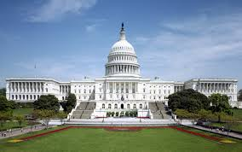
Coronavirus-Related Loans. During the next 180 days, 401(k) participants may take a plan loan of 100% of their vested account balance up to $100,000. Any interest payments are deferred up to one year and an additional year is added to the normal five-year loan term limit.

Required Minimum Distributions Eliminated for 2020. People subject to the Required Minimum Distribution rules (typically inherited IRA owners and those over age 72) do not have to take RMD distributions during 2020. Also, the RMD for 2021 will be based on the asset value as of December 31, 2020. If you have taken your RMD already this year and it has been in the last sixty days, you may be able to repay the plan as a “rollover” contribution and eliminate the tax on the distribution. This rule also does not apply to defined benefit plans.

The Paycheck Protection Program. Small businesses may apply for a loan guaranteed by the Small Business Administration of the U.S. Treasury that is forgivable if the business does not lay off employees for a period of eight weeks. The money may be used for payroll, mortgage interest, rent or utilities. Clients with payroll expense should contact their banks to apply for this loan.

Thanks for Your Business!

Michael Dunham CFP, CPC, QPFC, CRPC
Capstone Financial Group, Inc.
13919 Quail Pointe Drive
Oklahoma City, OK 73134
405-848-4646
md@capfinancial.com
www.capfinancial.com

Capstone Financial Group, Inc. is a registered investment advisor.

