Half Time 2018: The Economy and Markets

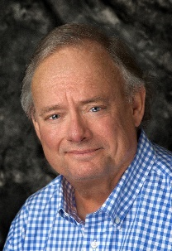
Stocks advanced 3.4% for the second quarter and are now up 2.6% for the year. The stock index has gained 118% since the market high of October 2007 and 389% since the market low of March 2009. Energy companies led the way with a 13.5% average gain while technology was up 7.1% and consumer stocks were up 8.2%. Weaker sectors included financials and industrials, both down 3.2%.
Gross Domestic Product increased at a 2.8% annualized rate for the first quarter of 2018 and is expected to increase to above 3% for the full year. Many economists are expecting a strong GDP growth of well more than the consensus. A conservative economist I follow expects GDP to exceed 4%. Were this to happen, stocks would likely advance.

The ten-year U.S. Treasury bond now yields 2.85%. This is up somewhat for the year but is well below the long-term average of just over 6%. The FED is committed to higher market interest rates. I expect them to be successful. We hope to be able to buy bonds at higher yields not available since the financial crisis. I think we will eventually be able to do just that. For years we were able to obtain 8% returns on worry-free bond portfolios.

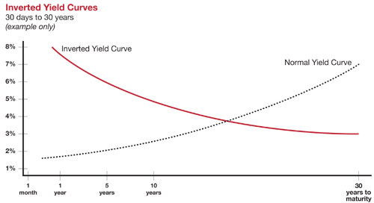
Recently, there has been talk of an inverted yield curve. The chart to the left illustrates both normal and inverted yield curves. A normal yield curve involves increasingly higher interest rates for longer maturities. Longer bonds provide lower yields when the curve is inverted. Over the last sixty years, the economy has gone into recession every time the yield curve has inverted. When the yield curve inverts, investors are betting on lower inflation over the long-term rather than the short-term. This implies a weaker economy going forward. This bears (pun intended) watching.

Unemployment is currently running at 4% compared to the long-term average of 6.2%. This is the strongest employment number in my career. Wage levels have been slow to keep up, but the FED is seeing signs of wage growth beginning to appear. This is part of the reason they are committed to higher interest rates. Higher rates, in their view, would reduce the chances of an inflation shock stemming from wage growth too fast for the economy to handle.
Get the Five-Year Clock Started! Open a Roth IRA Today.

The Roth IRA is the swiss army knife of financial planning tools. It provides tax-free growth rather than just tax-deferred growth. Distributions from Roth accounts are tax-free if distributed after age 59 ½ and after the account has been open for five years. Roth accounts are not subject to age 70 ½ required distributions. The Roth features an exception to the 10% penalty for up to $10,000 for a first-time home purchase. I recommend a Roth for just about everyone. Clients with children and grandchildren should consider opening one for them to trigger the start of the five-year clock. There are no minimum deposits and Fidelity has eliminated custodial fees on all IRA accounts. Call me if you would like to talk Roth.
Oklahoma 529 College Savings Plan

Oklahoma, fortunately, has a strong, low-cost 529 plan. OK4saving.org is a self-service 529 plan that does not impose brokerage commissions and allows for an Oklahoma income tax deduction of up to $10,000 per year. I can help you with projections of college costs for children or grandchildren. I also can help you with the Oklahoma plan by showing you how set up accounts and by explaining the investment options. We do not receive any renumeration from the plan or investments in the plan. This is a great way to save for college for children or grandchildren.

A College Success Story!

My son Drew graduated from OU in 2016. When he was born, I couldn’t wait to get his Social Security number, so I could start saving for college. I saved enough to send him to a mid-priced private school. When he selected OU over OSU (my alma mater) and other schools I knew I had enough for him to get his degree. I also knew we would have built-in family Bedlam on a permanent basis. Oh, well, life’s not perfect.

My college projections involve estimating future costs for three different schools. The client selects a state school, a mid-priced private school and a high priced private school. We obtain cost information from each school and make projections based on what we feel are reasonable account earnings and cost escalation numbers. We had slightly overestimated my son’s actual costs at OU. He did his part by graduating in four years. He now has the G.I. Bill, so I am using his extra college money helping one of his cousins finish her senior year at OU. Now I’ve got to work on grandchildren and making sure they are Cowboy fans!

Thank you for your business!

Michael Dunham CFP®, CPC, QPFC

Investment advisory services offered through Access Financial Resources, Inc., an SEC Registered Investment Advisor

*Market Returns: All data is indicative of total return which includes capital gain/loss and reinvested dividends for noted period. Index data sources; MSCI, DJ-UBSCI, WTI, IDC, S&P. The information provided is believed to be reliable, but its accuracy or completeness is not warranted. This material is not intended as an offer or solicitation for the purchase or sale of any stock, bond, mutual fund, or any other financial instrument. The views and strategies discussed herein may not be appropriate and/or suitable for all investors. This material is meant solely for informational purposes and is not intended to suffice as any type of accounting, legal, tax, or estate planning advice. All forecasts mentioned are for illustrative purposes only and should not be interpreted as investment recommendations. Past performance is no guarantee of future results. Indexes are not available for directly investment. All investing involves risks, including the potential for loss of principal. There is no guarantee that any investment plan or strategy will be successful.

