In this week’s recap: an index of manufacturing activity hits a 10-year low, the jobless rate falls to a 50-year low, and the Nasdaq Composite outperforms the S&P 500 and Dow Jones Industrial Average.
Weekly Economic Update

Presented by Serge Mallat, CLTC, October 7, 2019

THE WEEK ON WALL STREET
The fourth quarter started with a mixed week for equities. A slip for an index of U.S. manufacturing activity proved to be a market mover, more so than the latest jobs report.
The Dow Jones Industrial Average lost 0.92% for the week; the S&P 500, 0.33%. In contrast, the Nasdaq Composite improved 0.54%. Overseas stocks pulled back: the MSCI EAFE index dipped 2.60%.^{1,2}

Attention on Manufacturing
The Institute for Supply Management’s Manufacturing Purchasing Managers Index (PMI) fell to 47.8 in September, its lowest level in ten years. Traders worried that the number reflected weakening business confidence. ISM’s latest Non-Manufacturing PMI also declined, but the 52.6 reading indicated growth in the service sector last month.
ISM does state that when a PMI is above 43.2, the overall economy is typically still expanding, even if a specific sector is not. Another widely watched Factory PMI, maintained by IHS Markit, rose to a five-month peak of 51.1 in September; a number above 50 indicates factory output is increasing.^{3,4}

Lowest Unemployment Rate in 50 Years
The Department of Labor said that employers added 136,000 net new workers in September. Unemployment was at 3.5%, a level last seen in December 1969. The U-6 jobless rate, which counts both the unemployed and underemployed, fell to a 19-year low of 6.9%.
Monthly job creation has averaged 161,000 so far in 2019, down from 223,000 in 2018. This may reflect the challenge companies face trying to fill job openings in an economy with so little unemployment. Annualized wage growth fell to 2.9% in September, the smallest yearly advance recorded since July 2018.⁵

What’s Next
Trade representatives from the U.S. and China return to the negotiating table on Thursday; their meeting is scheduled to conclude on Friday. Any news stemming from their talks could quickly affect equity markets here and abroad.

T I P O F T H E W E E K
If you are nearing retirement age, ask your employer if it allows phased retirements. More companies are offering this option, which gives a worker the flexibility to shift from full-time to part-time hours on the way to retiring.

THE WEEK AHEAD: KEY ECONOMIC DATA
Tuesday: Federal Reserve Chairman Jerome Powell speaks at the annual meeting of the National Association for Business Economics in Denver.
Wednesday: The Federal Reserve publishes the minutes from its September meeting.
Thursday: The Bureau of Labor Statistics presents the August Consumer Price Index, showing monthly and yearly inflation data.
Friday: The University of Michigan offers its preliminary October Consumer Sentiment Index, a measure of consumer confidence levels.
Source: Econoday, Federal Reserve, October 4, 2019
The Econoday and Federal Reserve economic calendars list upcoming U.S. economic data releases (including key economic indicators), Federal Reserve policy meetings, and speaking engagements of Federal Reserve officials. The content is developed from sources believed to be providing accurate information. The forecasts or forward-looking statements are based on assumptions and may not materialize. The forecasts also are subject to revision.

THE WEEK AHEAD: COMPANIES REPORTING EARNINGS
Tuesday: Domino’s (DPZ)
Thursday: Delta Air Lines (DAL)
Friday: Citigroup (C), Fastenal (FAST)
Source: Zacks.com, October 4, 2019
Companies mentioned are for informational purposes only. It should not be considered a solicitation for the purchase or sale of the securities. Any investment should be consistent with your objectives, time frame, and risk tolerance. The return and principal value of investments will fluctuate as market conditions change. When sold, investments may be worth more or less than their original cost. Companies may reschedule when they report earnings without notice.

Q U O T E O F T H E W E E K

“When anger rises, think of the consequences.”
Kong Qui (Confucius)

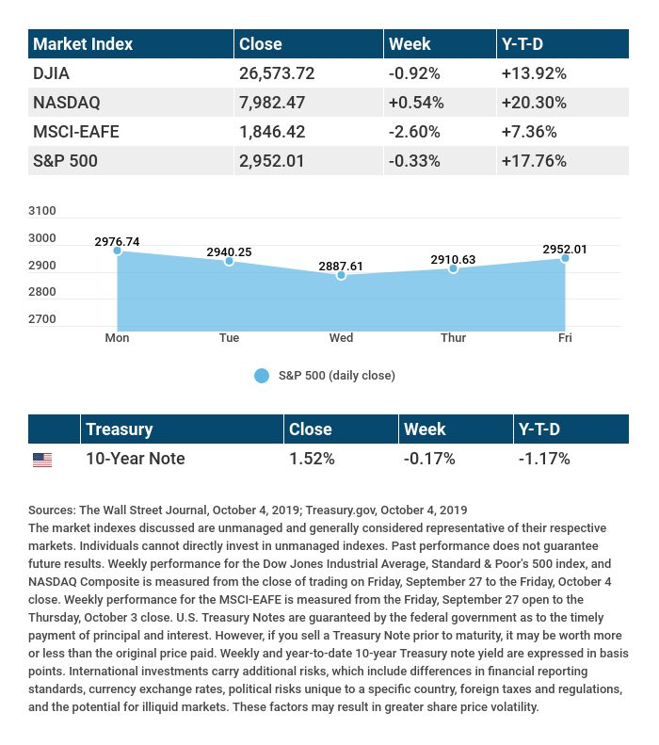

T H E W E E K L Y R I D D L E

Tamara donated $1 million to a charity. After she donated all that money, she was a millionaire. Can you explain this?

LAST WEEK’S RIDDLE: Which is heavier, a pound of lead or a pound of silver?
ANSWER: Neither; they both weigh one pound.

Serge Mallat, CLTC | 954-445-8222 | smallat@onesouthfloridawa.com
www.onesouthfloridawa.com
Know someone who could use information like this?
Please feel free to send us their contact information via phone or email. (Don’t worry – we’ll request their permission before adding them to our mailing list.)

Registered Representative and Investment Advisor Representative of and securities offered through OneAmerica Securities, Inc., a Registered Investment Advisor, Member FINRA, SIPC. OneSouth Florida Wealth Advisors is not an affiliate of OneAmerica Securities and is not a broker dealer or Registered Investment Advisor.
Do not transmit orders regarding your OneAmerica Securities, Inc. account via e-mail. OneAmerica Securities, Inc. and OneSouth Florida Wealth Advisors will not be responsible for carrying out orders and or instructions.
This message is intended only for the use of the individual or entity to which the transmission is addressed. Any interception may be a violation of law. If you are not the intended recipient, any dissemination, distribution or copying of this message is strictly prohibited. If you are not the intended recipient, please contact the sender and destroy all copies of the document.
Provided content is for overview and informational purposes only and is not intended and should not be relied upon as individualized tax, legal, fiduciary, or investment advice.
This material was prepared by MarketingPro, Inc., and does not necessarily represent the views of the presenting party, nor their affiliates. The information herein has been derived from sources believed to be accurate. Please note - investing involves risk, and past performance is no guarantee of future results. Investments will fluctuate and when redeemed may be worth more or less than when originally invested. This information should not be construed as investment, tax or legal advice and may not be relied on for the purpose of avoiding any Federal tax penalty. This is neither a solicitation nor recommendation to purchase or sell any investment or insurance product or service, and should not be relied upon as such. All market indices discussed are unmanaged and are not illustrative of any particular investment. Indices do not incur management fees, costs and expenses, and cannot be invested into directly. All economic and performance data is historical and not indicative of future results. The Dow Jones Industrial Average is a price-weighted index of 30 actively traded blue-chip stocks. The NASDAQ Composite Index is a market-weighted index of all over-the-counter common stocks traded on the National Association of Securities Dealers Automated Quotation System. The Standard & Poor's 500 (S&P 500) is a market-cap weighted index composed of the common stocks of 500 leading companies in leading industries of the U.S. economy. NYSE Group, Inc. (NYSE:NYX) operates two securities exchanges: the New York Stock Exchange (the “NYSE”) and NYSE Arca (formerly known as the Archipelago Exchange, or ArcaEx®, and the Pacific Exchange). NYSE Group is a leading provider of securities listing, trading and market data products and services. The New York Mercantile Exchange, Inc. (NYMEX) is the world's largest physical commodity futures exchange and the preeminent trading forum for energy and precious metals, with trading conducted through two divisions – the NYMEX Division, home to the energy, platinum, and palladium markets, and the COMEX Division, on which all other metals trade. Additional risks are associated with international investing, such as currency fluctuations, political and economic instability and differences in accounting standards. This material represents an assessment of the market environment at a specific point in time and is not intended to be a forecast of future events, or a guarantee of future results. MarketingPro, Inc. is not affiliated with any person or firm that may be providing this information to you. The publisher is not engaged in rendering legal, accounting or other professional services. If assistance is needed, the reader is advised to engage the services of a competent professional.
CITATIONS:
1 - wsj.com/market-data [10/4/19]
2 - quotes.wsj.com/index/XX/990300/historical-prices [10/4/19]
3 - tinyurl.com/y296rohg [10/2/19]
4 - investing.com/news/economic-indicators/newsbreak-ism-services-index-tumbles-to-3year-low-1991459 [10/3/19]
5 - tinyurl.com/y6s8emsr [10/4/19]

CHART CITATIONS:
wsj.com/market-data [10/4/19]
quotes.wsj.com/index/XX/990300/historical-prices [10/4/19]
quotes.wsj.com/index/SPX/historical-prices [10/4/19]
treasury.gov/resource-center/data-chart-center/interest-rates/Pages/TextView.aspx?data=yieldYear&year=2019 [10/4/19]
treasury.gov/resource-center/data-chart-center/interest-rates/Pages/TextView.aspx?data=yieldAll [10/4/19]

