ANTHONY E. LOCASCIO, CFP® EA
ANTHONY LOCASCIO, CONSULTING, LLC
Taxes, Investment, Wealth Management & Retirement Income Planning
59 Old Highway 22, Clinton, NJ 08809
Phone: 908-730-8599 ** 800-269-9329
Fax: 908-730-9656
Email: info@anthonylocascio.com
www.anthonylocascio.com

Education

Wagner College, Staten Island, NY
Pre-Law/Minor in Business Administration; B.A., Political Science,
GPA 4.0, Cum Laude Graduate
College for Financial Planning, Denver, CO
Accreditation Council for Accountancy and Taxation
Association for Investment Management & Research

Designations

CERTIFIED FINANCIAL PLANNER™ Practitioner
ENROLLED AGENT: Enrolled to represent taxpayers before the Internal Revenue Service
Ed Slott Master Elite IRA Advisor

Affiliations

Certified Financial Planner Board of Standards, Inc.
Financial Planning Association
Financial Planning Association of NJ
National Association of Enrolled Agents
New Jersey Department of Banking & Insurance
Better Business Bureau
National Association of Tax Practitioners
Member of Ed Slott’s Master Elite IRA Advisor Group

Anthony E. LoCascio is registered with and securities offered through Kovack Securities, Inc. Member FINRA/SIPC. 6451 N. Federal Highway, Suite 1201, Ft. Lauderdale, FL 33308 (954) 782-4771. Anthony LoCascio Consulting, LLC offers Financial Planning and Investment Advisory services through Investment Capital Advisors LLC. Anthony LoCascio Consulting, LLC and Investment Capital Advisors LLC are not affiliated with Kovack Securities, Inc. or Kovack Advisors, Inc. Kovack Securities, Inc. and Kovack Advisors, Inc. do not provide tax and/or legal advice. Anthony LoCascio Consulting offers Tax Planning Services.

ANTHONY E. LOCASCIO, CFP® EA
ANTHONY LOCASCIO CONSULTING, LLC

Accomplishments

- Host of Radio Show, “Make Your Money Work”

- Interviewed by NBC, Fox News, CNBC,
The New York Post, Reader’s Digest and the NY Times, 2001

- Author

- Nominated to Worth Magazine as one of the top Financial
Advisors in America, 1998

- Hosted “Who Stole the American Dream?” cable TV show, 1998

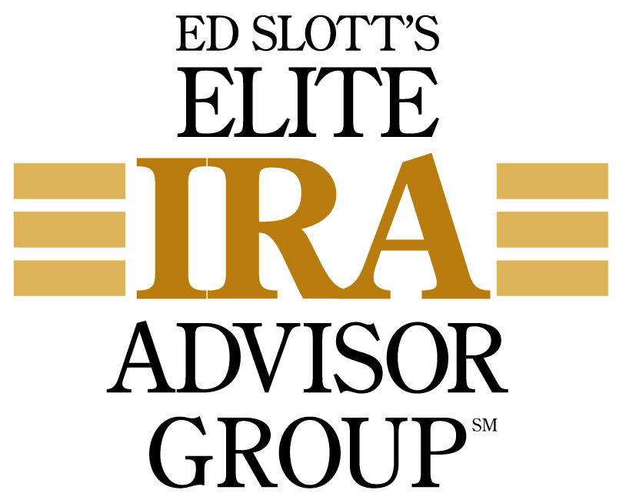

Anthony E. LoCascio is registered with and securities offered through Kovack Securities, Inc. Member FINRA/SIPC. 6451 N. Federal Highway, Suite 1201, Ft. Lauderdale, FL 33308 (954) 782-4771. Anthony LoCascio Consulting, LLC offers Financial Planning and Investment Advisory services through Investment Capital Advisors LLC. Anthony LoCascio Consulting, LLC and Investment Capital Advisors LLC are not affiliated with Kovack Securities, Inc. or Kovack Advisors, Inc. Kovack Securities, Inc. and Kovack Advisors, Inc. do not provide tax and/or legal advice. Anthony LoCascio Consulting offers Tax Planning Services.

