Where has this been all of my life? And, why did my hubby from Boston not know about this? Well, the good news is that now Nantucket Cranberry Pie is indeed in my life. It’s super easy to put together and so very tasty!

Nantucket Cranberry Pie
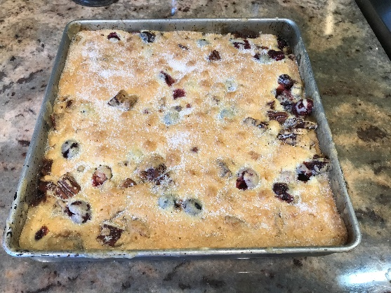

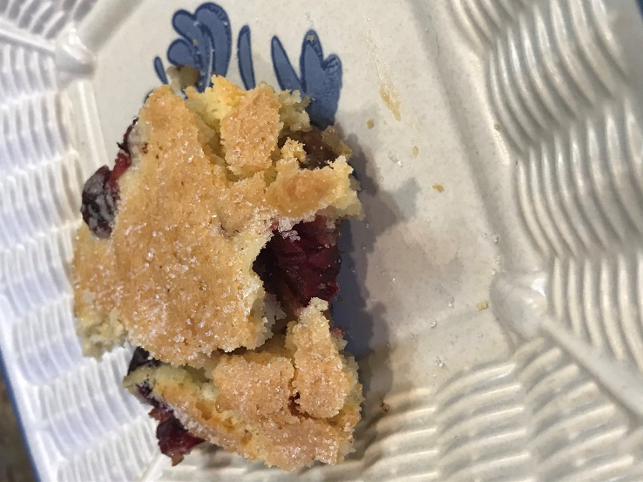

Ingredients:
1 stick unsalted butter, melted, plus more for the pan
2 heaping cups cranberries
¾ c pecans, chopped
1 2/3 c plus 1T sugar
2 large eggs
1 t pure almond extract
1 c all-purpose flour
¼ t kosher salt
Ice cream or freshly whipped cream for serving

Directions:
Preheat your oven to 350.
You can use a 9x9 cake pan or a deep pie pan or another similar sized oven safe dish.
Butter the pan. Sprinkle the cranberries over the bottom of the pan. Then, add the pecans followed by 2/3 c of sugar.
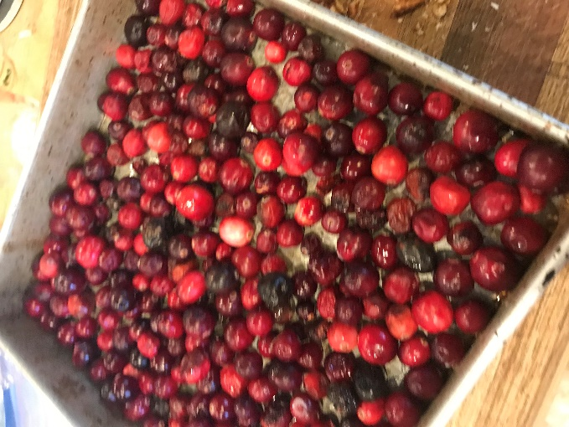
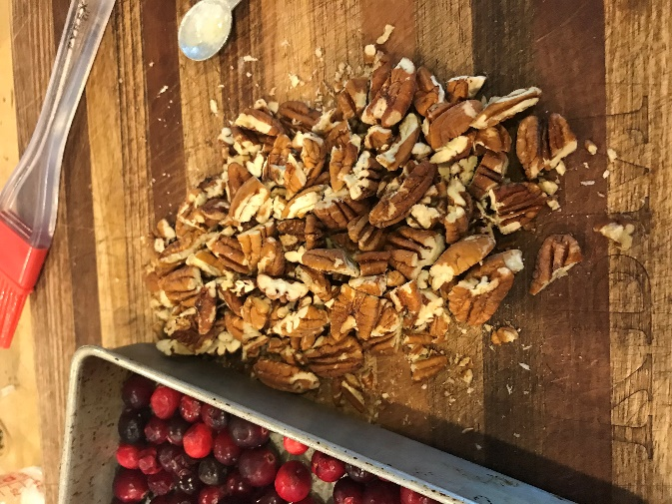
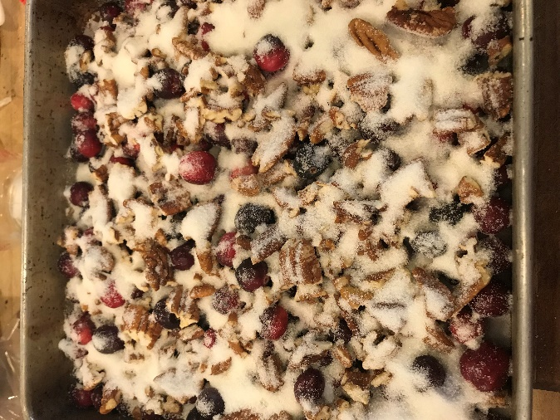

In a medium bowl, whisk the eggs. Add in the melted butter and almond extract and whisk. Next, add in one cup of sugar and the flour and salt. Stir gently until the ingredients are combined.
Next you pour the batter over the cranberries and the pecans. Be sure to fully cover them.
Sprinkle on the last tablespoon of sugar.
Bake for 45-50 minutes. Test to make sure a toothpick inserted into the cake comes out clean.
Serve with the whipped cream or ice cream.
Adapted from The Pioneer Woman

