Is the US Headed for a Recession?
After stellar economic growth in 2021, the US economy declined 1.4% in the first quarter of 2022. This was the first contraction of the economy since the beginning of the economic recovery in 2020. The S&P 500 is down 12.9% for the year through April 2022 and is off to its third-worst start in history. Bonds using the Bloomberg US Aggregate Bond Index, are also down -9.5%.
This performance is largely due to record high inflation, with all eyes focused on the Federal Reserve (Fed). Investors are concerned that the Fed may not be able to tame inflation without causing economic damage. This concern has led investors to worry that a major recession is right around the corner. While it’s true that the potential for a recession is greater, it is far from a foregone conclusion. This edition takes a look at some of the reasons why the risk of a recession, while possible, remains low in 2022.
Defining a Recession
Given the increasing worries of an impending recession, let’s start by defining a recession. The most widely accepted definition of a recession is two consecutive quarters of negative economic growth as measured by gross domestic product (GDP). Using this definition, the recent 1.4% drop in economic growth alone does not meet the definition of a recession, but certainly points to the possibility.
Looking beyond the headline numbers, the story is mixed. For the quarter, the US was hurt by a sharp drop in exports due to supply chain disruptions and decreased government spending. Yet at the same time, consumer and business spending increased. It’s clear that economic growth is slowing as the post-pandemic stimulus fades; however, underlying growth trends, as evidenced by continued consumer spending and business investments, show the economic engine has not yet run out of steam.
Additionally, there are several other reasons the US economic outlook may be brighter than some suspect.
Reasons for Optimism
First, the consumer remains healthy. Consumers have accumulated more than $2 trillion in excess savings during the pandemic. In addition, the household debt service ratio, which is the percent of after-tax income used to make payments on mortgages and other debt, remains at a 40-year low. High savings and low debt servicing costs support continued consumer spending, which drives 70% of US economic growth.
Second, inflation takes a smaller bite out of consumer spending today relative to history. It’s true that higher gas and grocery prices leave less for consumers to spend on other items. The current trend in energy prices is estimated to deliver a $200 billion hit to consumption for the year. However, while the hit is meaningful, it pales in comparison to $2 trillion US consumers have collected in excess savings. Finally, thanks to more fuel-efficient vehicles, spending on gasoline has declined 60% as a share of a consumer’s total wallet during the past four decades.
Third, the job market remains resilient. Job openings currently sit at 11.5 million, while the number of unemployed is approximately 5.9 million. In other words, there are roughly 5.6 million excess jobs. This imbalance in the job market has led to wage increases and ultimately adds to inflationary pressure; However, to date it has not derailed corporate profit margins.
To that final point, corporate profit margins remain resilient and suggest companies have been able to successfully navigate inflation pressures. Since World War II, after-tax profit margins have consistently peaked several quarters before the beginning of a recession. Today, despite higher costs for labor and goods, after-tax profit margins are at record highs not seen since the 1950s. With profit margins still healthy, businesses are unlikely to immediately cut costs, which is a common precursor to recessions.
Consumer Sentiment and Stock Returns Don’t Align
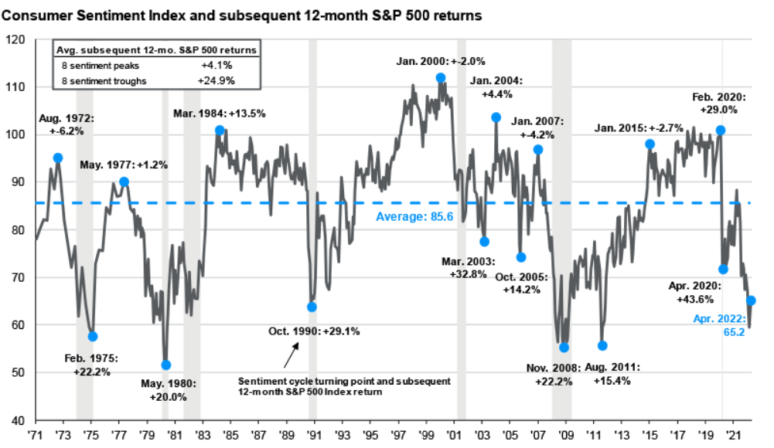
High Inflation, the war in Ukraine, rising mortgage rates and falling portfolio values have all impacted consumer sentiment, which measures how consumers view both their own financial situation and the general state of the economy. However, history shows how consumers feel about the economy does not necessarily correlate with future stock returns, as seen in the chart. Interestingly, when consumer confidence bottoms, it tends to precede stellar equity returns, while peaks in sentiment don't see as much upside. Hence, using how consumers feel about the economy to make large changes in portfolios can be a risky investment strategy.
Recessions are the inevitable end to all economic cycles. There are clear signs the economy is starting to slow after record growth, but slowing is not stalling, and the economic outlook may be brighter than how consumers feel. For investors, having a plan that can withstand a wide range of environments—including an eventual contraction—is far more important than predicting the start and end of the next recession.

Source: JPMorgan Asset Management.

AssetMark, Inc.
1655 Grant Street
10th Floor
Concord, CA 94520-2445
800-664-5345
IMPORTANT INFORMATION
This is for informational purposes only, is not a solicitation, and should not be considered investment, legal or tax advice. The information in this report has been drawn from sources believed to be reliable, but its accuracy is not guaranteed, and is subject to change. Investors seeking more information should contact their financial advisor. Financial advisors may seek more information by contacting AssetMark at 800-664-5345.
Investing involves risk, including the possible loss of principal. Past performance does not guarantee future results. Asset allocation cannot eliminate the risk of fluctuating prices and uncertain returns. There is no guarantee that a diversified portfolio will outperform a non-diversified portfolio. No investment strategy, such as asset allocation, can guarantee a profit or protect against loss. Actual client results will vary based on investment selection, timing, market conditions, and tax situation. It is not possible to invest directly in an index. Indexes are unmanaged, do not incur management fees, costs and expenses and cannot be invested in directly. Index performance assumes the reinvestment of dividends.
Investments in equities, bonds, options, and other securities, whether held individually or through mutual funds and exchange traded funds, can decline significantly in response to adverse market conditions, company-specific events, changes in exchange rates, and domestic, international, economic, and political developments.
Bloomberg® and the referenced Bloomberg Index are service marks of Bloomberg Finance L.P. and its affiliates, (collectively, “Bloomberg”) and are used under license. Bloomberg does not approve or endorse this material, nor guarantees the accuracy or completeness of any information herein. Bloomberg and AssetMark, Inc. are separate and unaffiliated companies.
Please read the Terms of Use posted at www.ewealthmanager.com that govern the use of these materials and also be advised:
AssetMark uses financial market information (“Information”) from third-party providers (“Providers”) in reports (“Materials”). The Information includes, but is not limited to, financial market data, quotes, news, analyst opinions and research reports. The Materials are for informational purposes only, not a solicitation or for use in the creation/management/offering/sale of any financial instrument or product based thereon and should not be considered investment, legal or tax advice. The Information has been drawn from sources believed to be reliable, but its accuracy and timeliness is not guaranteed, and is subject to change. You agree that neither AssetMark nor the Providers are liable for the use of the Information.
You agree not to redistribute the Information to recipients not authorized by AssetMark. You agree that the Providers are considered to be third-party beneficiaries of the Terms of Use.
AssetMark, Inc. is an investment adviser registered with the U.S. Securities and Exchange Commission. AssetMark and third-party service providers are separate and unaffiliated companies. Each party is responsible for their own content and services.
©2022 AssetMark, Inc. All rights reserved.
104105 | C22-18807 | 05/2022 | EXP 05/31/2024

IMPORTANT INFORMATION
This is for informational purposes only, is not a solicitation, and should not be considered investment, legal or tax advice. The information in this report has been drawn from sources believed to be reliable, but its accuracy is not guaranteed, and is subject to change. Investors seeking more information should contact their financial advisor. Financial advisors may seek more information by contacting AssetMark at 800-664-5345.
Investing involves risk, including the possible loss of principal. Past performance does not guarantee future results. Asset allocation cannot eliminate the risk of fluctuating prices and uncertain returns. There is no guarantee that a diversified portfolio will outperform a non-diversified portfolio. No investment strategy, such as asset allocation, can guarantee a profit or protect against loss. Actual client results will vary based on investment selection, timing, market conditions, and tax situation. It is not possible to invest directly in an index. Indexes are unmanaged, do not incur management fees, costs and expenses and cannot be invested in directly. Index performance assumes the reinvestment of dividends.
Investments in equities, bonds, options, and other securities, whether held individually or through mutual funds and exchange traded funds, can decline significantly in response to adverse market conditions, company-specific events, changes in exchange rates, and domestic, international, economic, and political developments.
AssetMark, Inc. is an investment adviser registered with the U.S. Securities and Exchange Commission. AssetMark and third-party service providers are separate and unaffiliated companies. Each party is responsible for their own content and services.
©2022 AssetMark, Inc. All rights reserved.
103305 | C22-18578 | 05/2022 | EXP 05/31/2024

AssetMark, Inc.
1655 Grant Street
10th Floor
Concord, CA 94520-2445
800-664-5345

US Bureau of Economic Analysis.
Source FactSet. Year to Date returns as of 4/29/2022
Source FactSet. Year to Date returns as of 4/29/2022
https://www.bea.gov/news/2022/gross-domestic-product-first-quarter-2022-advance-estimate
JPMorgan Guide to the Market. Q2 2022
JPMorgan Guide to the Market. Q2 2022
Morgan Stanley Wealth Management. 3 Reasons for Optimism About the U.S. Economy
https://am.jpmorgan.com/content/dam/jpm-am-aem/global/en/insights/market-insights/weekly-market-recap-us.pdf
https://privatebank.jpmorgan.com/gl/en/insights/investing/tmt/a-recession-in-the-near-term-is-possible-but-not-probable-heres-why
JPMorgan Guide to the Markets. Q2’2022

