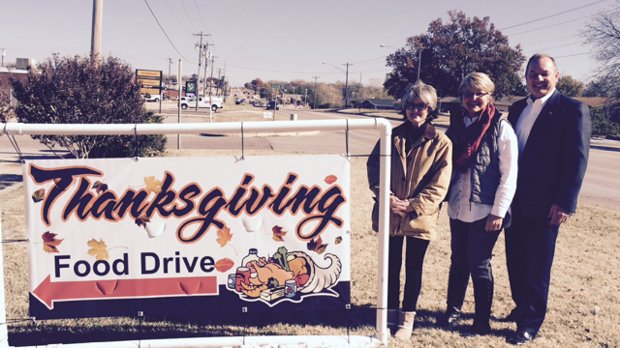

Gaddis & Gaddis Wealth Management Continues Thanksgiving Food Drive
Benefiting Abba’s Table

Ada, Okla., Nov. 21, 2014 -- In what has become an annual tradition, Gaddis & Gaddis Wealth Management, headquartered in Ada, is collecting can goods for distribution to the needy during the Thanksgiving Holiday.
This year, the firm has designated its food collection for Abba’s Tables here in Ada.
Pictured here before the food collection banner are (left to right): Edwina (Eddi) Lowry of Abba’s Tables; Leigh Gaddis and Roger Gaddis of Gaddis & Gaddis.
Gaddis & Gaddis office at 1530 Arlington Street in Ada is collecting cans goods from the public donations during the hours of 8:00 a.m. to 5:00 p.m., Monday through Friday. All canned food items are accepted as these goods will be used during and following Thanksgiving.
The food collection which is now underway will conclude Friday, Nov. 28. The canned goods will then be distributed to Abba’s Tables, which is located at 600 West 9th Street in Ada.
For more information on the G&G Thanksgiving Food Collection, call Gaddis & Gaddis at: 580-332-4144 or Leigh Gaddis directly at 580-310-4144.

