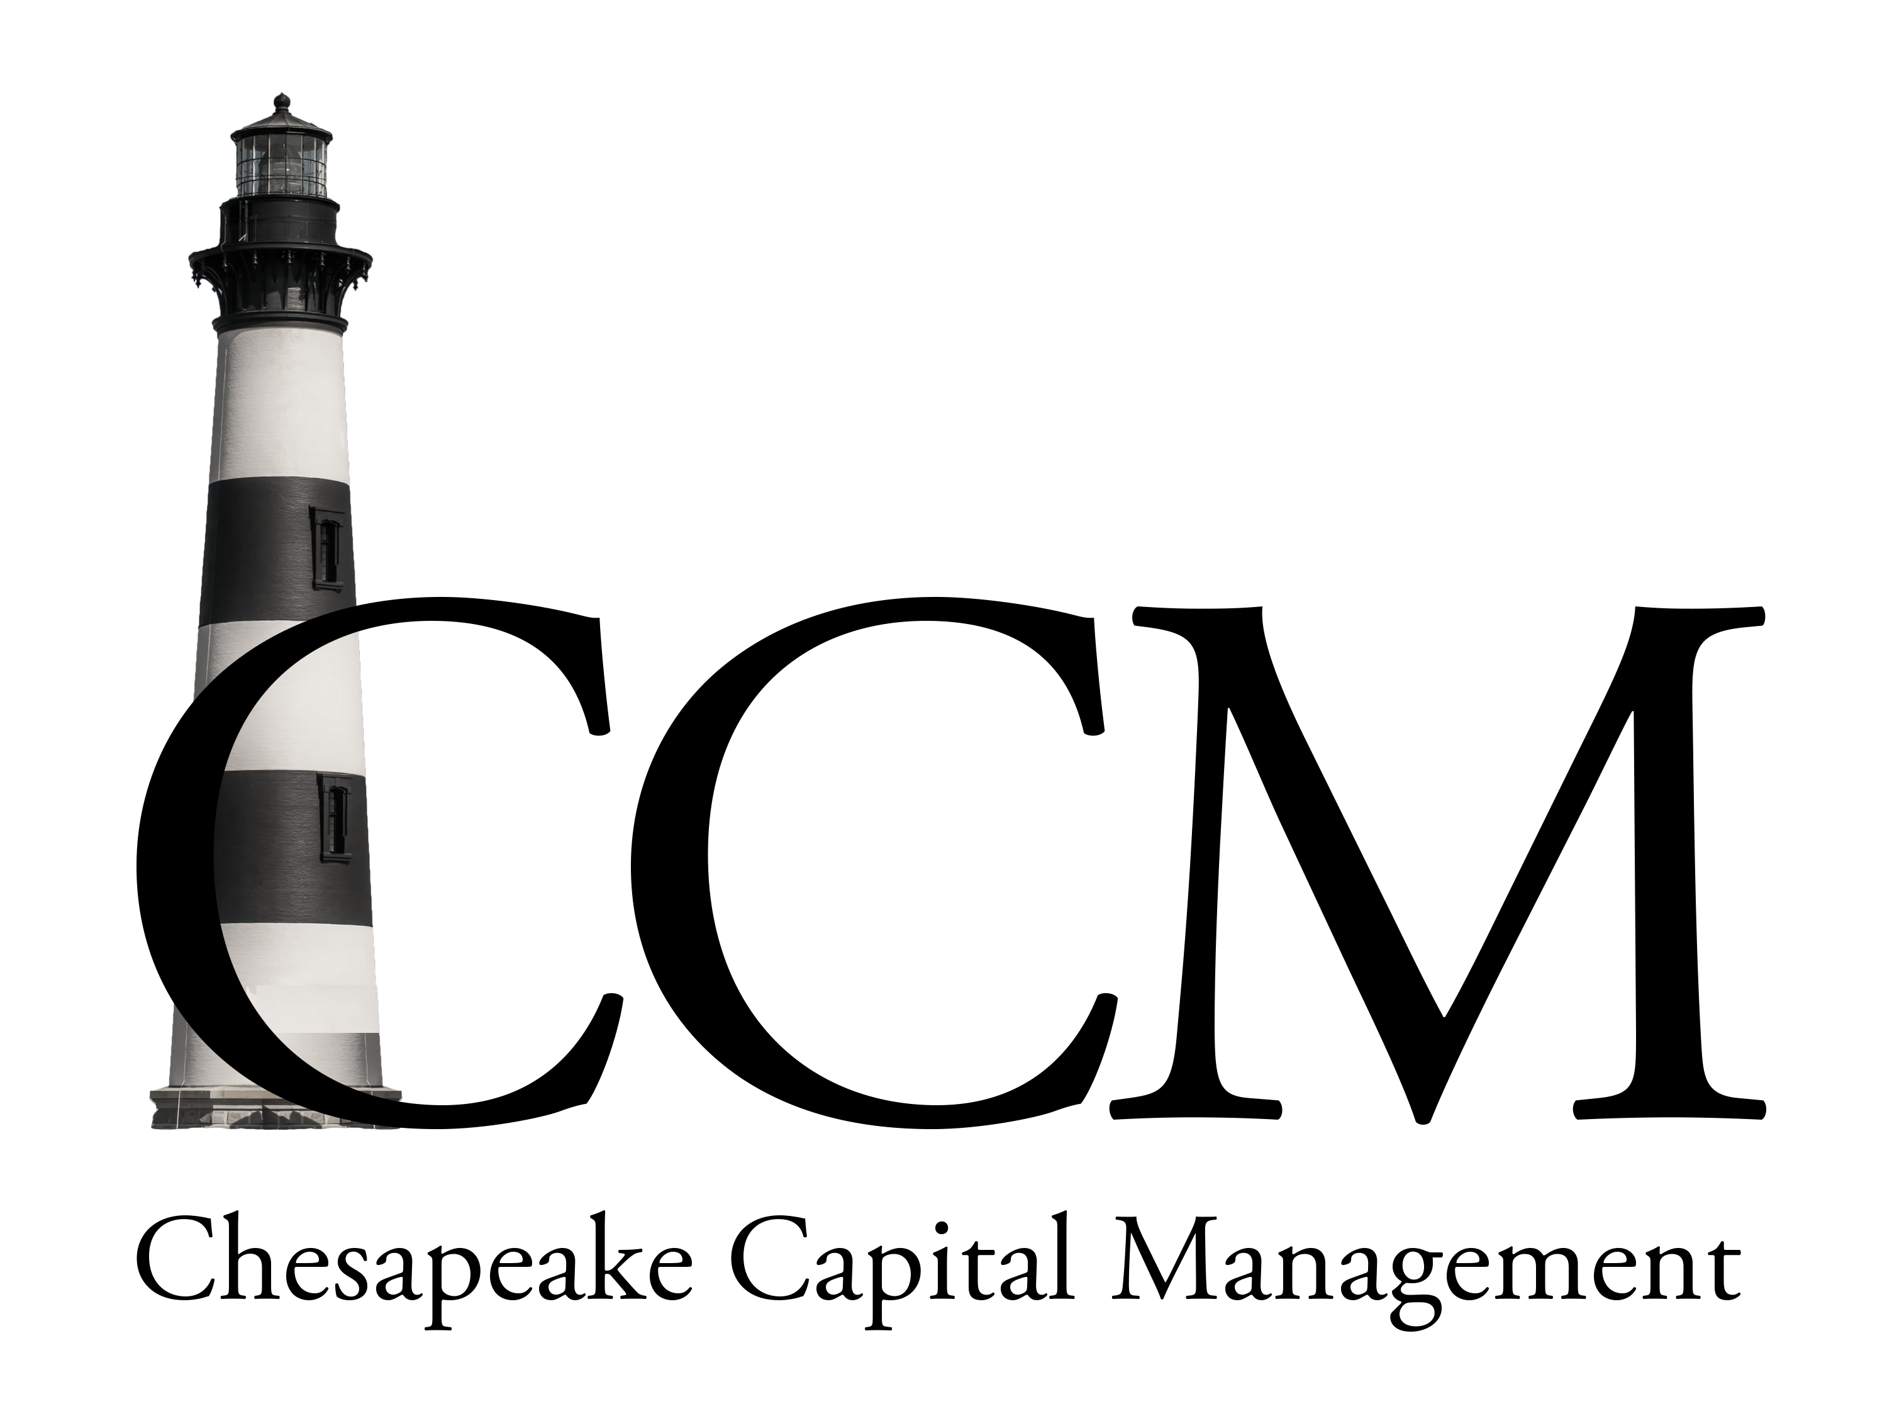

Estate Planning Checklist
This simple checklist is designed to help you assess whether the necessary preparations have been made to care for your family and estate in the unfortunate event of your passing. Although this is not a comprehensive guide, it does provide a starting point for you to determine how well prepared you actually are. If you are uncertain about the answers to any of these questions, it may be wise to make time for a legal and financial review.
Your Wishes:
- Do you have a will?
- Are you happy with the executor(s) and trustee(s) you have chosen?
- Have you executed a living will or health care proxy in the event of tragic illness or disability?
- Do you have a living trust to avoid probate?
- If you have a living trust, have you titled your assets in the name of the trust?
Your Family:
- If you have children, does your will name a guardian in case you and your spouse are deceased?
- If you want to limit your spouse's flexibility regarding the inheritance, have you created a Q-TIP trust?
- Are you sure you have the right type and amount of life insurance to provide for survivor income, loan repayments, capital needs and all estate settlement expenses?
- Have you considered creating trusts for family gift giving?
- Have you considered an irrevocable life insurance trust to exclude the insurance proceeds from being taxed as part of your estate?
Your Taxes:
- If you are married, are you taking full advantage of the marital deduction?
- Are you gifting to family members to take advantage of the $13,000 annual gift tax exclusion?
- Have you gifted assets with a strong likelihood of future appreciation in order to maximize future estate tax savings?
- Have you thought about charitable trusts that could provide you with both estate and income tax benefits?
Effective estate planning usually involves the coordinated efforts of qualified legal, tax, insurance, and financial professionals. The professionals at Chesapeake Capital Management are committed to protecting your legacy. Request your complimentary review today!
Your Business:
- If you own a business, do you have a succession plan?
- Do you have a buy/sell agreement to protect your family business interests?
- Have you considered a gift program that involves your family-owned business?

Why Plan Now?
- A good plan is central to the physical, emotional, and mental wellbeing of your survivors.
- By planning, you can properly preserve and allocate the assets you have worked hard to earn.
- A plan will help determine the most advantageous means of owning property while you are alive.
- Planning may help minimize estate and income taxes, administrative expenses, executor's commissions, and attorney's fees after your passing.
- An estate plan can help provide funds for the education of future generations.
- An estate plan can help provide adequate monies to care for expenses upon your death.
If you have any questions or concerns, I would love the opportunity to meet with you to discuss your estate planning, retirement, and investment questions.
Kind Regards,
Randy H. Packett
President & CEO Chesapeake Capital Management
2943 Emmorton Road
Abingdon, MD 21009
410-671-2260
Investing involves risks, and investment decisions should be based on your own goals, time horizon, and risk tolerance. The return and principal value of investments will fluctuate as market conditions change. When sold, investments may be worth more or less than their original cost.
The content is developed from sources believed to be providing accurate information. The information in this material is not intended as tax or legal advice. It may not be used for the purpose of avoiding any federal tax penalties. Please consult legal or tax professionals for specific information regarding your individual situation. This material was developed and produced by FMG Suite to provide information on a topic that may be of interest. FMG, LLC, is not affiliated with the named broker-dealer, state- or SEC-registered investment advisory firm. The opinions expressed and material provided are for general information and should not be considered a solicitation for the purchase or sale of any security. Copyright FMG Suite.
Investment Advisory Services offered through Chesapeake Capital Management, LLC, a Registered Investment Advisor.
No Client or potential client should assume that any information presented or made available on or through this website should be construed as personalized financial planning or investment advice. Personalized financial planning and investment advice can only be rendered after engagement of the firm for services, execution of the required documentation, and receipt of required disclosures. Please contact the firm for further information

