Douglas Miller Earns Ambassador of the Year

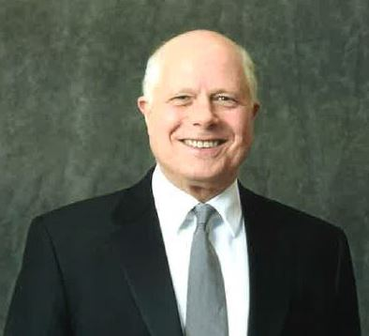
Alliance Advisory Group introduced a new award for 2018 - the Ambassador of the Year. Doug Miller is this year’s recipient. Doug is an incredible representation and promoter of AAG and Guardian in the Rochester community. When many of our associates share with someone in the community that they are associated with AAG and Guardian, the next question or comment revolves around Doug and how adored he is in the community. He can frequently be seen bringing staff Starbucks and helping new young associates shine their shoes. He recently served as the President of Rochester's Estate Planning Council. And impressively, over the past couple years he has been a role model within the AAG community as it relates to succession and securing a continuity for his clients, which not coincidentally contributed him to being a Leader's Club qualifier in '18. Well deserved, Doug!

