In this week’s recap: the blue chips have their best week of 2019, as investors like what they hear from the head of the Federal Reserve and interpret the latest monthly employment numbers.
Weekly Economic Update

Presented by Michael J. Levine, June 10, 2019

THE WEEK ON WALL STREET
Stocks rallied during a week in which Wall Street was buffeted by headlines. The S&P 500 rose 4.41%. The Nasdaq Composite and Dow Jones Industrial Average respectively added 3.88% and 4.71%. The MSCI EAFE index of overseas stocks improved 2.02% across five days.¹⁻²
Following a mixed Monday, the market jumped Tuesday after dovish remarks from Federal Reserve Chairman Jerome Powell. Breaking out of a 6-week losing streak, the Dow had its best week since November.³

JEROME POWELL’S COMMENTS
Speaking at the Federal Reserve Bank of Chicago, the Fed chair stated that central bank officials “will act as appropriate to sustain the expansion” of the economy in the face of “recent developments involving trade negotiations and other matters.”⁴
The next 2-day Fed policy meeting ends on June 19, with a press conference to follow.⁵

HIRING COOLS
Employers added just 75,000 net new jobs to their payrolls in May, according to the Department of Labor. Economists polled by Reuters thought that the gain would be 185,000. The main unemployment rate held at 3.6% last month; the U-6 rate, which includes the underemployed and those who have stopped looking for work, fell 0.2% to 7.1%.
To some analysts, the weak May hiring number hints at private-sector concern over tariffs. To others, it simply signifies the possibility that the economy may be at or near full employment.⁶

FINAL THOUGHT
While breaking news does often merit investor attention, refrain from letting the headlines of the moment prompt you into emotional decisions. Brace yourself for further headlines that may drive market volatility, because new developments are arriving quickly in the financial markets.

T I P O F T H E W E E K
In planning to insure your business, consider three things: how much coverage your operations need, how much coverage your workers need, and the amount of coverage that seems appropriate for your digital and physical assets.

THE WEEK AHEAD: KEY ECONOMIC DATA
Wednesday: The latest Consumer Price Index, showing the rate of inflation in May and across the past 12 months.
Friday: The Census Bureau’s May retail sales report as well as the University of Michigan’s initial June consumer sentiment index, measuring consumer confidence levels.
Source: Econoday / MarketWatch Calendar, June 7, 2019
The Econoday and MarketWatch economic calendars list upcoming U.S. economic data releases (including key economic indicators), Federal Reserve policy meetings, and speaking engagements of Federal Reserve officials. The content is developed from sources believed to be providing accurate information. The forecasts or forward-looking statements are based on assumptions and may not materialize. The forecasts also are subject to revision.

THE WEEK AHEAD: COMPANIES REPORTING EARNINGS
Tuesday: H&R Block (HRB)
Wednesday: Lululemon Athletica (LULU)
Thursday: Broadcom (AVGO)
Source: Morningstar.com, June 7, 2019
Companies mentioned are for informational purposes only. It should not be considered a solicitation for the purchase or sale of the securities. Any investment should be consistent with your objectives, time frame, and risk tolerance. The return and principal value of investments will fluctuate as market conditions change. When sold, investments may be worth more or less than their original cost. Companies may reschedule when they report earnings without notice.

Q U O T E O F T H E W E E K

“Do what you can, with what you have, where you are.”
THEODORE ROOSEVELT

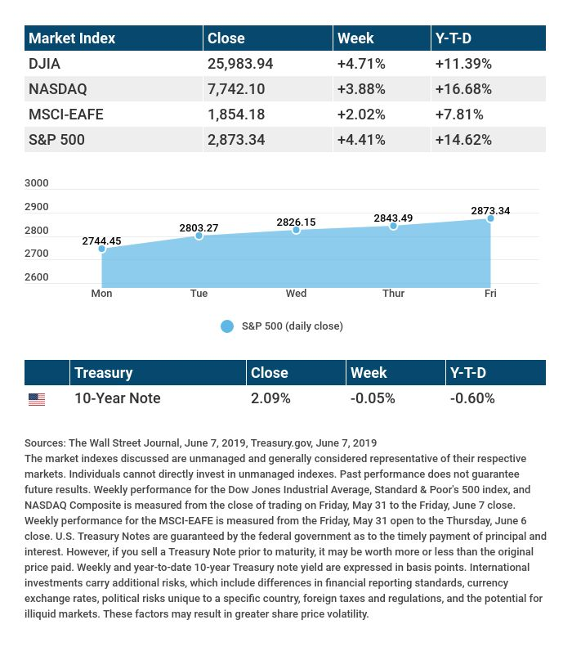

T H E W E E K L Y R I D D L E

What is taken before you can get it?

LAST WEEK’S RIDDLE: How many bricks does it take to complete a building made of brick?
ANSWER: Only one – the “last” one.

Know someone who could use information like this?
Please feel free to send us their contact information via phone or email. (Don’t worry – we’ll request their permission before adding them to our mailing list.)

Securities offered through Kestra Investment Services, LLC (Kestra IS), a member FINRA/SIPC. Investment advisory services offered through Kestra Advisory Services, LLC (Kestra AS), an affiliate of Kestra IS. Levine Group, LLC is not affiliated with Kestra IS or Kestra AS.
CITATIONS:
1 - wsj.com/market-data [6/7/19]
2 - quotes.wsj.com/index/XX/990300/historical-prices [6/7/19]
3 - cnbc.com/2019/06/07/us-futures-edge-higher-as-wall-street-rally-set-to-continue-jobs-data-in-focus.html [6/7/19]
4 - cnbc.com/2019/06/04/powell-says-the-fed-will-act-as-appropriate-to-sustain-the-expansion.html [6/4/19]
5 - federalreserve.gov/newsevents/calendar.htm [6/7/19]
6 - reuters.com/article/us-usa-economy-instant/us-may-payrolls-rose-less-than-expected-idUSKCN1T81GG [6/7/19]
CHART CITATIONS:
wsj.com/market-data [6/7/19]
quotes.wsj.com/index/SPX/historical-prices [6/7/19]
treasury.gov/resource-center/data-chart-center/interest-rates/Pages/TextView.aspx?data=yield [6/7/19]
treasury.gov/resource-center/data-chart-center/interest-rates/Pages/TextView.aspx?data=yieldYear&year=2019 [6/7/19]
treasury.gov/resource-center/data-chart-center/interest-rates/Pages/TextView.aspx?data=yieldAll [6/7/19]

