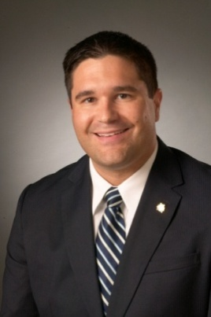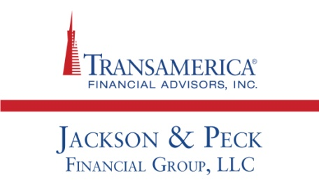

Why It Might Be Time for the Fed to Raise Rates
In doing so, the central bank would cast a vote of confidence in the economy.

Presented by Darrel Peck & Christian Jackson
Will the Federal Reserve make a move in December? As our central bank has avoided tightening U.S. monetary policy for nine years, an end-of-year interest rate hike might seem more possible than probable. Call it a strong possibility, if nothing else – after the November 18 release of the October Fed policy meeting minutes, trading in Fed funds futures indicated that investors saw a 68% chance of a December rate hike. In late October, they saw only a 38% chance of that happening.¹

The October Fed meeting minutes sent a strong signal. They noted that “most” Federal Open Market Committee members thought that conditions for a rate increase “could well be met by the time of the next meeting,” with another passage stating that “it may well become appropriate to initiate the normalization process” at that time.²

Investors want some certainty when it comes to monetary policy. The S&P 500 advanced 1.6% on November 18, carried by gains in financial shares (banks would benefit greatly from higher interest rates). It was the biggest one-day rally U.S. equities had seen in a month. After the FOMC elected to refrain from raising rates in both September and October, the question became “when?” To many market observers, the October FOMC meeting minutes seem to provide an answer.¹

The next jobs report could be a major influence. In October, the economy added 271,000 new jobs with 2.5% annualized wage growth and unemployment falling to 5.0%. If the next Labor Department employment report shows hiring well above the 200,000 level in November, the Fed could interpret that as a clear green light.²

The Fed would be going against the grain by raising rates in December. The People’s Bank of China has lowered its benchmark interest rate six times since October 2014. The European Central Bank, which has launched a major monetary stimulus, has reduced its key interest rate to 0.05%. Some analysts believe it could hit zero. The ECB’s deposit rate is currently at -0.2%.^{3,4}

Even so, investors might appreciate a decisive Fed move. The markets need to have confidence in the Fed, and as CNBC Fast Money panelist Guy Adami recently noted, a hawkish move might be followed by a long dovish interval – the FOMC could raise the federal funds rate in December, then leave it alone until late 2016. That could amount to a best-case scenario for Wall Street.⁵

Besides placating the market, are there other notable reasons to raise rates? Adami’s Fast Money colleague, Euro Pacific Capital CEO Peter Schiff, begged to differ. On the same broadcast, he shared his opinion that the Fed is standing pat because it feels the economy is not yet strong enough to handle a rate hike. “This is a bubble ... not a recovery,” he commented, adding that Wall Street remains in love with easing and “easy money.”⁵

These points of view aside, many analysts, journalists and market participants see a December rate move (and the tightening that would presumably follow it) as a net positive. As Cuttone & Co. senior vice president Keith Bliss told the Wall Street Journal, “I think it’s a relief for the market that in the opinion of the Fed policy makers the economy is not falling apart.”¹

One thing is certain – the federal funds rate will eventually rise from its current historic low, perhaps very soon, as what should be the first step a tightening cycle. In light of this eventuality, you might want to review your investments and your financial strategy.

This material was prepared by MarketingPro, Inc., and does not necessarily represent the views of the presenting party, nor their affiliates. This information has been derived from sources believed to be accurate. Please note - investing involves risk, and past performance is no guarantee of future results. The publisher is not engaged in rendering legal, accounting or other professional services. If assistance is needed, the reader is advised to engage the services of a competent professional. This information should not be construed as investment, tax or legal advice and may not be relied on for the purpose of avoiding any Federal tax penalty. This is neither a solicitation nor recommendation to purchase or sell any investment or insurance product or service, and should not be relied upon as such. All indices are unmanaged and are not illustrative of any particular investment.

Citations.
1 - tinyurl.com/nexyes9 [11/18/15]
2 - foxbusiness.com/economy-policy/2015/11/18/federal-reserve-minutes/ [11/18/15]
3 - reuters.com/article/2015/10/23/us-china-economy-policy-idUSKCN0SH18W20151023 [10/23/15]
4 - usnews.com/news/business/articles/2015/11/18/as-us-prepares-to-hike-rates-europe-could-reap-benefits [11/18/15]
5 - thestreet.com/story/13301410/1/with-latest-fomc-statement-released-will-or-won-t-the-fed-raise-rates.html [11/19/15]

