

***Monday, May 4th, 2020***

***“Tech Titans Support Rest of Market”***

Microsoft, Apple, Amazon, Facebook & Alphabet (Google) account for over 20% of the S&P 500’s weighting. These 5 companies have become a disproportionate weight in the index, which is why their results and commentary were justifiably put under the microscope last week.

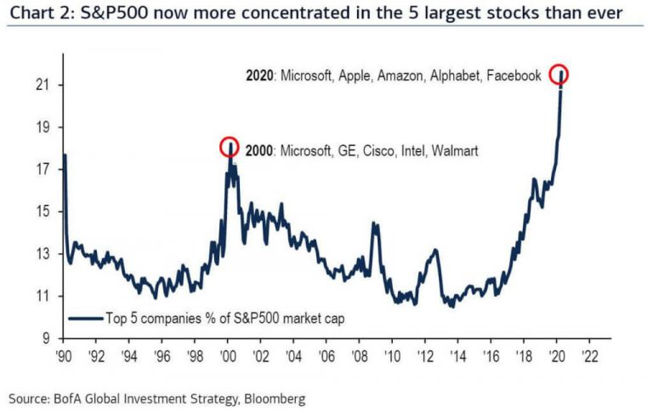

Luckily, all five had healthy balance sheets flush with cash and low debt coming into this crisis. Their stability may be one reason why the overall market seems to be brushing off the terrible economic news and also why these companies have been able to actually gain market cap share amidst the market selloff.

Their first quarter earnings were, for the most part, better than expected. Despite better than expected revenue and earnings, Apple opted to pull guidance* for the upcoming quarter amidst the uncertainty, a trend that has become more popular in recent weeks. In fact, less than 10% of companies in the S&P 500 have chosen to issue guidance for the second quarter.

The five tech leaders are benefiting from very strong balance sheets (high cash, low debt), high profitability, and resilient revenue. It is the companies that had more cyclical revenue, high debt levels and low profitability that have fared the worst in recent months. Several companies have had to file for bankruptcy protection in recent weeks, including Diamond Offshore Drilling, Frontier Communications, J. Crew & Pier 1 Imports, to name a few.

It could have been worse but there has been an unprecedented amount of corporate debt issued in March and April to buy companies time. Supported by the Federal Reserve’s bond market intervention, investment grade issuance totaled a record $235 billion in March and over $200 billion in April1. Even junk bond issuance bounced back in recent weeks as the market gained a footing, helping the most troubled companies.

Many companies are also opting to cut or cancel their dividend payments altogether, a risk for those companies that retained shareholders principally for their dividend payment. According to S&P Global Intelligence, 83 companies have suspended or cancelled their dividends in 2020, the highest number going back to 2001. Only 55 companies had done so over the past ten years2. A further 142 companies have lowered their dividend payment, the highest total since 2009.

As is the case for most crises, the weak companies become casualties and the strong become stronger. Balance sheet quality will continue to be paramount in the months to come.

**Jack Holmes, CFA®**

***WealthPLANPartners***

*\*Guidance = prediction of near-term revenue and profitability*

*Sources:*

1. [*https://www.reuters.com/article/us-health-coronavirus-fed-bonds/fed-support-fuels-corporate-debt-cspree-in-april-idUSKBN22B3D2*](https://www.reuters.com/article/us-health-coronavirus-fed-bonds/fed-support-fuels-corporate-debt-cspree-in-april-idUSKBN22B3D2)
2. [*https://www.wsj.com/articles/companies-are-suspending-dividends-at-fastest-pace-in-years-11588075203*](https://www.wsj.com/articles/companies-are-suspending-dividends-at-fastest-pace-in-years-11588075203)

*The opinions voiced in this material are for general information only and are not intended to provide specific advice or recommendations for any individual. To determine which Investment(s) may be appropriate for you, consult your financial advisor prior to investing. Information is based on sources believed to be reliable, however, their accuracy or completeness cannot be guaranteed. Statements of forecast and trends are for informational purposes, and are not guaranteed to occur in the future.*

*All indices are unmanaged and may not be invested into directly. Advisory services offered through Feltz WealthPLAN, DBA of WealthPLAN Partners. Securities offered through Securities America, Inc., Member FINRA/SIPC. Feltz WealthPLAN and Securities America are separate entities.*