

***Tuesday, May 12th, 2020***

***“Stock Dispersion Continues to Widen”***

Last week we provided context to how the major tech companies have weathered the pain for the broader stock market. If you peel back a layer of the S&P 500 index, you can find plenty of casualties from this recent market chaos, even if the index overall has recovered about 60% of its losses.

One way of seeing that dispersion, and the trend for the big companies becoming even bigger, is by looking at the relative performance of the ***equal-weighted*** S&P 500 index. This gives each company the same weighting, as opposed to the S&P 500 which weights each company by its respective market cap (size). For example, Apple and Microsoft would be ~0.20% weighting in the equal-weight S&P 500 index, whereas they are 5.4% and 5.9%, respectively, in the S&P 500 index1.

Year-to-date, the S&P 500 is down 9.8%, whereas the equal-weight S&P 500 index ETF (RSP) is down 18.2%. So the average company is doing much worse than the overall index. Part of that difference is because smaller companies are, in general, underperforming larger companies. IWM is an ETF that tracks the Russell 2000, an index of small companies. It is down over 21% year-to-date.

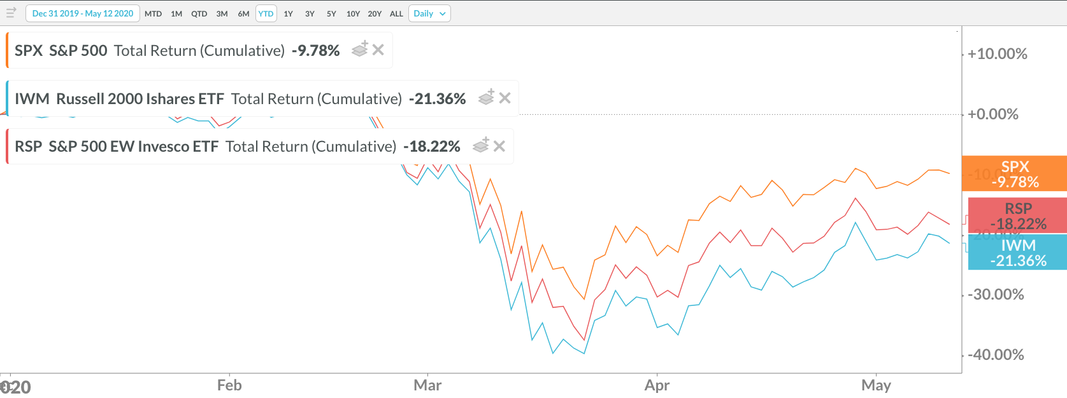

*Source: Koyfin*

If you look at some of the smaller companies in the S&P 500 index, you start to see some of the casualties of the recent crisis. Cruise line, restaurant, & energy industries are all well represented in the bottom part of the index, and in most cases their stocks have been obliterated. Compare that to the big 5 technology stocks, which have crawled all the way back to be within 5% of all-time highs.

It might seem like this is a pervasive long-term trend for the big companies to get bigger, but the trend has been compounded amidst this most recent market rout. That same equal-weighted S&P 500 index has actually outperformed the S&P 500 index by about 7% over the past ten years, inclusive of this most recent period of underperformance. Small caps (Russell 2000) still trail large caps (S&P 500) marginally, but that dispersion has only come from underperformance over the last two years.

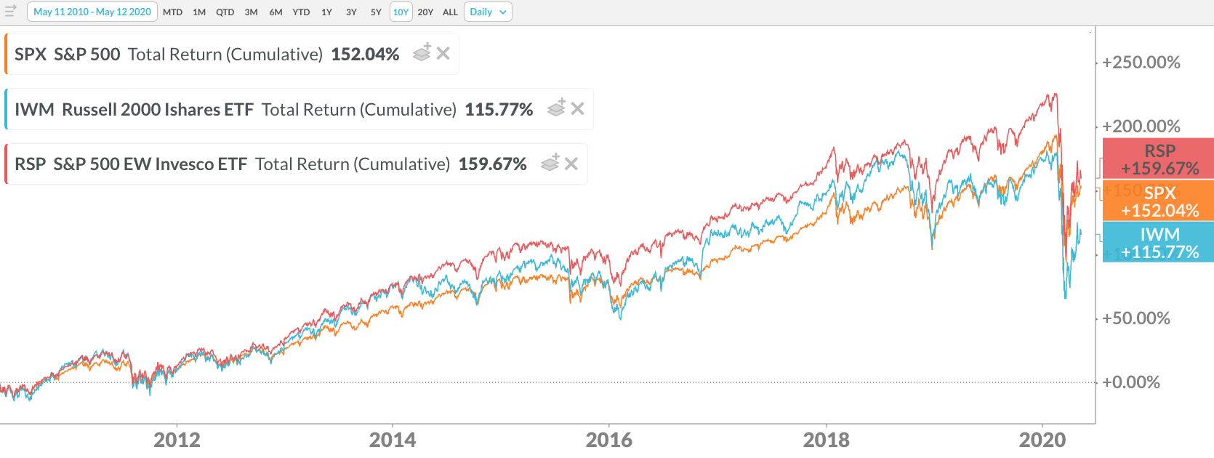

*Source: Koyfin*

So, although the index’s performance is often close to the performance of the average company within the index over the long-term, that is not the case this year.

As you observe the historic level of job losses and economic fallout, it can be confusing to watch the market rally in the face of all this bad news; however, you must factor in a few things:

1. The health of the big tech companies propping up the broader market (as outlined above).
2. The market is forward-looking. As the saying goes, bear markets end in recessions; recessions don’t end in bear markets.
3. The record amount of stimulus that has been injected into the financial system. This capital has to be allocated somewhere and, compared to bonds, the equity risk premium is still attractive.

There are plenty of obstacles to overcome in the months to come as the economy re-opens, but also don’t assume that there is not plenty of pain being felt in Corporate America today by looking simply at the value of the Dow or S&P 500. The dispersion of winners and losers continues to widen which will create challenges and opportunities for allocating capital in the months ahead, regardless of the shape of the recovery.

**Jack Holmes, CFA®**

***WealthPLANPartners***

*Source:*

1. [*https://www.slickcharts.com/sp500*](https://www.slickcharts.com/sp500)

*The opinions voiced in this material are for general information only and are not intended to provide specific advice or recommendations for any individual. To determine which Investment(s) may be appropriate for you, consult your financial advisor prior to investing. Information is based on sources believed to be reliable, however, their accuracy or completeness cannot be guaranteed. Statements of forecast and trends are for informational purposes, and are not guaranteed to occur in the future.*

*All indices are unmanaged and may not be invested into directly. Advisory services offered through Feltz WealthPLAN, DBA of WealthPLAN Partners. Securities offered through Securities America, Inc., Member FINRA/SIPC. Feltz WealthPLAN and Securities America are separate entities.*