Chicken Tortilla Soup

One of the things I like about Ree Drummond, aka The Pioneer Woman is the fact she has a lot of photos. I love seeing if I’m doing things the same way.
Ingredients:
2 boneless skinless chicken breasts (poached and shredded or use a rotisserie chicken and shred the breast meat)
1/2 t cumin
1/2 t garlic powder
1 T olive oil
1 c diced onion
3 garlic cloves, minced
1/4 c diced green bell pepper
1/4 c diced red bell pepper
10 oz can Rotel Diced Tomatoes and Green Chilies
4 c low-sodium chicken broth
3 T tomato paste (I omitted this)
2 t lime juice
4 c hot water (I added water and Better than Bouillon)
1 15 0z can black beans, drained and rinsed (the recipe called for two)
3 T cornmeal (I omitted this)
5 small corn tortillas (I used a handful of Tostitos Scoops, crushed)
diced avocado
diced red onion
sour cream
chopped cilantro
shredded extra sharp cheddar cheese
Directions:
Ree's recipe calls for baking the chicken after drizzling it with olive oil and sprinkling some of the seasonings on it. You can do that if you've got the time. I didn't and it was just fine. So, I started out by putting the broth, shredded chicken, seasonings, salsa (in place of the Rotel tomatoes,) and black beans in a big saucepan. Then, in a medium skillet I sautéed the onion, garlic and peppers in the olive oil. Once they were all softened I added them to the soup and heated everything through. After the soup was in the bowl, I added the splash of lime juice and garnished it. That's a bit more cumin on top of the sour cream. Here's how the soup went together:
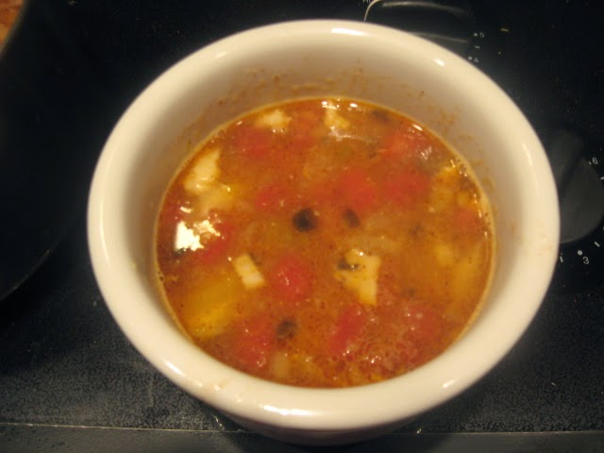

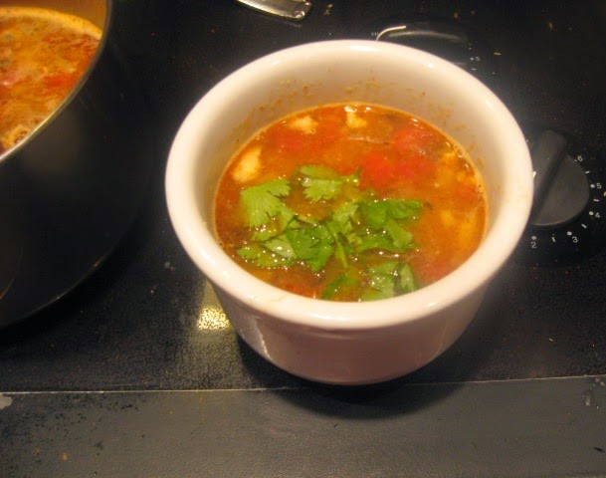

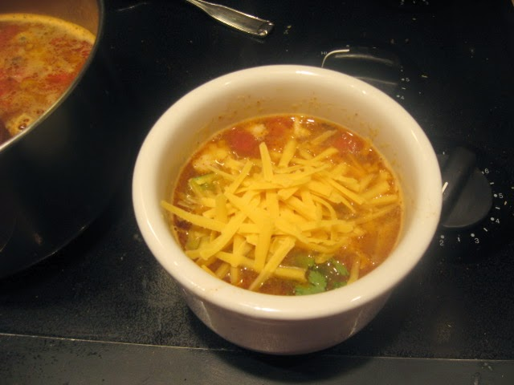

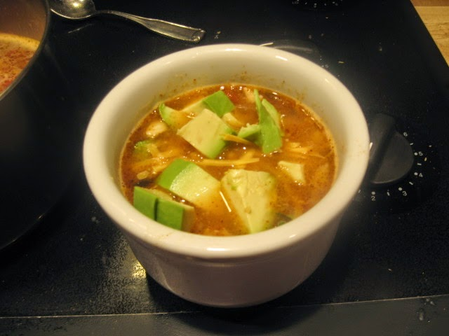

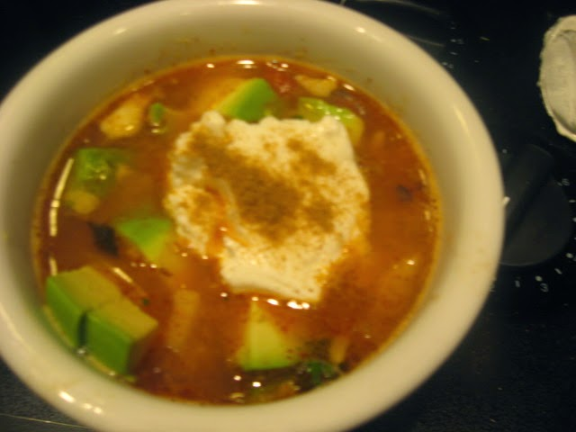

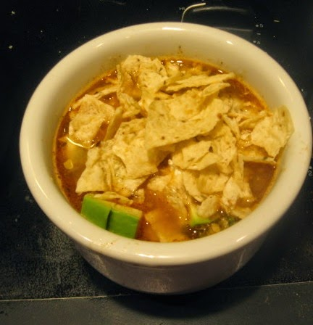
adapted from the Pioneer Woman Cooks, Food from my Frontier

