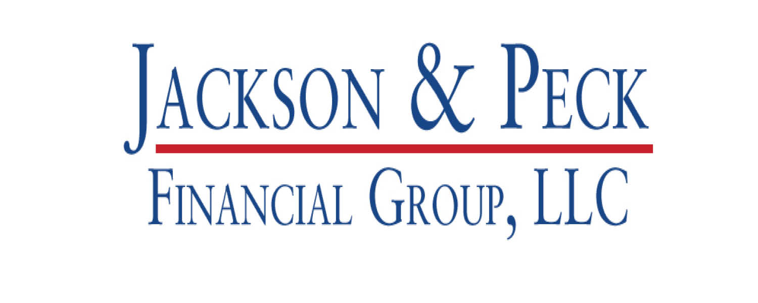

No Contest: Presidential Elections Have Been Good
for Long-Term Investors

Presented by Darrel Peck & Christian Jackson

As the battle for the White House heats up, candidates are drawing attention to the challenges facing the nation — everything from economic instability to immigration.

But while it might seem like we’re living in highly troubled times, tumultuous events have been a constant theme for presidential elections throughout history.

Look no further than 1968. Republican candidate Richard Nixon and Democratic nominee Hubert Humphrey vied for the Oval Office against a backdrop of violent Vietnam War protests, race riots and the assassinations of Robert F. Kennedy and Martin Luther King Jr.

Fast-forward 40 years to the 2008 election. As Barack Obama and John McCain faced off, the nation was gripped by the worst economic crisis since the Great Depression.

With all the negative campaign rhetoric highlighting the nation’s challenges, it’s no wonder investors grow more concerned during election years.

The key to successful investing in these times? Stay the course and rely on long time horizons — don’t try to time the market.

While past results do not guarantee future returns, history shows the value of not giving in to election-year fears. In fact, investing during election years has almost always turned out to be a good idea for long-term investors.

Which Party is Better for the Markets: Republicans or Democrats?

The short answer: neither. Investment success depends more on the strength of the U.S. economy than on which party occupies the White House. They’re both about the same.

Consider the historical performance of the Standard & Poor’s 500 Index during the past eight decades. In 17 out of 18 presidential election years, a hypothetical $10,000 investment in the index made at the beginning of each election year was larger 10 years down the road.

When a Democrat won, a hypothetical $10,000 initial investment totaled an average of $29,456 a decade later; when a Republican won, the average was $32,413. Both parties have had multiple instances when their 10-year returns exceeded $30,000.

For instance, $10,000 invested at the beginning of 1936 — when the U.S. was in the grips of the Great Depression and Democrat Franklin D. Roosevelt won the election — would have grown to $22,418 by 1946, an 8.41% compound annual growth rate.

That same amount invested in the index in 1968, the year Republican Richard Nixon was voted in, would have grown to $14,240 over the next decade. That represents a 3.6% compound annual growth rate, even as the U.S. went on to invade Cambodia, the Watergate scandal erupted, and Nixon resigned.

Investing in 1988, the year George H. W. Bush won office, led to the biggest election-year return, as $10,000 would have grown to $52,448 by 1998.

Which presidential election bucked the trend? George W. Bush’s defeat of Al Gore in 2000 ushered in the so-called “lost decade” for stocks, with the S&P 500 posting a negative return for that period. But those 10 years include two seismic events: the 2000 dot-com crash and the financial meltdown of 2008.

The Bottom Line

Presidential campaigns draw the public’s attention to bad news, which can be a serious distraction for investors.

But those who tune out the noise, focus on long-term goals and avoid trying to time the market have tended to reap the rewards in the long run.

That’s true during presidential elections — and any time of the year.

This material was prepared by Capital Ideas and does not necessarily represent the views of the presenting party, nor their affiliates. This information has been derived from sources believed to be accurate. Please note - investing involves risk, and past performance is no guarantee of future results. The publisher is not engaged in rendering legal, accounting or other professional services. If assistance is needed, the reader is advised to engage the services of a competent professional. This information should not be construed as investment, tax or legal advice and may not be relied on for the purpose of avoiding any Federal tax penalty. This is neither a solicitation nor recommendation to purchase or sell any investment or insurance product or service, and should not be relied upon as such. All indices are unmanaged and are not illustrative of any particular investment.

