January 5th MARKET WATCH
WEEKLY AND YEAR-TO-DATE RETURNS (THRU 12/30/22:)
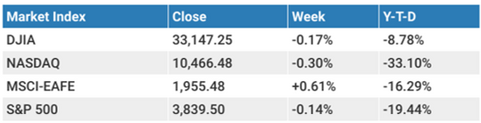

TODAY’S TOPICS:
Mid-Week Outlook – Chart 2022 Asset Class Returns
Key Market Levels
This Week / What We Are Watching

Market Outlook:
The S&P 500 was flat in the final week of 2022, a year that saw the market benchmark lose -19.4% amid ongoing worries over inflation, interest rates and ultimately the economy. 2022 marked the third worst year for the S&P going back 40 years. In addition, the Bloomberg US Aggregate bond index fell -13% in 2022, its worst year since 1994 where the index fell just -2.9% for that year.

Fed officials have recently said that short-term rates will need to climb to over 5% to bring inflation under control. Meanwhile, the bond futures markets are disagreeing with the Fed, saying the fed funds rate will top out at 4.5%. These futures markets are predicting one rate-cut at the end of 2023 so time will tell which forecast is right. Given the Fed is generally wrong about its outlooks though, it’s not surprising that the markets are disagreeing with this message.

Turning to the current week, key economic data is set for release culminating with Friday’s nonfarm payroll report. On Wednesday, the December Institute for Supply Management (ISM) Manufacturing Index showed that manufacturing activity remained in contraction territory meaning it has a reading below 50. The index declined to 48.4 from the prior month’s 49.0 reading. This manufacturing index is a key economy leading indicator that has shown over time to have good predictive power for the S&P 500.
On Friday, we’ll get the release of the December jobs report where investors will pay close attention to the wage growth component of the report to gauge where inflation might be going from here.

CHART
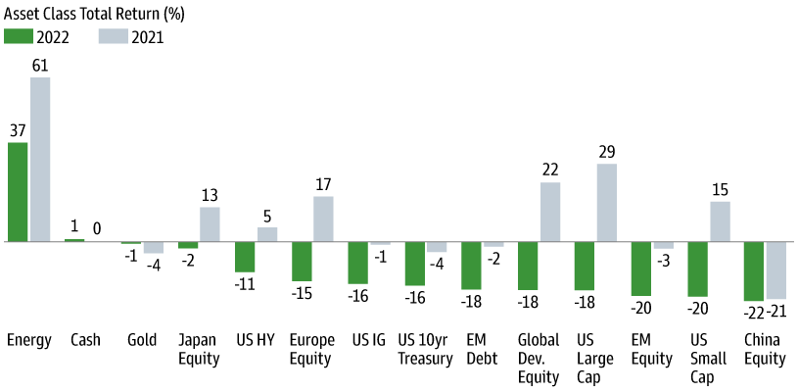

MARKET SUPPORT & RESISTANCE LEVELS:
The next levels of support to watch for the S&P 500 on the downside are at around 3,800, followed by 3,666.
The next level of resistance to watch for the S&P 500 on the upside is at 4,035.

S&P 500 - 12-Month Chart
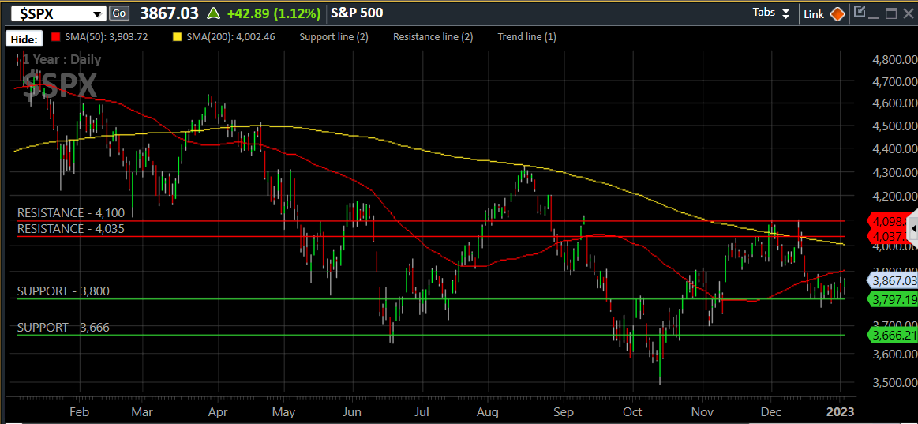
These are key technical levels we look for the market to either hold or push through when look at the potential for future moves. Common support levels can be the 50- and 200-day moving averages as well as other technical levels such as previous market highs or lows.

THIS WEEK / WHAT WE ARE WATCHING:
The following economic data is slated to be released during the week ahead:
Monday: New Year holiday. None scheduled.
Tuesday:
Wednesday: ISM Manufacturing (Dec.), JOLTS Job Openings (Nov.), FOMC meeting minutes from Dec. meeting
Thursday: Weekly initial unemployment claims
Friday: Nonfarm Payrolls (Dec.), ISM services index (Dec.)
Content in this material is for general information only and not intended to provide specific advice or recommendations for any individual. All performance referenced is historical and is no guarantee of future results. All indices are unmanaged and may not be invested into directly.
AUTHOR:
Johlfs Financial Group
5299 DTC Blvd. Suite 1170
Greenwood Village, CO 80111
johlfsfg.com

