Inflation and Asset Performance: Clues From the Past Half Century
By Craig L. Israelsen, PhD
The past does not predict the future, but it can give us clues as to how inflation affects asset performance—and portfolios. Here we examine the nominal performance of seven core asset classes since 1970 to see what we can learn about strategizing for inflation.
The past does not predict the future. Then why have a credit score? Why have a pre-season football ranking? The past gives us clues—and those clues can be helpful even if they are not predictive.
So, let’s look at past performance. Specifically, we’ll examine the nominal (or gross pre-inflation) performance of seven core asset classes—by decade—since 1970. As shown in Table 1, the asset classes include large-cap U.S. stock, small-cap U.S. stock, non-U.S. stock, U.S. bonds, U.S. cash, real estate and commodities. Inflation, as measured by the Consumer Price Index (CPI), is also included in the table.
Table 2 provides “real” (or inflation-adjusted) performance for the same asset classes. The returns listed in each table are “total” returns, meaning that dividends and capital gains were assumed to be reinvested. The three best performing asset classes during each decade are highlighted in yellow.
The historical performance of large-cap U.S. equities was represented by the S&P 500 Index, while the performance of small-cap U.S. equities was captured by using the Ibbotson Small Companies Index from 1970-1978 and the Russell 2000 Index from 1979-2020.
The performance of non-U.S. equities was represented by the Morgan Stanley Capital International EAFE Index (Europe, Australasia, Far East) Index. U.S. bonds were represented by the Ibbotson Intermediate Term Bond Index from 1970-75 and the Bloomberg Barclays Capital Aggregate Bond Index from 1976-2020. Cash was represented by 3-month Treasury Bills.
The performance of real estate was measured by using the annual returns of the NAREIT Index (National Association of Real Estate Investment Trusts) from 1970-1977 and from 1978-2020 the annual returns of the Dow Jones U.S. Select REIT Index were used. Finally, the historical performance of commodities was measured by the Goldman Sachs Commodities Index (GSCI). As of February 6, 2007, the GSCI became known as the S&P GSCI.
Table 1: Nominal (Gross) Returns by DecadeThree best-performing asset classes during each decade highlighted in yellow
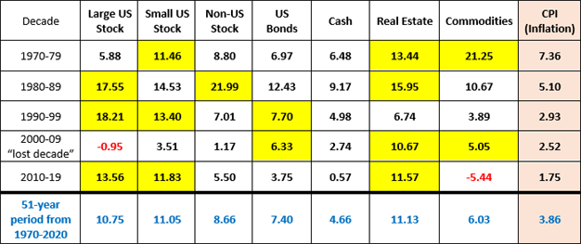
Source: Craig Israelsen
Table 2: Real (Inflation-Adjusted) Returns by Decade3 best-performing asset classes during each decade highlighted in yellow
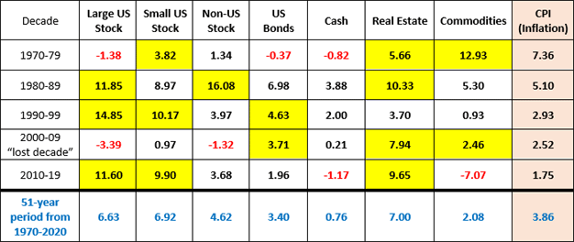
Source: Craig Israelsen
During the seventies (1970-1979) inflation grew at an annualized pace of 7.36% and commodities were by far the best performer among this group of seven asset classes during this inflationary decade (as noted in both tables). Commodities had a 10-year real annualized return of 12.93% during the 1970s.
However, broad-based commodity indexes such as the S&P Goldman Sachs Commodity Index (note: there are many other commodity indexes today) suffer when the inflation rate is low. We observe this during the most recent decade from 2010-2019 in which the inflation rate was a meager 1.75% per year and commodities produced an annualized real return of -7.07%.
When inflation is high (because energy and other commodity prices have gone higher—thus effectively creating inflation) commodity indexes and commodity funds perform well. As we have been in a period of low interest rates and low inflation in recent decades it is not surprising that commodities have performed relatively poorly.

Portfolio performance
As shown in Figure 1, an equally weighted 7-asset portfolio (14.28% allocation to each of the seven asset classes with annual rebalancing) significantly out-performed the classic 60% stock/40% “balanced” portfolio during the 1970s—a period of high inflation. The 10-year real return from 1970-1979 was 4.39% for the 7-asset portfolio and -0.61% for a 60/40 2-asset portfolio.
During the 1980s, the 7-asset portfolio and the 60/40 portfolio had comparable performance. The 1990s favored the 60/40 model by 431 bps.
From 2000-2009 the multi-asset portfolio produced a 10-year “real” return of 2.69% versus 0.07% for the 60/40 model. This particular decade is sometimes referred to as the “lost decade.” It certainly wasn’t lost if your portfolio was broadly diversified. In fact, the 10-year gross return for the 7-asset portfolio was 5.28% during the “lost decade” (and 2.69% after accounting for inflation).
The term “lost decade” refers to the performance of the S&P 500. During the 10 years from 2000-2009 the S&P 500 had a 10-year gross return of -0.95% and a 10-year real return of -3.39%. For U.S. bonds, real estate and commodities the lost decade from 2000-2009 was actually quite good (as noted in Tables 1 & 2).
If inflation remains low going forward a 60/40 two-asset portfolio should work well. However, if inflation rears its ugly head again (and interest rates rise—punishing bond funds) it would be wise to build a portfolio that has demonstrated an ability to defend itself against inflation in the past. This requires a portfolio with a wider variety of asset classes—including real estate, small-cap U.S. stock and commodities.
In short, build a broadly diversified portfolio.
Figure 1: Multi-Asset Portfolio vs. 60/40 PortfolioReal return indicating inflation-adjusted performance shown
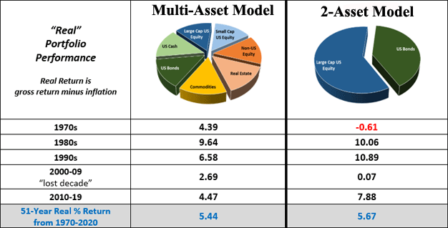
Source: Craig Israelsen
If you have any questions or concerns, I would love the opportunity to meet with you to discuss your retirement and investment goals.
Kind Regards,
Randy H. Packett
President & CEO Chesapeake Capital Management
2943 Emmorton Road
Abingdon, MD 21009
410-671-2260

Investment Advisory Services offered through Chesapeake Capital Management, LLC, a Registered Investment Advisor. Securities offered through TD Ameritrade Institutional, located at 7801 Mesquite Bend Drive, Suite 112, Irving, TX 75063-6043, (800) 431-3500. Chesapeake Capital Management, LLC is neither an affiliate nor subsidiary of TD Ameritrade Institutional and does not provide tax or legal services”.
Chesapeake Capital Management is neither an attorney nor an accountant, and no portion of this content should be interpreted as legal, accounting or tax advice.

Additional information about Chesapeake Capital Management is available in its current disclosure documents, Form ADV, Form ADV Part 2A Brochure, and Client Relationship Summary report which are accessible online via the SEC’s investment Adviser Public Disclosure (IAPD) database at www.adviserinfo.sec.gov, using CRD # 270014.

