The Predictability of Behavior
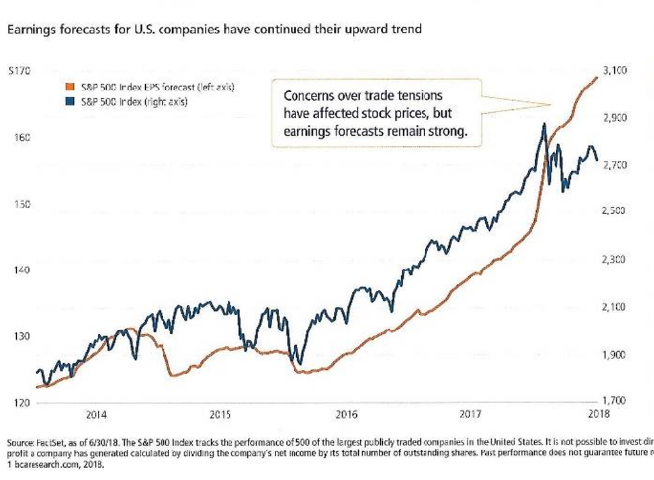
As many have heard me repeat, “While the acts of individuals are nearly impossible to guess, human beings in large groups are incredibly easy to predict.” As proof of this, market patterns seem to be repeating movements seen nearly every mid-term election year. Typically, mid-term years are marked by a climb in the first 1-2 months and then things slow down and level out as we approach the election. Regardless of any individual’s political leanings, all sides are operating in a space of uncertainty about the outcome of the election so they tend to take a “wait and see.” attitude. Historically, this has caused pent up demand and a build up of cash that will find a home as soon as the uncertainty is gone, the only question is, where will it go? In previous mid-term years, over 80% of the year’s market gains are earned in the last 7 weeks of the year and I expect this year to be similar.

My prediction is that the market has more delayed capital this year than the norm primarily due to the outstanding strength of the economy right now. Add to that the fact that we have seen near record numbers of companies releasing earnings that exceed estimates by huge margins for two quarters in a row (See chart 1). To see this level of earnings growth with very little reaction from the markets tells me there are a lot of investors waiting until November and that perhaps we will see a very strong finish this year. In the short term, however, it does create a risk for the next few weeks as buyers wait and thus do not provide buying support to hold prices steady when sellers arrive. This could produce a short term swing lower, but without negative fundamentals, I expect it will recover quickly.
Chart 1

My prediction; if the Republicans retain control of both houses of congress we may see capital rush into the Financial, Technology and Commodities sectors. While the outcome if the Democrats take control of either house will most likely be a huge relief rally in international stocks and emerging markets as it may be seen as a referendum against further trade war policies.
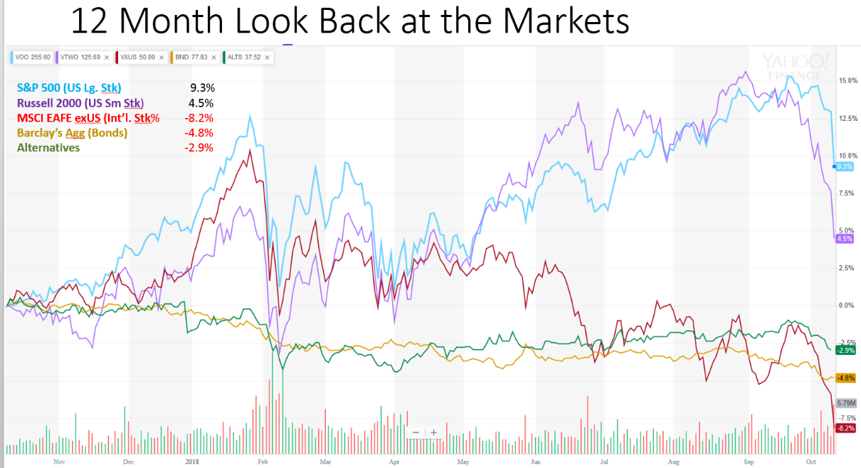
The US market has continued climbing all year while international markets, bonds, and alternatives have all declined. But in just the last week, only 1 month before the election, US stocks are retreating to neutral return territory to wait with all other asset classes for the results to come in. (See chart 2)

The good news here is worth mentioning. Yes, the markets have had a horrible start to the 4th quarter and, so far, 2018 looks like a big zero in terms of gains. But, in the underlying economic data we still do not see a single leading indicator that is signaling a contraction, let alone a recession. In fact, not only is the basket of leading indicators still in the green, signaling growth ahead, but they are near record highs. (See chart 3)
Chart 2
Source: Yahoo Finance
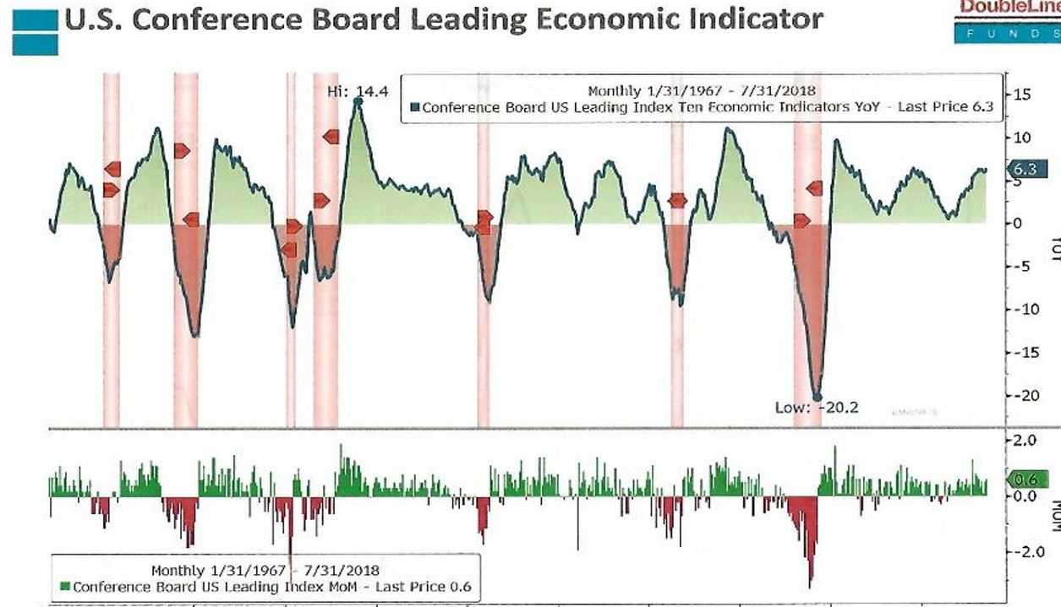
When we see market volatility spike, yet there is no deterioration in economic conditions, we are cautious about taking action. It can be easy with markets swinging wildly to convince ourselves that the strategies we have been employing and the trade triggers we have set are all wrong and we want to take action to protect our money. But this is the time of greatest risk and it is when we commonly make the biggest mistakes because any trading decision made in the moment based on short term data really isn’t logical at all, those decisions are 100% emotionally driven and almost always incorrect. We remain consistent in the belief that the triggers we have set at the onset when we buy certain investments are made thoughtfully and rationally and that they should not be changed in the heat of the moment. This is especially true when economic data does not suppprt the negative action in the markets. Eventually, stocks will return to a price that is based on the underlying company’s earnings and if we have sold out of fear, we miss the gains made with the return of rationality. In fact, the long term investor should consider buying at these levels. Everything is undervalued and without a reason, those values don’t last forever. And I’m not the only one seeing opportiunity in this market. (Please see the article reprint attached.)
Chart 3
Chart 3
Source: Doubleline Funds

It is my fervent hope that we, as a nation, can get through the next 4 weeks and begin to find common ground and civil discourse again without killing each other over our political beliefs in the meantime. The election will pass and we will all still be here, let’s try to treat each other well.

Be well and have a happy fall season!
Sincerely,
Gustin D. Fox-Smith, AIF®, ChFC®
President and Chief Financial Advisor
Regional Director

"The views depicted in this material are for information purposes only and are not necessarily those of Cetera Advisor Networks LLC. They should not be considered specific advice or recommendations for any individual. Certain statements contained herein are forward-looking in nature. There is no guarantee that the events described will come to pass. All investing involves risk, including the possible loss of principal. There is no assurance that any investment strategy will be successful. Indices are unmanaged and cannot be invested into directly. Past performance is not indicative of future results."
Securities and Investment Advisory Services offered through Cetera Advisor Networks LLC, Member FINRA/SIPC.
Fox-Smith Wealth Management, 8471 Turnpike Dr., Ste 115, Westminster, CO 80031 303-650-2727 and Cetera are not affiliated companies.

Definitions
- The Standard & Poor's 500 (S&P 500) is an unmanaged group of securities considered to be representative of the stock market in general.
- The Russell 2000 is an index that measures the performance of approximately 2,000 small-cap companies based on a combination of market capitalization and current index membership. It is a subset of the Russell 3000 Index, which is comprised of 3,000 of the biggest U.S. stocks.
- The MSCI EAFE Index was created by Morgan Stanley Capital International (MSCI) that serves as a benchmark of the performance in major international equity markets as represented by 21 major MSCI indexes from Europe, Australia and Southeast Asia.
- The Bloomberg Barclay’s Capital US Aggregate Bond Index is a broad-based flagship benchmark that measures the investment grade, US dollar-denominated, fixed-rate taxable bond market. The index includes debt securities rated at least Baa3 by Moody’s and BBB0 by S&P.
- Additional risks are associated with international investing, such as currency fluctuations, political and economic stability, and differences in accounting standards.
- “Alternatives” is the Morningstar Alternative Index (ALTS). ALTS in a fund of ETFS designed to track the performance of the Morningstar Diversified Alternative Index.
- Dow (DJIA): The Dow Jones Industrial Average is a price-weighted average of 30 significant stocks traded on the New York Stock Exchange and the NASDAQ. The DJIA was invented by Charles Dow back in 1896.
- Nasdaq COMP: The Nasdaq Composite is an index of the common stocks and similar securities listed on the NASDAQ stock market and is considered broad indicator of the performance of stocks of technology companies and growth companies.
- US Dollar (DXY): The U.S. Dollar index is a weighted geometric mean that provides a value measure of the United States dollar relative to a basket of major foreign currencies.
- Europe (SXXP): The STOXX Europe 600 Index is derived from the STOXX Europe Total Market Index (TMI) and is a subset of the STOXX Global 1800 index. The STOXX Europe 600 Index represents large, mid and small capitalization companies across 17 countries of the European region.
- Shanghai Composite (SHCOMP): The Shanghai Stock Exchange Composite Index, is a market composite made up of all the A-shares and B-shares that trade on the Shanghai Stock Exchange. The first day of reporting was July 15, 1991.
- Nikkei (NIK): The Nikkei is short for Japan’s Nikkei 225 Stock Average, the leading and most-respected index of Japanese stocks.

