What Does a Biden Victory Mean for Me?

With the long-awaited election results nearly in hand, many investors are asking themselves what to expect from the markets with a Biden-Harris administration in the White House.
After a decade-long bull run was interrupted by a global pandemic, investors are understandably seeking a return to baseline, turning to pundits to predict our best chances to do so. Unfortunately, an election taking place at the height of an unprecedented global pandemic doesn't exactly lend itself to historical comparisons. Still, there are some patterns we can look toward to understand where we are and where we might be going.
Rally Red or Booming Blue?
Figure 1
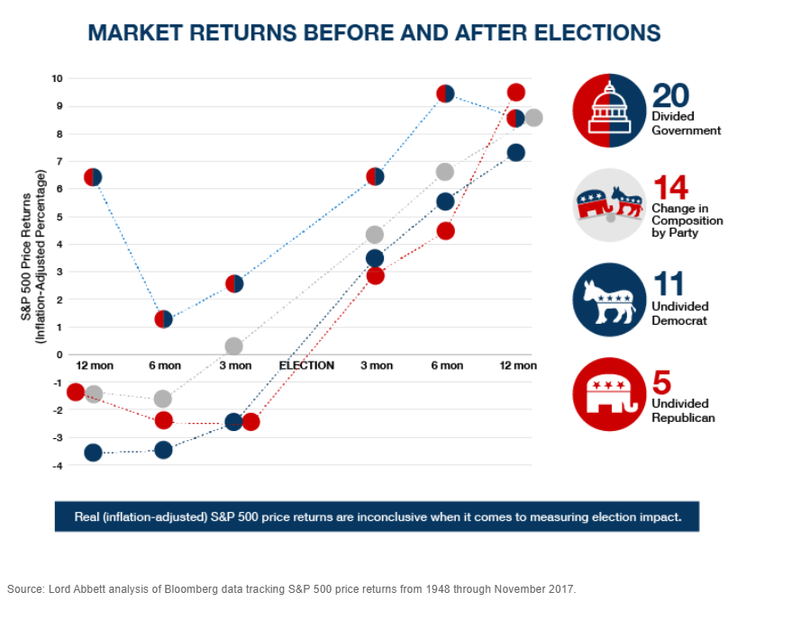
If you've read The 2020 Election and the Star-Spangled Stock Market, you already know that political party doesn't historically have a huge impact on market performance. Even when you account for party lines shifting across history, the truth is, presidents don't operate in a vacuum, and a few major corporations most heavily influence the markets. So, if you were thinking of pulling your funds based on party affiliation, evidence suggests you best stay put and stick to your long-term plan.

Divided Government:
Another piece of good news for investors is that we're likely headed for a divided government. While the final election results haven't officially been announced, all indications point to a Republican-controlled Senate and a Democratic-controlled House of Representatives. As you can see in Figure 1, a divided government has historically produced the best returns overall. While past performance can't guarantee future results, investors can take some comfort in the fact that this balance of power will oblige more middle-of-the-road approaches to some of the more progressive proposals from the incoming administration.

Biden's Tax Plans:
Many investors are concerned about the impact that Democratic leadership will have on their tax bill more so than their portfolio performance. It's a valid concern, but a divided government will almost certainly result in more moderate tax law changes compared to the initial proposals from the Biden ticket. Many of those proposals depended on a Democratic sweep of Congress and the presidency, which is no longer forthcoming.
Some of the proposed changes include:
- Raising the top individual tax rate from 37% to 39.6%
- Extending the Social Security tax from earnings up to $137,700 to earnings over $400,000
- Raising the capital gains rate to 39.6% for taxpayers with income over $1 million
If you're concerned about how any of these shifts may affect you, now is a great time to speak to a financial professional about how you can prepare to face these changes with certain tax-advantaged vehicles. There are many tools designed to restructure your investments in a tax-efficient way while continuing to work toward your long-term objectives.
Figure 2:
Performance during 2000 Election to Inauguration
The Impact of a Contested Election:
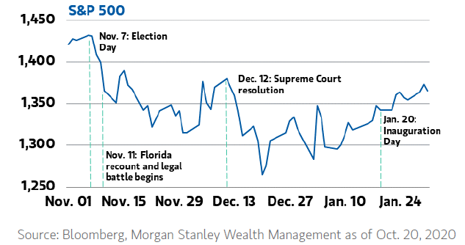
A piece of bad news: a contested election will likely result in a period of volatility. Luckily, the United States of America rarely encounters disputed elections. The most recent experience we have to reference is the 2000 election between George W. Bush and Al Gore. After Florida was called in favor of Republican candidate Bush, the results were called into question when voters in one Florida county claimed that the "butterfly ballot" was confusing and many voters feared they didn't vote for their intended candidate. The recount process marked a period of volatility for investors, as demonstrated in Figure 2.
Of course, that was a very different election—particularly since only one state—won by a very narrow margin—was contested.

We're still waiting to see what the recount process will look like this time, how far it will move forward, and in how many states. Although the markets are likely to react to such a period of uncertainty, it behooves investors to remember that a resolution will ultimately be made, and the markets will stabilize once again. While it may be tempting to "opt-out" during this period or even attempt to "time the markets," periods of volatility don't only move in one direction, and the high points tend to follow the low points very closely. In our whitepaper, The 2020 Election and the Star-Spangled Stock Market, we demonstrated how missing just the best ten days of market performance can cost investors dearly, and the best course of action has historically been to play the long game.

Coronavirus
We can't talk about market performance in 2020 without mention of the Coronavirus. In terms of the pandemic, we aren't out of the woods yet. The full economic impact remains to be seen, as does the new administration's approach to solving it. As with much of the pre-election volatility, it won't be easy to pinpoint which moving parts of the economic landscape are influencing the markets at any given time. One important factor to keep in mind is that the stock market and the economy aren't synonymous. While they often follow the same patterns, the stock market is comprised of corporations— predominantly five key tech giants: Amazon, Alphabet, Apple, Microsoft, and Facebook, whose industry has been relatively safe from the economic shutdown while unemployment, GDP, retail spaces, and small businesses have been impacted significantly. Luckily, in terms of market performance, it appears the initial Coronavirus panic has mostly subsided. However, the path forward from an economic standpoint is still unclear.

The Horse Races
Figure 3
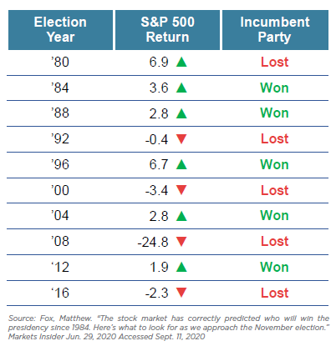
We didn't forget about those of you taking bets.
In The 2020 Election and the Star-Spangled Stock Market, we debunked many myths between politics and the stock market, predominantly the myth that one party is pro-business while the other is pro-labor. However, one relationship has held statistical significance: when the markets are up the months preceding the election, the incumbent party is likely to be reelected. When the markets are down, the opposition is more likely to win. The historical manifestation of this relationship is shown in Figure 3.
During the 2020 election, the S&P 500 was down .04% for the 3rd quarter of the year, and the opposition party was elected over the incumbent, which makes this election the 21st (out of 24) to be correctly predicted by this method.

The sage wisdom "only time will tell" can often feel anti-climactic and even frustrating when faced with concerns about the future. It is, however, one of the great lessons from a year that has been a whirlwind of historic hurdles and uncharted territory for individuals and the community at large. Only time will tell if this new administration will positively or negatively impact the markets; only time will tell if we're at the end or at the height of the pandemic. But if time has told us one thing: your best bet is to stay true to your long-term strategy. Working with a trusted professional who listens and understands your unique circumstances and objectives can help you stay the course with a plan that doesn't break at the first sign of disruption. Now is a great time to evaluate your portfolio and ensure that your long-term objectives are front-and-center of your financial plan.

Disclaimer: Investment advisory and financial planning services are offered through Alphastar Capital Management LLC, a SEC registered investment adviser. SEC registration does not constitute an endorsement of the firm by the Commission nor does it indicate that the adviser has attained a particular level of skill or ability. Asset Preservation Group and Alphastar are separate and independent entities.

