In this week’s recap: the Dow crests 28,000; more hints emerge that the U.S. and China could be heading toward a new trade pact; retail sales rise.
Weekly Economic Update

Presented by Michael J. Levine, November 18, 2019

THE WEEK ON WALL STREET
Stock benchmarks were little changed for much of last week, but a rally occurred Friday after news broke that the U.S. and China could be closing in on the first phase of a new trade pact.
At Friday’s close, the Dow Jones Industrial Average crossed the 28,000 level. The Dow rose 1.17% for the week, outgaining the S&P 500 (which advanced 0.89%) and the Nasdaq Composite (which added 0.77%). The MSCI EAFE index, representing developed overseas stock markets, fell 0.77%.^{1,2}

Will There Be a Trade Breakthrough?
Friday, Secretary of Commerce Wilbur Ross told the media that “in all likelihood,” a phase-one trade deal between China and the U.S. would presently happen, stating that the talks were “down to the last details.” Thursday evening, White House economic adviser Larry Kudlow expressed similar optimism, noting that negotiations were “coming down to the short strokes.”
That said, the Wall Street Journal reported last week that President Trump is not yet committed to signing a phase-one trade deal. Secretary Ross noted that such an agreement would be “relatively limited in scope.”^{3,4}

Consumers Boost Their Buying
Retail sales advanced 0.3% in October, according to the Department of Commerce. That matched the gain forecast by economists polled by MarketWatch. This was a comeback after a September decline.⁵

T I P O F T H E W E E K
Do you have a life insurance policy outside of work? Do you know who its beneficiary is? From time to time, you want to periodically review your beneficiary decisions, to make sure you still agree with them.

THE WEEK AHEAD: KEY ECONOMIC DATA
Wednesday: Minutes from the October Federal Reserve meeting appear.
Thursday: The National Association of Realtors presents data on October existing home sales.
Friday: The University of Michigan publishes its final Consumer Sentiment Index for November (an assessment of consumer confidence).
Source: Econoday, November 15, 2019
The Econoday economic calendar lists upcoming U.S. economic data releases (including key economic indicators), Federal Reserve policy meetings, and speaking engagements of Federal Reserve officials. The content is developed from sources believed to be providing accurate information. The forecasts or forward-looking statements are based on assumptions and may not materialize. The forecasts also are subject to revision.

THE WEEK AHEAD: COMPANIES REPORTING EARNINGS
Tuesday: Home Depot (HD), Medtronic (MDT), TJX Companies (TJX)
Wednesday: Lowe’s (LOW), Target (TGT)
Thursday: Intuit (INTU), Ross Stores (ROST)
Source: Zacks.com, November 15, 2019
Companies mentioned are for informational purposes only. It should not be considered a solicitation for the purchase or sale of the securities. Any investment should be consistent with your objectives, time frame, and risk tolerance. The return and principal value of investments will fluctuate as market conditions change. When sold, investments may be worth more or less than their original cost. Companies may reschedule when they report earnings without notice.

Q U O T E O F T H E W E E K

“Every next level of your life will demand a different you.”
Leonardo DiCaprio

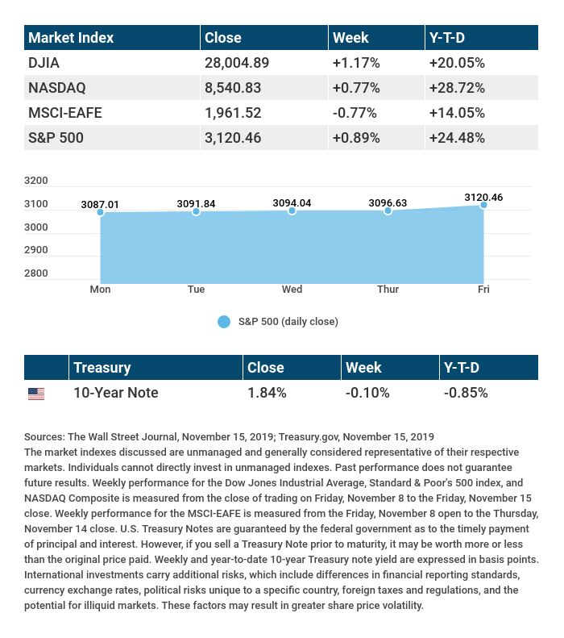

T H E W E E K L Y R I D D L E

I give light by night, but not by day. Wicked I am, but not evil in any way. I mostly wax, but always wane. Except when I'm out, I stay the same. What am I?

LAST WEEK’S RIDDLE: I float when I am born, lay down when I am alive, and run when I am dead. What am I?
ANSWER: Snow.

Know someone who could use information like this?
Please feel free to send us their contact information via phone or email. (Don’t worry – we’ll request their permission before adding them to our mailing list.)

Securities offered through Kestra Investment Services, LLC (Kestra IS), a member FINRA/SIPC. Investment advisory services offered through Kestra Advisory Services, LLC (Kestra AS), an affiliate of Kestra IS. Levine Group, LLC is not affiliated with Kestra IS or Kestra AS.
CITATIONS:
1 - wsj.com/market-data [11/15/19]
2 - quotes.wsj.com/index/XX/990300/historical-prices [11/15/19]
3 - bloomberg.com/news/articles/2019-11-15/kudlow-says-phase-one-china-deal-down-to-the-short-strokes-k2zgbx0k [11/15/19]
4 - foxbusiness.com/politics/u-s-china-trade-deal-near-but-trump-not-signing-yet [11/15/19]
5 - marketwatch.com/story/us-retail-sales-rebound-in-october-but-a-small-group-of-stores-reap-most-of-the-gains-2019-11-15 [11/15/19]

CHART CITATIONS:
wsj.com/market-data [11/15/19]
quotes.wsj.com/index/XX/990300/historical-prices [11/15/19]
quotes.wsj.com/index/SPX/historical-prices [11/15/19]
treasury.gov/resource-center/data-chart-center/interest-rates/Pages/TextView.aspx?data=yield [11/15/19]
treasury.gov/resource-center/data-chart-center/interest-rates/Pages/TextView.aspx?data=yieldAll [11/15/19]

