                                               **Special Economic Brief: *COVID-19***

                                                                                                                   Gary Bedford, ChFC, CIMA

Comments:  As of 3-16-2020 the COVID-19 “Coronavirus” market correction is in full swing, with the various stock indices in “BEAR” territory of -20%.  While this is not panic time, it is a pivotal learning moment – we have to understand this event using larger paradigms, or frameworks of understanding than prime media are offering.  First, historical perspective:  Covid-19 is the 19th version of coronavirus. Other global health crises have occurred over the last many years:  HIV-AIDS, SARS, Dengue Fever, Avian-Bird Flu, Swine Flu, MEERS, Ebola…etc.  These crises produced significant volatility (upside and downside) until markets recovered.  Note the graph, below:

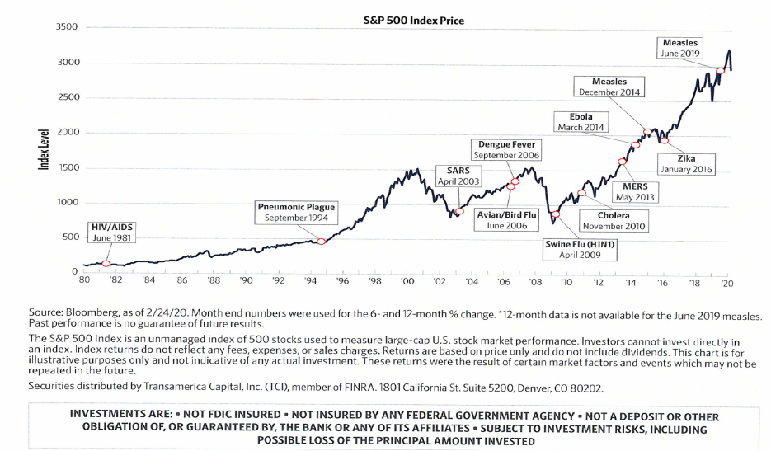

Bedford Macro-Economic Paradigms:  So, what are the *larger paradigms*?   See “Articles & Videos”, 2019 Market & Economic Review at our web site:  <https://www.garybedford.com/garys-articles> where the 5 key drivers (below) to this ***emerging global economic- market paradigm*** are outlined:

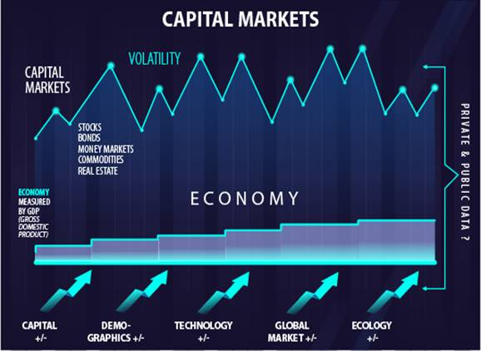

**Capital:**  First, capital markets are now very liquid – money can move in micro-seconds.  Entire markets, like the S&P 500[1][i], with the 500 largest U.S. NYSE companies, can now be “bought” and “sold” in micro-seconds – “buy at 10AM then sell at 10:15 AM then buy back at 10:16 AM.”  Trillions of $’s are bought and sold in capital markets every day.  Second, bond or fixed income interest rates are at historic lows, which has favored and even driven capital into higher risk stocks to gain better income yields.  This has increased risk in the equity markets now for many years – it might even be the “new normal.”   As we move through the COVID-19 crisis expect very quick and sudden liquidity events, i.e., selling on the downside, and then, just as quickly, very sudden buying events on the upside.  Finally, note that -20 to -30% corrections are not unusual – what’s unusual is that they have not occurred as frequently in the last decade:

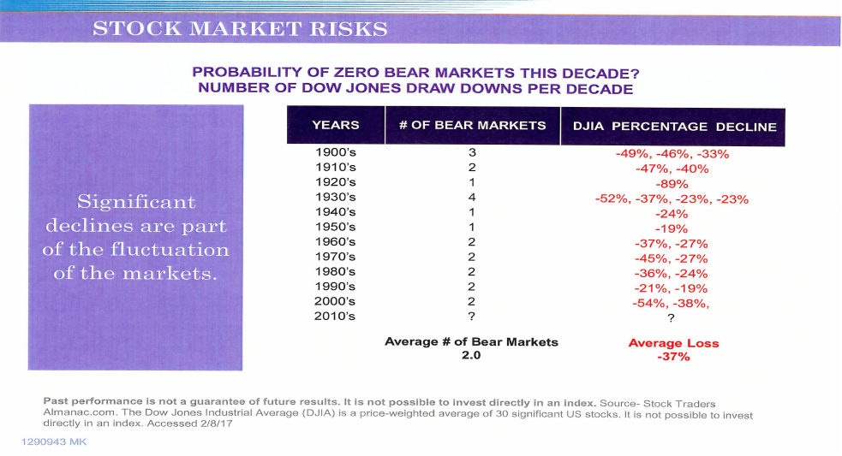

**Demographics – the Human Factor:**  Human cultures are now more “fluid” (e.g., air-travel) than ever before – so virus outbreaks are almost instantly global in scope.  China appears to have underestimated and understated the COVID-19 impact and scope – the virus moved out from Wuhan Province for at least a month before formal response occurred.  New paradigm:  the world is hyper-connected, it’s a “global village.”   Takeaways:  First, whether one is excited about “globalism” or not, as humans travel around the planet this is the new “norm” – the new paradigm.  Second, *prepare* means optimizing event preparedness (e.g., emergency food supplies) and optimizing personal health as much as possible – regular exams (including heart scans, etc.), exercise/sleep, optimize immune systems.  On a national scale it may mean countries will need to produce medicines and emergency equipment independently – currently, 80% of U.S. anti-biotics and most of U.S. pharma originates in the Chinese supply chains. (!)

**Technology:**  Tech, and tech hyper-connectedness, ***is*** the new norm, the new paradigm – virtually all technical consumer gadgets are developed and produced in the global tech economy.  The good news is that nations are now more inter-dependent, and so far less inclined to go to war, than ever before.  Other good news:  as COVID-19 became a clear threat, the world appears to be improving its reaction methodologies, i.e., short-term restrictions of large gatherings and global travel, and the more rapid development of a vaccine.

**Global Markets:**    It may be that a “wet market” in Wuhan China will be the origin of the COVID-19 virus – un-regulated exotic food markets are found throughout China.  China appears to have closed these markets and may impose new oversight.  But again, the world is now a fluid, moving, increasingly synchronized market, and goods (as well as viruses) move quickly.  There are nearly 3 billion people in China and India – their impact and influence will continue to leverage global markets and communities.

**Ecology:**  The big COVID-19 factor of the 5 is the environment, that is, how ecologies effect our human communities, and as well how ecologies are affected by human activity (e.g., pollution, climate change).  The world is a very dangerous place – can you say San Andreas fault, Mt. Rainier’s lahars, Hurricane Katrina, Fukushima?  It’s not just the actual risk (viruses, plate tectonics) but also how human technical cultures are much more vulnerable – landlines and carburetors work great during solar storms, cell phones and fuel injection not so much.  And over the last 100-150 years a lot more people have moved into very dangerous ecological zones – e.g., the U.S. West Coast cities, or Tokyo.  Many of the risks have always been present – what’s new is how science has increased risk-awareness.

**Summary:  On the street the word is – *don’t panic, don’t talk to strangers, don’t touch your face and don’t touch your portfolio!  As the above graphics show, we don’t know how long COVID-19 will last, but these crises do complete their cycles.  We are here to discuss and review your situation – call Gary at 303 499-8800, or 800 499-8101.***

*Opinions expressed do not necessarily reflect the opinions or investment outlook of Cambridge Investment Research, Inc., or Cambridge Investment Research Advisors, Inc. (“Cambridge”).  Investment returns and are not guaranteed, and investments in stocks and bonds involve risk, including risk of principal. Cambridge shall not be held liable for inaccurate information obtained from these sources from which they could normally and reasonably depend upon as accurate.  Investment advice is offered through Cambridge Investment Research Advisors, Inc. a Registered Investment Advisor.  Cambridge and Bedford Wealth Advisors are not affiliated.  This material was written and prepared by Gary Bedford.*

[1] The S & P 500 or Standard & Poor's 500 Index is a market-capitalization-weighted index of the 500 largest U.S. publicly traded companies. The index is widely regarded as the best gauge of large-cap U.S. equities. Other common U.S. stock market benchmarks include the Dow Jones Industrial Average or Dow 30 and the Russell 2000 Index, which represents the small-cap index.

1. [i] The S & P 500 or Standard & Poor's 500 Index is a market-capitalization-weighted index of the 500 largest U.S. publicly traded companies. The index is widely regarded as the best gauge of large-cap U.S. equities. Other common U.S. stock market benchmarks include the Dow Jones Industrial Average or Dow 30 and the Russell 2000 Index, which represents the small-cap index.