In this week’s recap: China unveils new tariffs, the U.S. responds in kind, Jerome Powell speaks at Jackson Hole, leading economic indicators rise, and stocks fall.
Weekly Economic Update

Presented by Michael J. Levine, August 26, 2019

THE WEEK ON WALL STREET
Traders assumed that the week’s biggest news event would be Federal Reserve Chairman Jerome Powell’s speech at the annual Jackson Hole banking conference. Instead, China seized the headlines by announcing new tariffs on U.S. goods.
Domestic stocks ended up lower for the week. The Nasdaq Composite fell 1.83%; the S&P 500, 1.44%; the Dow Jones Industrial Average, 0.99%. International stocks posted a weekly gain: the MSCI EAFE benchmark rose 0.96%.^{1,2}

Beijing Plans New Tariffs
Friday morning, China’s finance ministry stated it would levy import taxes of 5-10% on an additional $75 billion of American imports. One set of tariffs is slated to start September 1, targeting U.S. crops, meats, and seafood. A second set, effective December 15, will put tariffs on U.S.-made cars and car parts. In total, these taxes are scheduled for more than 5,000 American products.
Friday evening, the White House announced two rounds of 5% increases on existing U.S. tariffs on Chinese goods, to be successively implemented on September 1 and October 1.^{3,4}

Powell Reflects at Jackson Hole
Friday, Jerome Powell delivered an address on monetary policy at the Kansas City Fed’s annual Jackson Hole symposium. He noted that the global economy currently presented a “complex, turbulent picture,” and added that the Fed was “carefully watching developments” and would “act as appropriate.”
Investors wonder if, at its September meeting, the central bank will consider another rate cut. Comments from other Fed officials at Jackson Hole did not indicate a consensus on that matter.⁵

Leading Indicators Rise
The Conference Board, the business research group known for its monthly Consumer Confidence Index, also publishes a monthly Leading Economic Indicator (LEI) Index. The Conference Board’s LEI provides a forward-looking analysis of the health of the business cycle, looking at ten factors ranging from consumer expectations to stock prices to construction activity.
In July, the LEI rose 0.5%, following 0.1% descents in May and June. This sudden increase offers optimism at a time when investors are wondering about the momentum of the economy.⁶

FINAL THOUGHT
Bond prices have risen around the world, leading to lower bond yields. In some instances, yields have turned negative. While the yield on the 10-year Treasury has also declined, it is still above 1.5%, notably exceeding the yields of similar-duration bonds in France, Germany, Spain, and the United Kingdom.⁷

T I P O F T H E W E E K
Remember that you must itemize to claim a federal tax deduction for charitable contributions. It is to your advantage to itemize when your total individual deductions exceed the standard deduction amount for your federal tax filing status.

THE WEEK AHEAD: KEY ECONOMIC DATA
Tuesday: The Conference Board’s July Consumer Confidence Index.
Thursday: The Bureau of Economic Analysis presents the second estimate of second-quarter economic growth, and the National Association of Realtors publishes new data on pending home sales.
Friday: July consumer spending data from the Department of Commerce, and July’s final University of Michigan Consumer Sentiment Index (a gauge of consumer confidence levels).
Source: Econoday / MarketWatch Calendar, August 23, 2019
The content is developed from sources believed to be providing accurate information. The forecasts or forward-looking statements are based on assumptions and may not materialize. The forecasts also are subject to revision. The release of data may be delayed without notice for a variety of reasons.

THE WEEK AHEAD: COMPANIES REPORTING EARNINGS
Tuesday: Autodesk (ADSK)
Thursday: Abercrombie & Fitch (ABF), Best Buy (BBS), Lululemon Athletica (LULU).
Source: Zacks, August 23, 2019
Companies mentioned are for informational purposes only. It should not be considered a solicitation for the purchase or sale of the securities. Any investment should be consistent with your objectives, time frame, and risk tolerance. The return and principal value of investments will fluctuate as market conditions change. When sold, investments may be worth more or less than their original cost. Companies may reschedule when they report earnings without notice.

Q U O T E O F T H E W E E K

“Whether it’s the best of times or the worst of times, it’s the only time we’ve got.”
ART BUCHWALD

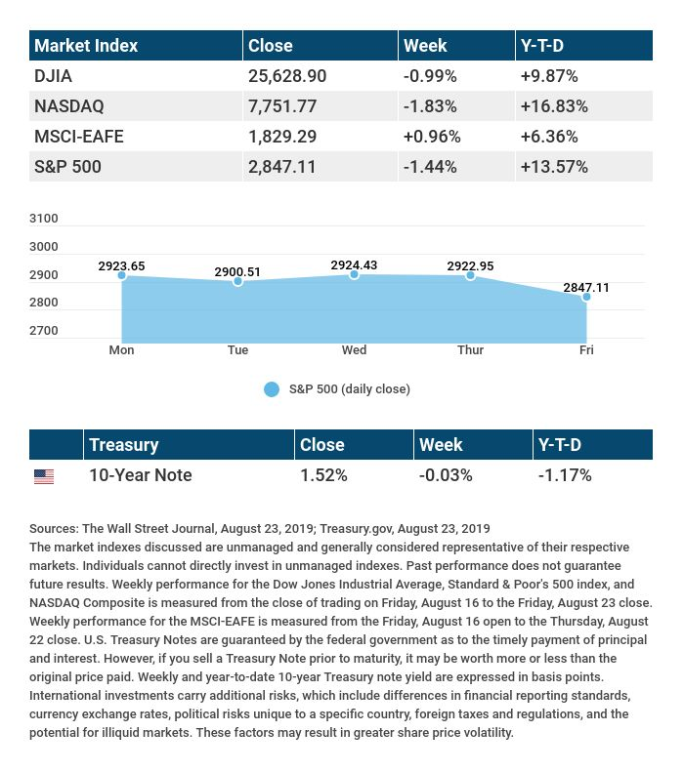

T H E W E E K L Y R I D D L E

A crook steals $100 from a cash register. The crook returns an hour later with the same $100 and buys $70 in items, receiving $30 in change. How much does the merchant lose?

LAST WEEK’S RIDDLE: Without fingers, I point; without arms, I strike; without feet, I run. What am I?
ANSWER: A clock.

Know someone who could use information like this?
Please feel free to send us their contact information via phone or email. (Don’t worry – we’ll request their permission before adding them to our mailing list.)

Securities offered through Kestra Investment Services, LLC (Kestra IS), a member FINRA/SIPC. Investment advisory services offered through Kestra Advisory Services, LLC (Kestra AS), an affiliate of Kestra IS. Levine Group, LLC is not affiliated with Kestra IS or Kestra AS.
CITATIONS:
1 - wsj.com/market-data [8/23/19]
2 - quotes.wsj.com/index/XX/990300/historical-prices [8/23/19]
3 - cnn.com/2019/08/23/business/china-tariff-products-soybeans-oil/index.html [8/23/19]
4 - marketwatch.com/story/trump-says-us-tariffs-will-increase-on-chinese-goods-2019-08-23 [8/23/19]
5 - marketwatch.com/story/powell-says-fed-carefully-watching-developments-and-will-act-as-appropriate-2019-08-23-10103027 [8/23/19]
6 - conference-board.org/data/bcicountry.cfm?cid=1 [8/22/19]
7 - cnbc.com/2019/08/20/investing-in-the-strange-negative-yield-world-its-very-hard-to-wrap-your-arms-around.html [8/20/19]

CHART CITATIONS:
wsj.com/market-data [8/23/19]
quotes.wsj.com/index/SPX/historical-prices [8/23/19]
treasury.gov/resource-center/data-chart-center/interest-rates/Pages/TextView.aspx?data=yield [8/23/19]
treasury.gov/resource-center/data-chart-center/interest-rates/Pages/TextView.aspx?data=yieldAll [8/23/19]

