

***Tuesday, May 26th, 2020***

***“Economy Shows Signs of Stabilization”***

The number of job losses continues to pile up, with another 2.4 million Americans filing their first claims for unemployment benefits in the week ending May 16th. Continuing claims, the cumulative level of those seeking benefits, jumped to 25.1 million from 22.5 million the week prior1. Even though these job losses continue to be historic and tragic, the economy has started to show some forward-looking signs of stabilization.

The stock market appears to be looking past the terrible backward-looking data, instead focusing on a) improved optimism on a COVID-19 vaccine, b) signs that the economy is starting to improve, and c) the surge in money supply injected by the Federal Reserve. The combination of these factors has brought the S&P 500 back to within 13% of all-time highs as of Friday’s close.

The absolute level of economic activity is coming off very depressed levels from March and April, but we have started to see some signs of stabilization, including:

* Consumer confidence edging up in May to 86.6 from 85.7 in April
* The number of travelers passing through TSA security screening checkpoints was up to 267,451 on May 24th. That is down 87% from last year but well up from the 87,534 travelers on April 143.
* Truckstop.com, which measures demand in trucking’s spot market, saying its weekly index has improved for four straight weeks and that available loads were up 27% in the week ended May 18.
* Real estate showings in the 100 top markets were up 27% as of May 24. New home sales even showed an unexpected gain in April4.
* Restaurants are gradually seeing activity pick up, especially in economies with looser restrictions. Restaurant and travel spending is likely to be one of the last parts of the economy to fully recover.

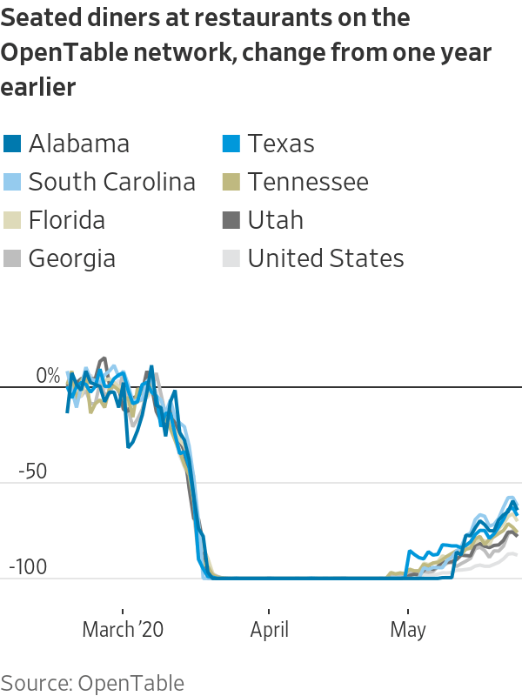

The percentage improvements are a bit misleading, because they are coming off a very low base. Nevertheless, the trend is going in the right direction and there is the very real possibility that demand will recover faster than originally expected for components of economic activity that matter most.

One thing that has been lacking in this stock market rally is breadth, the number of stocks contributing to the market’s rise. So far, the market’s rally has been heavily influenced by mega-cap tech companies. For example, the 10 largest stocks in the Nasdaq have gained, in aggregate, almost $900 billion year-to-date. The other 2,600 or so stocks have lost about $300 billion5. The top-heavy names have allowed the Nasdaq to eke out a 3.5% gain YTD despite the Dow and S&P 500 being down 13.4% & 7.8%, respectively.

The performance of the Nasdaq vs. the Dow & S&P 500 shows how narrow this rally has been, with the more cyclical sectors of the market (financials, industrials, materials) trailing the most. That makes sense given that those names are more economically sensitive, but to truly see that the economy is on a path towards recovery, we would want to see the cyclical names start to take on more of a leadership role.

Today, we are seeing a surge in cyclical names as the S&P 500 breaks above 3,000 for the first time since early March. Those hoping for a faster economic recovery should be focusing on the relative performance of the cyclical stocks over the coming months, many of which still trade at very distressed levels.

**Jack Holmes, CFA®**

***WealthPLANPartners***

*Sources:*

1. [*https://www.wsj.com/articles/self-employed-arent-counted-in-wave-of-unemployment-claims-11590053402*](https://www.wsj.com/articles/self-employed-arent-counted-in-wave-of-unemployment-claims-11590053402)
2. [*https://www.reuters.com/article/us-usa-economy/us-consumer-confidence-stabilizes-as-economy-reopens-idUSKBN232248*](https://www.reuters.com/article/us-usa-economy/us-consumer-confidence-stabilizes-as-economy-reopens-idUSKBN232248)
3. [*https://www.wsj.com/articles/for-economy-worst-of-coronavirus-shutdowns-may-be-over-11590408000?tesla=y&mod=article_inline&mod=article_inline*](https://www.wsj.com/articles/for-economy-worst-of-coronavirus-shutdowns-may-be-over-11590408000?tesla=y&mod=article_inline&mod=article_inline)
4. [*https://www.cnbc.com/2020/05/26/us-new-home-sales-april-2020.html*](https://www.cnbc.com/2020/05/26/us-new-home-sales-april-2020.html)
5. [*https://www.barrons.com/articles/only-a-few-big-stocks-are-driving-the-markets-gains-thats-a-problem-and-an-opportunity-51590146101?mod=past_editions*](https://www.barrons.com/articles/only-a-few-big-stocks-are-driving-the-markets-gains-thats-a-problem-and-an-opportunity-51590146101?mod=past_editions)

*The opinions voiced in this material are for general information only and are not intended to provide specific advice or recommendations for any individual. To determine which Investment(s) may be appropriate for you, consult your financial advisor prior to investing. Information is based on sources believed to be reliable, however, their accuracy or completeness cannot be guaranteed. Statements of forecast and trends are for informational purposes, and are not guaranteed to occur in the future.*

*All indices are unmanaged and may not be invested into directly. Advisory services offered through Feltz WealthPLAN, DBA of WealthPLAN Partners. Securities offered through Securities America, Inc., Member FINRA/SIPC. Feltz WealthPLAN and Securities America are separate entities.*