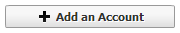
- From your Accounts Navigation bar (on the left), select
- In the Add Account dialog box, select Brokerage under the Investing category then click Next
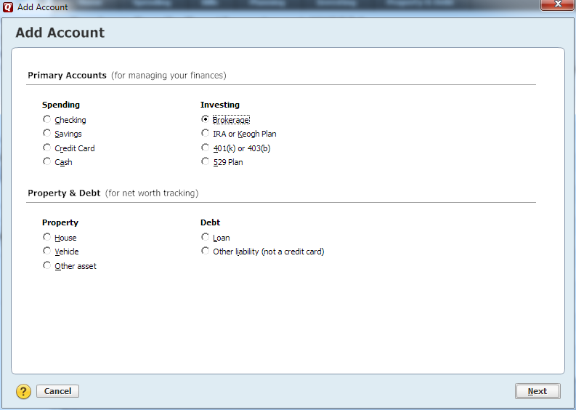

- In the Add Brokerage Account dialog box, enter “NetExchange” in the entry field, then select “NetExchange Client” from the list and click Next.
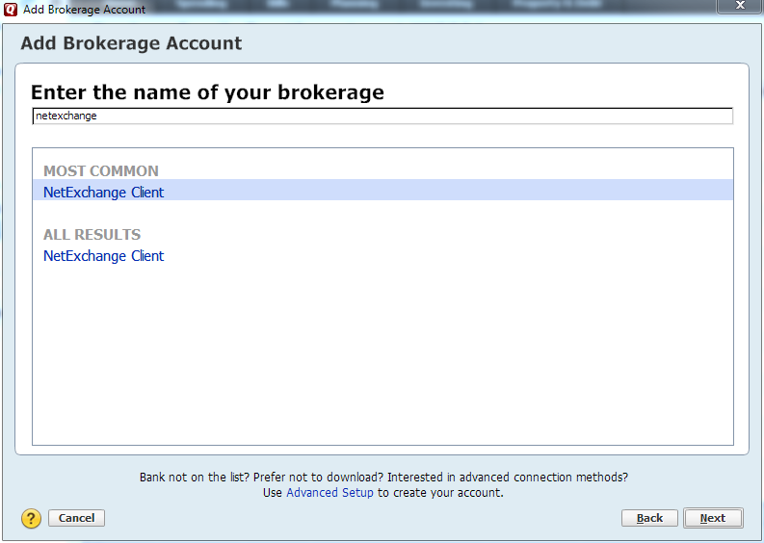

- In the Customer ID field, enter HWA followed by your NetXInvestor login ID. For example: HWABROKERAGEOPS
- In the Pin field, enter your password for NetXInvestor and click the Connect button to continue.

- Verify the account information, select Add and create an account Nickname for easy identification. Click the Next button to begin the download into Quicken.

- Once the download has completed click Finish to review the downloaded transactions

- Select either Review First to review all transactions before accepting them or Accept All to accept all transactions as is into the Quicken account.

- If you have selected to review first, examine the transactions at the bottom of the screen and select Accept if you wish to move them into your Quicken account.

- As the transactions are accepted, they will begin to show at the top of the screen in the Quicken account.

Having Trouble?
Please call our office at 408-963-2874 or
Email Fatima Franco at ffranco@wradvisors.com

