December 13th MARKET WATCH
WEEKLY AND YEAR-TO-DATE RETURNS (THRU 12/9/22:)
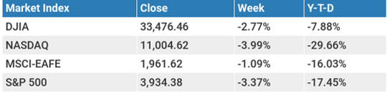
TODAY’S TOPICS:
Mid-Week Outlook, Chart - “Revenge of the 60/40?”
Key Market Levels
This Week / What We Are Watching

Market Outlook:
The S&P continues to bounce between various levels of support and resistance heading into year-end (see 6-month S&P 500 chart below), as investors continue to speculate the trajectory of both inflation and the Fed funds rate. Equities and bonds rallied Tuesday morning after a lower-than-expected CPI report came out before the opening bell. Then on Wednesday, investors will be closely watching the mid-day release of the Fed’s FOMC interest rate announcement where a hike of 0.50% (50 bps) is expected.

The November CPI report released early Tuesday morning, showed a faster than expected drop in inflation and thereby giving investors something to cheer about heading into year end. The cost of living rose just 0.1% in November from the previous month, which compared to economists’ expectations for a 0.3% rise. The annual rate fell to 7.1% for the month, down from 7.7% in October marking the lowest level we’ve seen since August of last year. One of the biggest contributors for the drop came from the continued decline in price of gasoline, which now costs about the same as it did before Russia invaded Ukraine in February.

Meanwhile, the highly anticipated year-end Fed meeting announcement comes midday Wednesday where investors will be eyeing two major items in the release: The updated “dot plot” projections, and Powell’s commentary following the announcement. The “dot plot” is only updated four times throughout the year and shows what the committee expects for the future path of interest rates. Most importantly it will update the FOMC’s expected peak, or “terminal rate” in the fed funds interest rate next year, which is one of the biggest questions on investors’ minds. We believe they will likely raise their terminal rate projections somewhat.

Chart - “Revenge of the 60/40?”
The below chart from Bloomberg and Goldman Sachs shows the average annual performance of the 60/40 portfolio. As you can see in other big down years, the portfolio has bounced back nicely the following year. While this scenario is far from guaranteed, it should still give investors hope as we head into 2023.

“Performance for an illustrative traditional 60/40 portfolio has been challenged in 2022 amid surges in interest rates, recession risk, and broader market uncertainty. However, past instances of 60/40 drawdowns have delivered strong performance in subsequent calendar years. We believe 2023 may be able to deliver a similar rebound, as attractive yields across the fixed income universe may offset rate market volatility.”

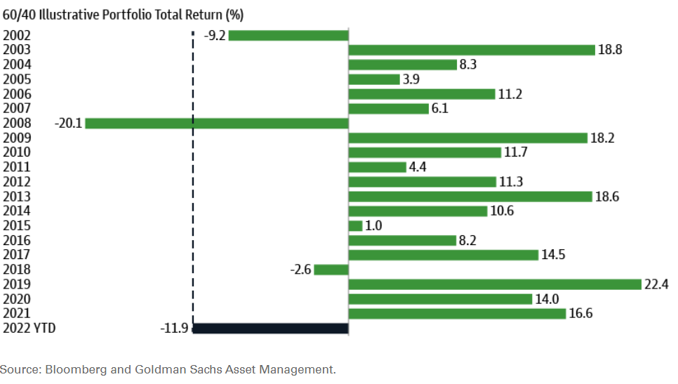

MARKET SUPPORT & RESISTANCE LEVELS:
The next level of resistance to watch for the S&P 500 on the upside is at 4,100, its recent high.
The next levels of support to watch for the S&P 500 on the downside are at around 4,035, followed by 3,500.

S&P 500 - 6-Month Chart
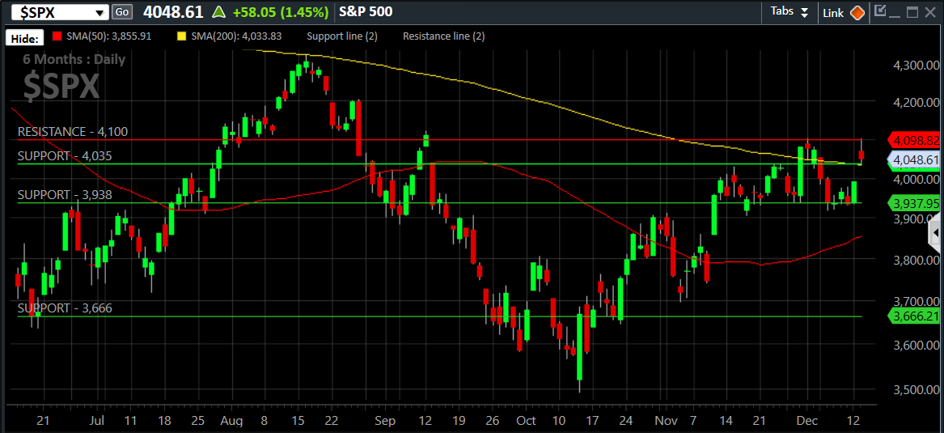
These are key technical levels we look for the market to either hold or push through when look at the potential for future moves. Common support levels can be the 50- and 200-day moving averages as well as other technical levels such as previous market highs or lows.

THIS WEEK / WHAT WE ARE WATCHING:
The following economic data is slated to be released during the week ahead:
Monday:
Tuesday: CPI Inflation Report (Nov.), NFIB Small Business Optimism (Nov.)
Wednesday: Fed Announcement Day, FOMC Dot Plot updated
Thursday: Weekly initial unemployment claims, Retail Sales (Nov.), Industrial Production (Nov.)
Friday:
Content in this material is for general information only and not intended to provide specific advice or recommendations for any individual. All performance referenced is historical and is no guarantee of future results. All indices are unmanaged and may not be invested into directly.
AUTHOR:
Johlfs Financial Group
5299 DTC Blvd. Suite 1170
Greenwood Village, CO 80111
johlfsfg.com

