

***Monday, June 15th, 2020***

***“Dividend Stocks Remain Out of Favor Despite Drop in Interest Rates”***

One of the surprises during this most recent market selloff has been the relative underperformance of dividend-paying stocks, especially in comparison to outperformance during historic market selloffs, including the tech bubble and great financial crisis. There are several indices that segment the various types of dividend-paying stocks (growers, high-yielders, etc.), but they have mostly underperformed the S&P 500 since the start of the year, some by a significant margin.

There are a few reasons that may be leading to this dynamic, but we feel it mostly comes down to two major contributors:

1. **Relative underperformance of value vs. growth stocks** – Many dividend stocks fall into the value segment of the market and value vs. growth performance dispersion is at near record-highs.
2. **Uncertainty on current and future dividend cuts** – As the chart below illustrates, we have seen a much higher number of dividend cuts during this crisis as companies opt to retain cash flow amidst an unprecedented level of short-term business uncertainty.

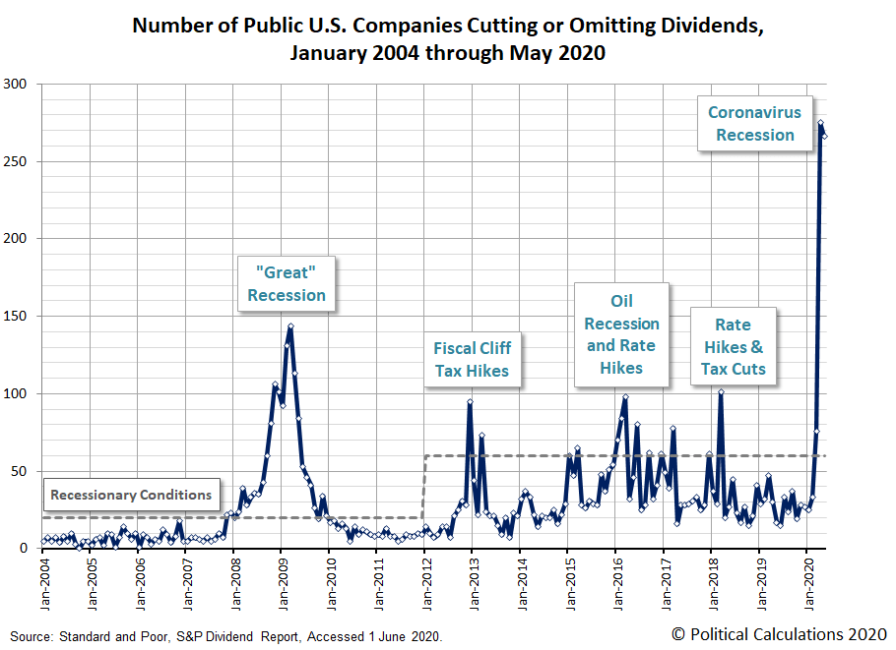

There have been some high-profile dividend cuts, but the largest contingent has come from smaller companies. In fact, 21% of the Russell 2000’s 820 dividend payers have trimmed or suspended their payouts this year1. This has been the most shocking business disruption for many of these companies, so it is not surprising that they have acted more cautious than, in most cases, better-capitalized larger companies. As the economy starts to improve and outlooks become a bit less cloudy, we anticipate many of these companies, small and large, will resume paying dividends.

And while many companies have chosen to act conservatively, there are still 155 S&P 500 companies that have ***raised*** their dividends this year1. We feel that the S&P 500 Dividend Aristocrat index is a great fishing spot for higher quality dividend growers, as these companies have raised dividends every year for at least the last 25 years. Companies that have a proven ability to raise dividends through various market cycles can provide more reliability for both current yield and future income growth.

When we screen for our own dividend-paying stocks, we put a high emphasis on a track record of dividend growth, but also on companies that have a low-to-moderate payout ratio (dividends as a % of earnings) and underlying cash flow growth. Lower payout ratios make the dividend less of a burden and offers the potential for dividends to grow at or above business growth.

While dividend yields have been much higher in the past, they have rarely been as attractive as they are today in comparison to interest rates. As the chart below illustrates, the ratio of the S&P 500’s dividend yield (~2%) is more than 3x the yield of the 10-year treasury bond (~0.67%). Dividends also have the potential to grow while the 10-year treasury bond’s coupon is fixed.

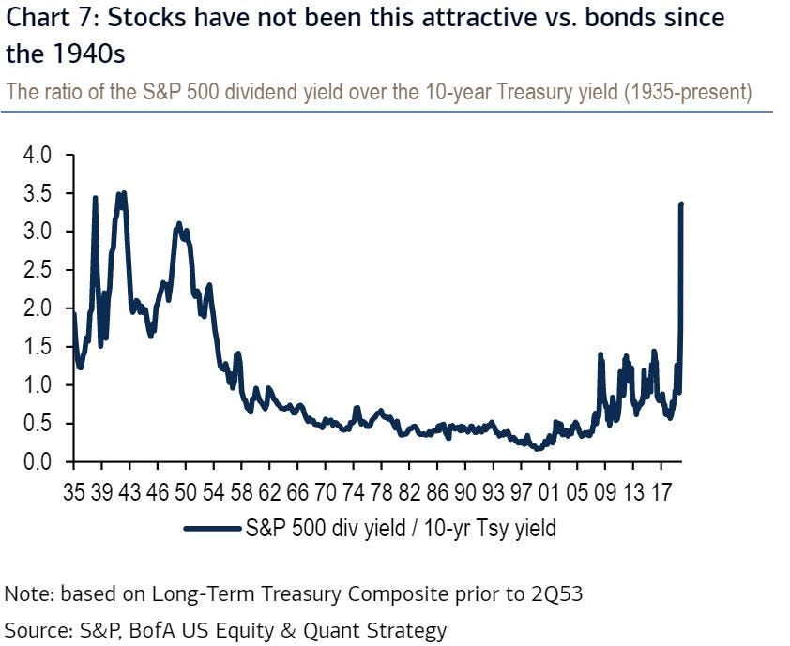

So while dividend-paying stocks have generally lagged the market during this economic shock, we think it has rarely been a better time to consider higher quality dividend compounders as part of a growth and income portfolio solution for the decade ahead. If you are not already an investor in our Dividend Aristocrat Portfolio, please reach out to us for further information.

**Jack Holmes, CFA®**

***WealthPLANPartners***

*Sources:*

1. <https://www.barrons.com/articles/dividends-are-down-but-not-out-here-are-8-stock-picks-for-the-pandemic-era-51591972201>

*The opinions voiced in this material are for general information only and are not intended to provide specific advice or recommendations for any individual. To determine which Investment(s) may be appropriate for you, consult your financial advisor prior to investing. Information is based on sources believed to be reliable, however, their accuracy or completeness cannot be guaranteed. Statements of forecast and trends are for informational purposes, and are not guaranteed to occur in the future.*

*All indices are unmanaged and may not be invested into directly. Advisory services offered through Feltz WealthPLAN, DBA of WealthPLAN Partners. Securities offered through Securities America, Inc., Member FINRA/SIPC. Feltz WealthPLAN and Securities America are separate entities.*