Wild Turkey Breast (half)
TOTAL TIME 1hr 10mins
PREP 10 MINS
COOK 1 HR
INGREDIENTS
SERVINGS 6 UNITS US
- 1 wild turkey breast half
- 8 ounces’ zesty Italian salad dressing
- 8 ounces white wine
- 1small Reynolds oven cooking bag
- creole seasoning
- lemon pepper seasoning
- ¹⁄₂cup butter
- ²⁄₃cup olive oil

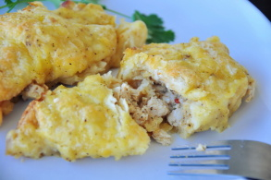
Check Out Our Top Turkey Breasts Recipe

DIRECTIONS
- Mix the dressing and wine.
- Pour into a 1-gallon size zip-lock bag.
- Add the turkey breast and marinate overnight, turning at least once.
- Drain off the marinade & discard.
- Sprinkle turkey breast with the seasonings.
- Place in oven roasting bag.
- Melt the butter in the olive oil and add to the turkey breast.
- Place the roasting bag & turkey breast in a 9"x5" loaf pan.
- Bake at 350 degrees for 1 1/2 hours.

