In this week’s recap: Wall Street finishes August with a rally, China decides to pause a potential response to oncoming U.S. tariffs, and two consumer confidence indices send different messages.
Weekly Economic Update

Presented by Michael J. Levine, September 2, 2019

THE WEEK ON WALL STREET
Fears of an impasse in the U.S.-China trade dispute lessened last week. While additional U.S. tariffs on Chinese imports were scheduled to take effect on September 1, China’s government communicated that it would refrain from taking retaliatory measures for the moment.
U.S. stock benchmarks advanced during the week. The S&P 500 rose 2.79% across five trading days, and the Nasdaq Composite and Dow Jones Industrial Average respectively gained 2.72% and 3.02%. The MSCI EAFE international index added just 0.25%.^{1,2}

Positive News in the Trade Dispute
Thursday, a spokesman for China’s commerce ministry said that negotiations could resume this month, and that discussions need to focus on “removing the new tariffs to prevent escalation.”
In addition, officials in Beijing indicated they would hold off on responding to the U.S. tariff hikes announced Friday by the White House.³

Mixed Consumer Confidence Signals
The Conference Board’s monthly Consumer Confidence Index was at 135.1 in August. Analysts polled by Reuters had projected a reading of 129.5. Consumers’ view of the present economic situation was the best since November 2000.
On the other hand, the University of Michigan’s monthly Consumer Sentiment Index (based on a different collection of survey data) dropped 8.6 points during August to 89.8; that was its biggest monthly descent in nearly seven years.^{4,5}

WHAT’s NEXT
After a pause for the Labor Day holiday, U.S. financial markets have an abbreviated trading week. The August jobs report may influence Friday’s Wall Street session, and any news pertaining to U.S.-China trade talks could also influence the markets.

T I P O F T H E W E E K
If you still receive paper bank statements, you should know that there could be a financial perk for going digital: some financial institutions may offer you lower fees in return for your choice to manage your money online.

THE WEEK AHEAD: KEY ECONOMIC DATA
Tuesday: The Institute for Supply Management releases its August Purchasing Managers Index (PMI) for the factory sector, assessing U.S. manufacturing activity.
Thursday: ISM presents its August PMI for the service sector, and payroll giant ADP publishes its latest private-sector employment snapshot.
Friday: The Department of Labor offers its August employment report.
Source: Econoday / MarketWatch Calendar, August 30, 2019
The content is developed from sources believed to be providing accurate information. The forecasts or forward-looking statements are based on assumptions and may not materialize. The forecasts also are subject to revision. The release of data may be delayed without notice for a variety of reasons.

THE WEEK AHEAD: COMPANIES REPORTING EARNINGS
Wednesday: Palo Alto Networks (PANW), Slack Technologies (WORK)
Thursday: Lululemon Athletica (LULU)
Source: Zacks, August 30, 2019
Companies mentioned are for informational purposes only. It should not be considered a solicitation for the purchase or sale of the securities. Any investment should be consistent with your objectives, time frame, and risk tolerance. The return and principal value of investments will fluctuate as market conditions change. When sold, investments may be worth more or less than their original cost. Companies may reschedule when they report earnings without notice.

Q U O T E O F T H E W E E K

“Take rest; a field that has rested gives a bountiful crop.”
OVID

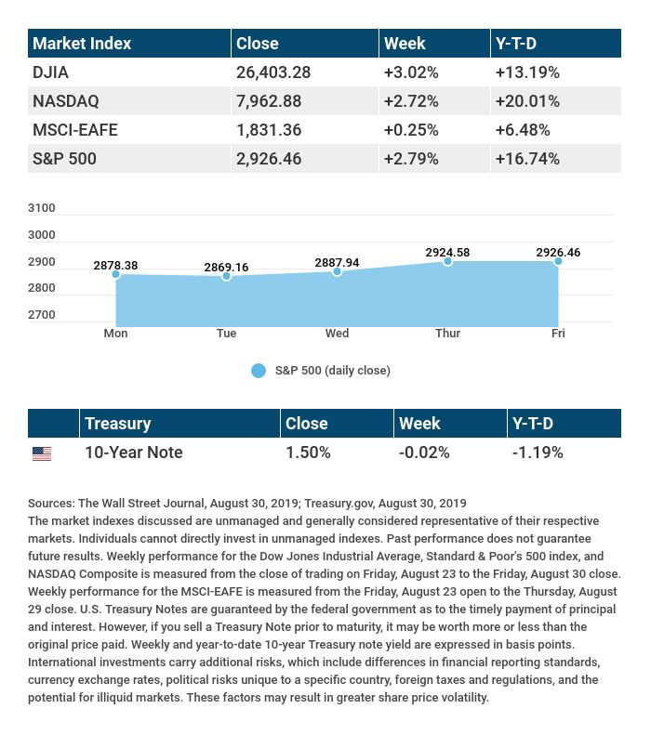

T H E W E E K L Y R I D D L E

When I was 2 years old, my brother was half my age. Now I am 100 years old, how old is my brother?

LAST WEEK’S RIDDLE: A crook steals $100 from a cash register. The crook returns an hour later with the same $100 and buys $70 in items, receiving $30 in change. How much does the merchant lose?
ANSWER: $100. The shop loses $70 worth of goods, plus $30 dollars in cash. It is as if the merchant gave the goods out for free as well as $30.

Know someone who could use information like this?
Please feel free to send us their contact information via phone or email. (Don’t worry – we’ll request their permission before adding them to our mailing list.)

Securities offered through Kestra Investment Services, LLC (Kestra IS), a member FINRA/SIPC. Investment advisory services offered through Kestra Advisory Services, LLC (Kestra AS), an affiliate of Kestra IS. Levine Group, LLC is not affiliated with Kestra IS or Kestra AS.
CITATIONS:
1 - wsj.com/market-data [8/30/19]
2 - quotes.wsj.com/index/XX/990300/historical-prices [8/30/19]
3 - marketwatch.com/story/dow-futures-up-over-250-points-as-china-tamps-down-fears-of-further-trade-war-escalation-2019-08-29 [8/29/19]
4 - cnbc.com/2019/08/27/us-consumer-confidence-august-2019-index-dips.html [8/27/19]
5 - sca.isr.umich.edu/ [8/30/19]

CHART CITATIONS:
wsj.com/market-data [8/30/19]
quotes.wsj.com/index/SPX/historical-prices [8/30/19]
treasury.gov/resource-center/data-chart-center/interest-rates/Pages/TextView.aspx?data=yield [8/30/19]
treasury.gov/resource-center/data-chart-center/interest-rates/Pages/TextView.aspx?data=yieldAll [8/30/19]

