- Go to https://waddell.netxinvestor.com/web/waddell/login
- Enter your User ID into the Login field; DO NOT use the Register link. Your User ID should have been selected during your account opening process. If you do not recall your User ID, please give us a call.
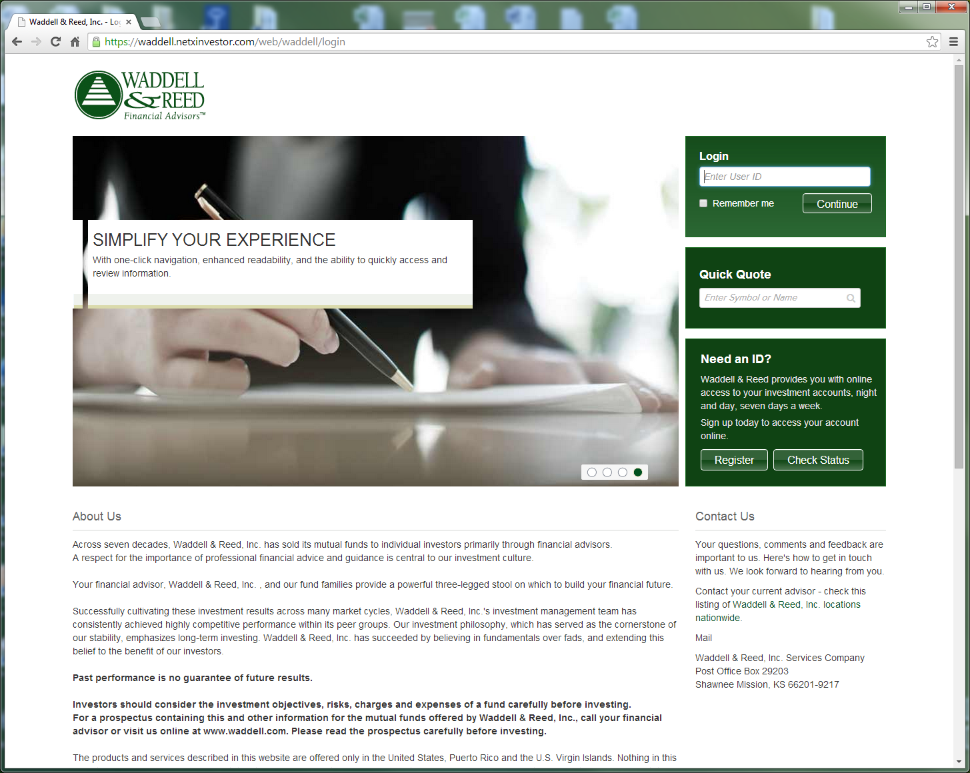

- You will then be prompted to enter your password. The first time you log in, your password will default to wa followed by your birthday (MMDDYY). Example: wa010115

- You will then be asked to change your password. This will be your password going forward. It must be 8 characters long and no more than 12. It must have 1 letter and 1 number, cannot contain special characters and cannot be things such as your name or User ID.
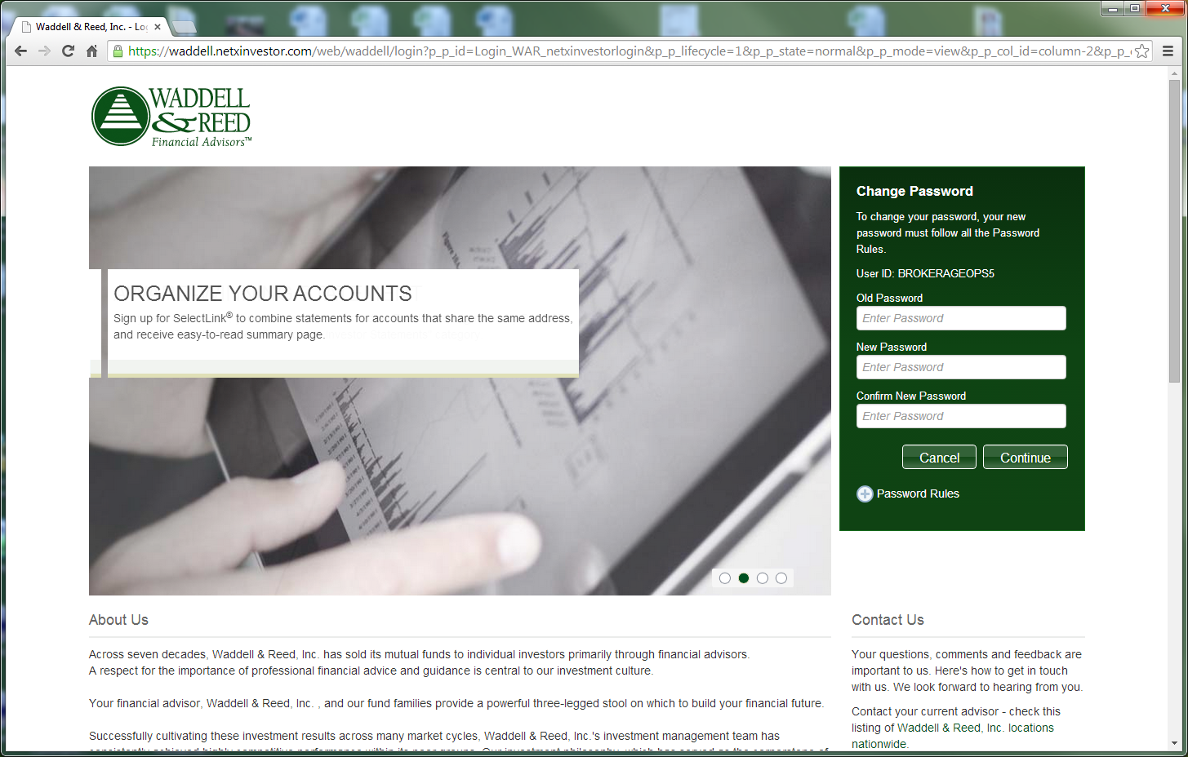

Having Trouble?
Please call our office at 408-963-2874 or
Email Fatima Franco at ffranco@wradvisors.com

