In this week’s recap: stocks decline as Wall Street adjusts its expectations about the potential duration of the U.S.-China trade dispute, and some retail giants post first-quarter earnings.
Weekly Economic Update

Presented by Michael J. Levine, May 28, 2019

THE WEEK ON WALL STREET
Stocks drifted lower last week as investors considered the possibility that the world’s two largest economies might take some time to resolve key trade issues.
The S&P 500 retreated 1.17%; the Nasdaq Composite, 2.29%; the Dow Jones Industrial Average, 0.69%. The concern over trade was felt elsewhere: the overseas developed markets benchmark, the MSCI EAFE, also lost 1.41% in five trading sessions.^{1,2}

Market Waits for Further Trade Talk Cues
A compromise on tariffs between the U.S. and China did not seem forthcoming last week. Negotiations appeared stalled. Regardless, President Trump and Chinese President Xi are slated to meet at June’s G20 summit in Japan.
The Department of Commerce has effectively banned U.S. companies from doing business with Chinese tech giant Huawei, a major global player in 5G technology. Some analysts think China may respond with retaliatory measures.³

Leading Retailers Report Earnings
Big-box stores and other major retail chains announced first-quarter results last week. While some traditional department store chains disappointed (Kohl’s, JC Penney, Nordstrom), Macy’s recorded its sixth straight quarter of comparable sales growth. Target reported a 10.8% jump in earnings in the first quarter, Walmart announced Q1 gains in earnings and revenue, and Urban Outfitters saw record sales in Q1.^{4,5}
Any companies mentioned are for informational purposes only, and this should not be considered a solicitation for the purchase or sale of their securities. Any investment should be consistent with your objectives, time frame, and risk tolerance.

FINAL THOUGHT
As new chapters in the U.S.-China trade drama continue to unfold, remember that your investment approach is built around your long-term objectives and risk tolerance. There will always be day-to-day price changes; there will always be breaking news alerts. The disciplined, long-term investor stays the course through the ups and downs.

T I P O F T H E W E E K
Young adults can potentially see significant auto insurance savings if their parents include them on their policy. That is permissible as long as the younger driver is under a certain age and either still living at home or living on a college campus.

THE WEEK AHEAD: KEY ECONOMIC DATA
Tuesday: The Conference Board’s latest monthly consumer confidence index.
Friday: May consumer spending numbers and May’s final University of Michigan consumer sentiment index (another important measure of consumer confidence levels).
Source: Econoday / MarketWatch Calendar, May 24, 2019
The Econoday and MarketWatch economic calendars list upcoming U.S. economic data releases (including key economic indicators), Federal Reserve policy meetings, and speaking engagements of Federal Reserve officials. The content is developed from sources believed to be providing accurate information. The forecasts or forward-looking statements are based on assumptions and may not materialize. The forecasts also are subject to revision.

THE WEEK AHEAD: COMPANIES REPORTING EARNINGS
Wednesday: Dick’s Sporting Goods (DKS), PVH (PVH)
Thursday: Costco (COST), Dell (DELL), Dollar General (DG), Ulta Beauty (ULTA)
Source: Morningstar.com, May 24, 2019
Companies mentioned are for informational purposes only. It should not be considered a solicitation for the purchase or sale of the securities. Any investment should be consistent with your objectives, time frame, and risk tolerance. The return and principal value of investments will fluctuate as market conditions change. When sold, investments may be worth more or less than their original cost. Companies may reschedule when they report earnings without notice.

Q U O T E O F T H E W E E K

“The successful person knows how to put energy into time and how to draw success from time.”
DENIS WAITLEY

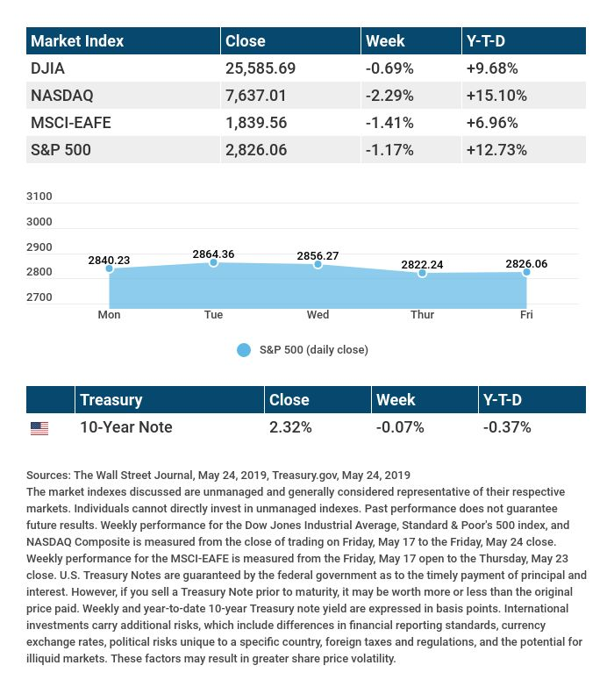

T H E W E E K L Y R I D D L E

If I say, "everything I tell you is a lie," am I telling you the truth or a lie?

LAST WEEK’S RIDDLE: Can you name two perennial vegetables? (That is, vegetables that don’t need to be replanted and can live on to produce in a future growing season?)
ANSWER: Asparagus and rhubarb.

Know someone who could use information like this?
Please feel free to send us their contact information via phone or email. (Don’t worry – we’ll request their permission before adding them to our mailing list.)

Securities offered through Kestra Investment Services, LLC (Kestra IS), a member FINRA/SIPC. Investment advisory services offered through Kestra Advisory Services, LLC (Kestra AS), an affiliate of Kestra IS. Levine Group, LLC is not affiliated with Kestra IS or Kestra AS.
CITATIONS:
1 - wsj.com/market-data [5/24/19]
2 - quotes.wsj.com/index/XX/990300/historical-prices [5/24/19]
3 - cnbc.com/2019/05/21/tech-stocks-are-feeling-the-pain-but-may-emerge-better-off-after-trade-war.html [5/21/19]
4 - seekingalpha.com/article/4265991-q1-2019-u-s-retail-scorecard-may-21-update [5/21/19]
5 - just-style.com/news/us-q1-in-brief-ross-stores-l-brands-target-corp_id135965.aspx [5/24/19]
CHART CITATIONS:
wsj.com/market-data [5/24/19]
quotes.wsj.com/index/SPX/historical-prices [5/24/19]
treasury.gov/resource-center/data-chart-center/interest-rates/Pages/TextView.aspx?data=yield [5/24/19]
treasury.gov/resource-center/data-chart-center/interest-rates/Pages/TextView.aspx?data=yieldAll [5/24/19]

