In this week’s recap: Stocks end up higher and oil ends up lower after an up-and-down week, as traders react to events in the Middle East and the data in the December unemployment report.
Weekly Economic Update

Presented by Michael J. Levine, January 13, 2020

THE WEEK ON WALL STREET
The market had a choppy five days, with traders reacting to geopolitical developments and weaker-than-expected jobs data. Even so, the three major U.S. equity indices posted weekly gains and continued their strong start to the new year. During Friday’s trading session, the Dow Jones Industrial Average topped 29,000 for the first time.
Rising 1.75% for the week, the Nasdaq Composite outgained both the Dow (up 0.66%) and the S&P 500 (up 0.94%). The story for foreign stocks was different: the MSCI EAFE index declined 0.30%.^{1,2}

Holiday Hiring Numbers
Wall Street was unimpressed by the latest jobs report from the Department of Labor. Employers added 145,000 net new workers in December; economists surveyed by Dow Jones had forecast a gain of 160,000. Wages grew less than 3% year-over-year for the first time in 17 months.
Unemployment remained at a 50-year low of 3.5%, however. The broader U-6 jobless rate, which also includes the underemployed, decreased to 6.7%, the lowest in 26 years of recordkeeping.³

Oil Prices Decline
The rally in crude oil spurred by strained U.S.-Iran relations ebbed this past week. At Friday’s closing bell, WTI crude was worth $59.04 a barrel on the New York Mercantile Exchange, down 6.36% for the week and 3.31% year-to-date.⁴

What’s AHEAD
A new earnings season starts Tuesday, with big banks leading off and reporting fourth-quarter results. Chinese Vice Premier Liu He will be in Washington, D.C., through Wednesday, and during his visit, he and President Trump are expected to sign the phase-one trade deal between the U.S. and China.⁵

T I P O F T H E W E E K
When it comes to naming an executor for your estate, a family member or relative is not your only option. You can also name an attorney or a corporate trustee as your executor.

THE WEEK AHEAD: KEY ECONOMIC DATA
Tuesday: The December Consumer Price Index, providing a look at inflation last month and for all of 2019.
Thursday: December retail sales figures from the Department of Commerce.
Friday: The University of Michigan’s preliminary January Consumer Sentiment Index, assessing consumer confidence levels from multiple angles.
Source: MarketWatch, January 10, 2020
The MarketWatch economic calendar lists upcoming U.S. economic data releases (including key economic indicators), Federal Reserve policy meetings, and speaking engagements of Federal Reserve officials. The content is developed from sources believed to be providing accurate information. The forecasts or forward-looking statements are based on assumptions and may not materialize. The forecasts also are subject to revision.

THE WEEK AHEAD: COMPANIES REPORTING EARNINGS
Tuesday: Citigroup (C), Delta Air Lines (DAL), JPMorgan Chase (JPM), Wells Fargo (WFC)
Wednesday: Bank of America (BAC), Goldman Sachs (GS), United Health (UNH), US Bancorp (USB)
Thursday: Morgan Stanley (MS)
Friday: Schlumberger (SLB)
Source: Zacks, January 10, 2020
Companies mentioned are for informational purposes only. It should not be considered a solicitation for the purchase or sale of the securities. Any investment should be consistent with your objectives, time frame and risk tolerance. The return and principal value of investments will fluctuate as market conditions change. When sold, investments may be worth more or less than their original cost. Companies may reschedule when they report earnings without notice.

Q U O T E O F T H E W E E K

“The man who says he is willing to meet you halfway is usually a poor judge of distance.”
LAURENCE J. PETER

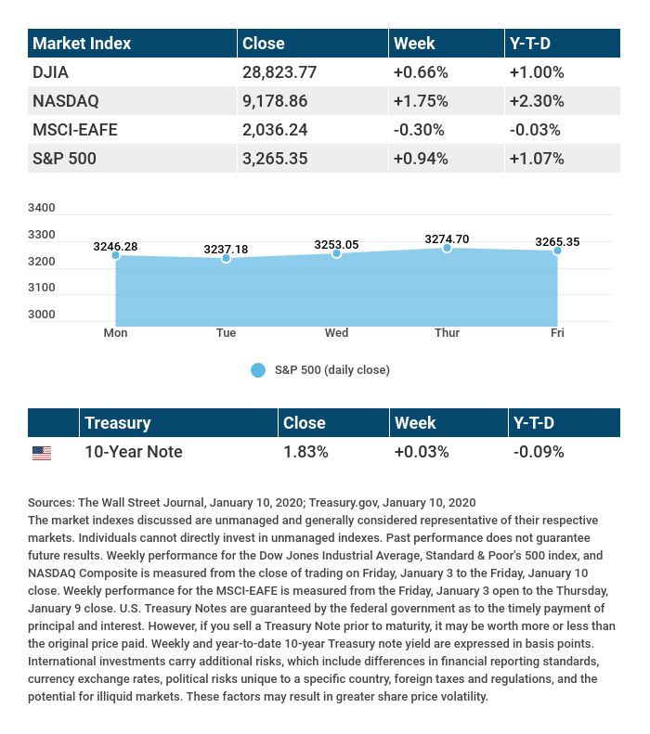

T H E W E E K L Y R I D D L E

I can be used to build castles, but I crumble in your hands. I can help a man see, and am found all around the lands. What am I?

LAST WEEK’S RIDDLE: A couple took a trip to the Arctic Circle, and they were disappointed that they did not see any penguins. What didn’t they realize about penguins?
ANSWER: They did not realize that almost all penguins live in the Southern Hemisphere.

Know someone who could use information like this?
Please feel free to send us their contact information via phone or email. (Don’t worry – we’ll request their permission before adding them to our mailing list.)

Securities offered through Kestra Investment Services, LLC (Kestra IS), a member FINRA/SIPC. Investment advisory services offered through Kestra Advisory Services, LLC (Kestra AS), an affiliate of Kestra IS. Levine Group, LLC is not affiliated with Kestra IS or Kestra AS.
CITATIONS:
1 - wsj.com/market-data [1/10/20]
2 - quotes.wsj.com/index/XX/MSCI%20GLOBAL/990300/historical-prices [1/10/20]
3 - cnbc.com/2020/01/10/us-nonfarm-payrolls-december-2019.html [1/10/20]
4 - marketwatch.com/investing/future/crude%20oil%20-%20electronic [12/3/20]
5 - cnbc.com/2020/01/09/chinas-vice-premier-liu-to-sign-us-trade-deal-in-washington-next-week.html [1/9/20]

CHART CITATIONS:
wsj.com/market-data [1/10/20]
quotes.wsj.com/index/XX/MSCI%20GLOBAL/990300/historical-prices [1/10/20]
quotes.wsj.com/index/SPX/historical-prices [1/10/20]
treasury.gov/resource-center/data-chart-center/interest-rates/Pages/TextView.aspx?data=yieldAll [1/10/20]

