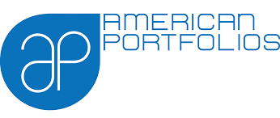

addressing the needs of individual investors and planting the seeds for a secure future.

We at [American Portfolios](http://public.americanportfolios.com/about.asp)  are committed to maintaining the highest standards of integrity and professionalism in our relationship with you, our client. We endeavor to know and understand your financial situation and provide you with only the highest quality information, services, and products to help you reach your goals. We know how hard you work for your money here in the Valley, your money should work just as hard for you

We have been working with individuals and businesses in the Valley for decades.

Each of our agents have extensive personal and professional experience specialized in a variety of services to meet your individual financial planning needs - and as an independent financial office, we offer only offer opportunities that fit your personalized goals.

Your Partner for Success

• Advice and Planning

• Asset Allocation

• Estate Planning

• Managing

• Income Taxes

• Disability

• Asset Accumulation

• Education Planning

• Forecasting

Financial Consultation

43 N. Broad St

Canfield, OH 44406 USA

(724)856-2259

ncannon@americanportfolios.com

www.AmericanportfoliosOhio.com

  

Please call for a free financial consultation