Home Title Fraud: How to Protect Yourself
By Devin Kropp Horsesmouth Associate Editor
One uncommon but disastrous form of identity theft can put you or your client’s home at risk. Learn how to prevent this costly and frightening fraud.
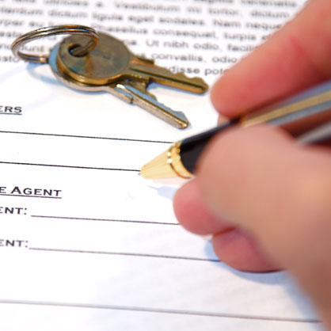
Imagine sitting in your home that you had saved and worked for only to be notified that it is for sale—except you didn’t list it. You are told that your home title is not in your name anymore. What could have possibly happened?
Home title fraud occurs when a scammer obtains your home property title and transfers the ownership into their name. In some cases, the scammer creates fraudulent home title documents and tries to pass them off as legitimate. In more advanced cases, the scammer will commit identity theft first and then do a home title transfer.
What happens when your home title is stolen? The fraudster can use your home equity to secure other loans in your name. In extreme cases, the thief can also try to sell your home using the documents. Often this type of fraud can go unnoticed until the true homeowner begins receiving foreclosure notices, seemingly out of nowhere.
While this type of fraud can be devastating, it is still fairly rare compared to other threats. In general, scammers go after older homeowners or people that own more than one home. Older homeowners tend to have more equity, while owners of multiple properties may not pay as close attention to their second home.
Scammers often use phishing emails to gather enough information to execute the fraud. In some cases, they will impersonate real estate agents and send emails to homeowners asking to verify the information. Be sure to always confirm by calling the real estate agent if you receive an email asking for details on your home.

How can you protect yourself?
What can you do to ensure that your home stays safe against this threat? There are companies that advertise home title insurance. They act like LifeLock and supposedly will monitor and notify you if your home title is compromised. In most cases, those services do little to protect you from home title fraud. In fact, such a service can be a scam itself.
Instead, you can take steps yourself to protect your home from this type of scam.

1. Freeze your credit
Setting up a credit freeze at the big three credit bureaus (Experian, Equifax, and TransUnion) is your first big step in protecting your home title from fraud. A credit freeze locks your credit file with a special PIN. Anytime you apply for a new line of credit, you need to provide the PIN before the credit can be approved.
A credit freeze will make it difficult for the scammer to take out new credit using your home equity. Setting up a credit freeze is free in all 50 states and easy to do. You can apply online (or over the phone) with all of the credit bureaus. If you do need a new, legitimate line of credit—you simply lift the freeze with your PIN 24-48 hours prior to applying.

2. Regularly check your property deed
Another way to protect yourself is to regularly check your property deed status with your county. This will ensure that if someone has stolen your home title, you will catch the fraud early. You can call your county to see how you can check your deed details. You may also want to check your county tax records yearly to confirm that you are listed as the owner.

3. Monitor your utility bills
One sign that something might be wrong with your home title is if your regular bills stop arriving in your name to your address. Make sure you are regularly receiving utility, tax and mortgage bills properly addressed to you.

What to do if you think you are a victim?
If you think your home title has been stolen, you will want to take action right away. First, contact your county recorder and alert them to the fraud. You may need to provide documents such as a mortgage bill and a copy of your deed. You should also reach out to your bank if you think any money is in motion.
File a police report so you have a paper trail of the fraud. You should also file a report with the Federal Trade Commission. You may need this documentation if you need to get a lawyer involved in the case. If you do need a lawyer, reach out to one that specializes in real estate fraud or title fraud.
Home title fraud prevention is much easier than dealing with a stolen home title. Be sure to take the steps above to avoid becoming a victim.
Investment Advisory Services offered through Chesapeake Capital Management, LLC, a Registered Investment Advisor. Securities offered through TD Ameritrade Institutional, located at 7801 Mesquite Bend Drive, Suite 112, Irving, TX 75063-6043, (800) 431-3500. Chesapeake Capital Management, LLC is neither an affiliate nor subsidiary of TD Ameritrade Institutional and does not provide tax or legal services”.
This letter is not intended to be relied upon as forecast, research or investment advice, and is not a recommendation, offer or solicitation to buy or sell any securities or to adopt any investment strategy. The opinions expressed are as of the date noted and may change as subsequent conditions vary. The information and opinions contained in this letter are derived from proprietary and nonproprietary sources deemed by Chesapeake Capital Management to be reliable.

Chesapeake Capital Management is neither an attorney nor an accountant, and no portion of this content should be interpreted as legal, accounting or tax advice.

Additional information about Chesapeake Capital Management is available in its current disclosure documents, Form ADV, Form ADV Part 2A Brochure, and Client Relationship Summary report which are accessible online via the SEC’s investment Adviser Public Disclosure (IAPD) database at www.adviserinfo.sec.gov, using CRD # 270014.

