6/06/2015 @ 10:01AM 6,864 views
Michael L. Rosenberg, RFC
Managing Partner
293 Eisenhower Parkway, Suite 360
Livingston, NJ 07039
Telephone 973.533.1919
www.diversifiedinv.com

How Ignoring Stock Market Forecasts Will Make You A Better Investor
Ky Trang Ho - Contributor

There’s no shortage of investing gurus who soared to stock market stardom for calling epic moments in Wall Street history. Black Money 1987. The 2010 Flash Crash. Judgement Day Dec. 21, 2012. After their 15 minutes of fame expire, you never see them on CNBC again because they’ve been wrong ever since. They fall into oblivion like the Tri-County All-Star quarterback who peaked in high school.
If you make enough predictions, you’re bound to be right at least once the way a broken clock is right twice a day. There’s no way to know ahead of time that stock market forecasts will be right. Thus, you best ignore all of them. I asked some investment advisers share why investors are better off ignoring stock market forecasts.
2. Remember Eastern Airlines, Standard Oil, and Paine Webber?
According to Eugene Fama, of the University of Chicago and Noble laureate, 2013 along with his partner Kenneth French of Dartmouth College the market is efficient. If one looks at world equity trading, in 2014 there were 60 million trades daily on average, the volume averaged $302 billion. The market is an effective information processing machine. If you are one of those 60 million trades in any given day and you’re buying a stock, what do you know that the world doesn’t?
In order to better understand this theory of market efficiency, I always tell my client’s to think about something they buy routinely like a gallon of orange juice. Each week they do their daily shopping they buy that gallon of orange juice for $4, and they trust the price. But one week later, the news says there was a bad frost in Florida. They go the supermarket a couple of days later, and now orange juice is $6 a gallon, they understand why. There was no way to predict this occurrence. They can elect to buy it or not to buy and wait for the price to come down.
This is how stocks work, each day the price is efficiently set by all known information on that particular stock. The future price is uncertain. I don’t think Apple (AAPL) or Google (GOOG) are going out of business tomorrow, but remember Eastern Airlines, Standard Oil, and Paine Webber? I am sure the people that bought stock in those companies thought they would be around forever.
Interesting fact that I believe best illustrates why stock market forecasting is pretty useless. For the period between the years 2000-2009 (10 years), there were 2,711 us equity mutual funds that began the period, and only 25% (682) outperformed their benchmark. More interesting is that for the next five years, 2010-2014, of those top funds that were considered the best of the best for 10 years, only 28% failed to beat the benchmark. Or simply put 72% failed to perform up to expectations.
My recommendation is put more emphasis on portfolio design and own low-cost index funds, asset class funds or exchange-traded funds, ETFs, and let the market be your friend not your foe. In the words of Peter Lynch of Fidelity Funds, when asked about stock forecasting: “nobody has been right twice in a row.” I agree with that. Taking a strategic approach by using asset allocation is not exciting or sexy and doesn’t make for great cocktail party conversation. But, in the long run, you will be glad you did.
– Michael Rosenberg, RFC, managing partner of Diversified Investment Strategies, LLC in $250 million in assets in Livingston, N.J
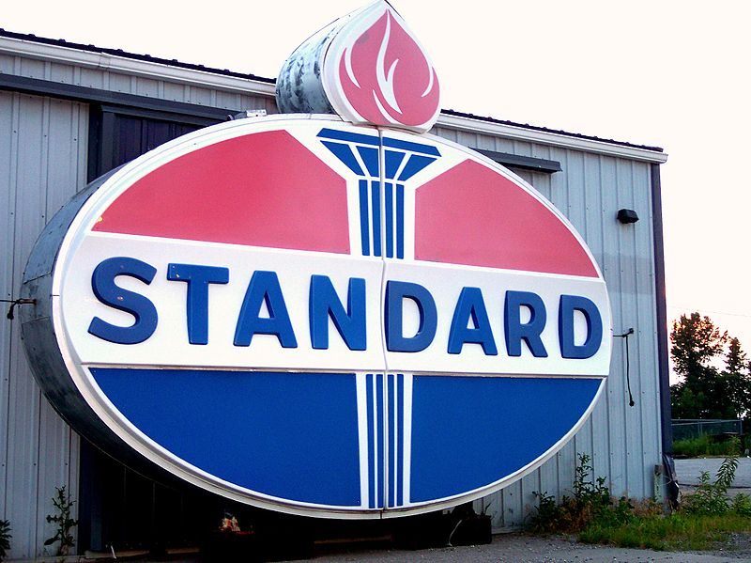
Old Standard Oil sign (Courtesy: Wikimedia.org)

