Does Your Financial Dashboard Have An “Idiot Light?”
By Carl Lutz, ChFC®, CLTC

Have you ever asked yourself the question, “Where is the best place to begin when reviewing my finances?” Is it cash flow, debt reduction or an investment analysis? Is it understanding beta, standard deviation or the differences between tactical, active or passive investing? The answer might surprise you. But, without giving you my opinion directly, let’s discover the answer together through a story.
Imagine you are driving down the highway and you begin to notice a slight shimmy in the steering wheel. After careful consideration, you decide that it’s most likely that your car needs a front end alignment. However, like most of us, there just isn’t enough time in the schedule to deal with it. So, you decide, I will get it taken care of the next time I am at the garage, maybe at my next oil change or inspection.
Now let’s take a break from the story and let me ask you a question.
What might happen to the car by delaying the front end alignment?
Yes, you are right, maybe the delay will create bigger problems.

At the very least, your tires will wear down more quickly. Perhaps you will burn more fuel than necessary? None of this is good, but at the same time none of these problems are life threating. At most, they are inefficiencies.
Let’s get back to the story. Now you are driving down the road and this time a warning light on your dashboard appears and it’s telling you that your airbags are defective. When I was a kid my father called those lights “the idiot light.” But this idiot light is important - why? If you didn’t receive a warning signal, when would you discover that there was a problem? Right, at the time of impact!
Let me ask you, when the dysfunction of your airbag is brought to your attention, does your sense of urgency change?
Do you think you will find or make the time to have the car checked out or will you wait until the next time you are at the garage? Hopefully you love yourself enough and you’re not in denial about your own mortality and you would take care of it right away.
Let’s get back to the original question. When it comes time to reviewing your finances, where should you begin? But before you answer that, it is important to understand that when taking a holistic view of your finances you will discover that there are four financial domains that are interdependent: Protection, Assets, Liabilities and Cash flow.
So, where should you begin your review?
If you haven’t figured it out yet – it should always be protection.
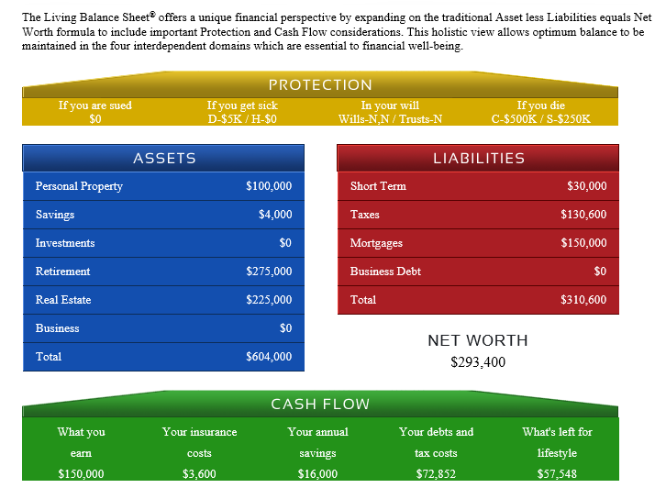
There are no “do overs” if at the time of impact you discover that your liability limits are inadequate, or that your group disability insurance does not include your bonuses. Or that your legal documents such as your will, health care proxy and power of attorney are outdated and no longer meet your objectives.
Or worse yet- that you have a current will but the beneficiaries on your life insurance and IRAs are not coordinated with your stated objectives.
What about your life insurance? How did you determine what the right amounts was? How long ago did you review your insurance? When does it expire? Is it funded properly? But protection does not just mean insurance and legal documents. What about liquidity? What about downside protection from the market losses?
Does your financial plan have an idiot light?
Unfortunately, no.

It is your responsibility to be proactive or better yet to work with an advisor who has a protection- first philosophy and sees you as the primary asset.
There is plenty of time to work on the inefficiencies of your plan. As a matter of fact, when working with an advisor that focuses on all four financial domains, many times inefficiencies can be identified, recaptured and redeployed allowing you to obtain optimal financial balance without any additional outlay.

Registered Representative and Financial Advisor of Park Avenue Securities, LLC (PAS), 600 Delaware Avenue, Buffalo, NY (800) 777-3411. Securities products/services and advisory services are offered through PAS, a registered broker/dealer and investment advisor. Financial Representative, The Guardian Life Insurance Company of America, New York, NY. PAS is an indirect, wholly owned subsidiary of Guardian. Lutz & Associates is not an affiliate or subsidiary of PAS or Guardian.

PAS is a member of the FINRA & SIPC

The Living Balance Sheet® (LBS) and the LBS Logo are registered service marks of The Guardian Life Insurance Company of America (Guardian), New York, NY. © Copyright 2005-2016 Guardian
2016-28725 Exp. 9/18

