- When arriving at the section Let Us Enter Your1099-INT, select Import from my bank or brokerage and click Continue.
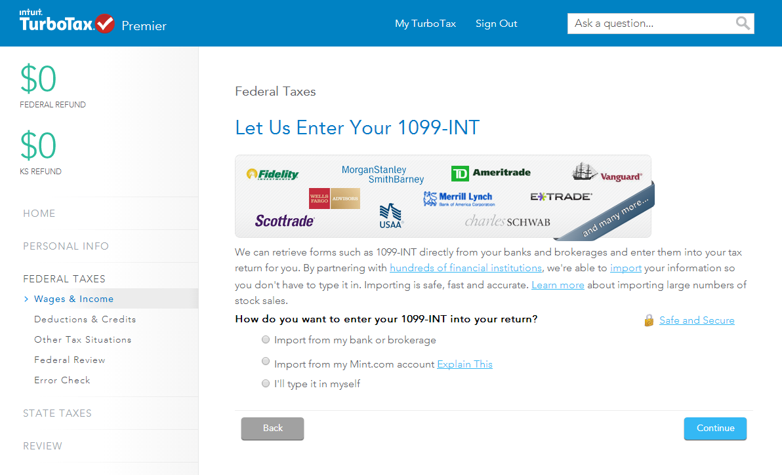

- Enter “NetXInvestor” into the search field, then select NetXInvestor (Pershing) Formerly NetXClient from the list of firms and click Continue.
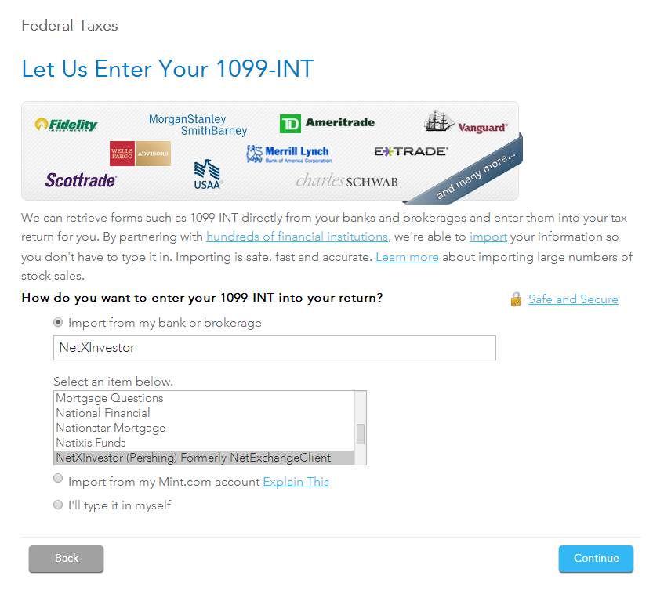

- In the Financial Institution Number box, enter “HWA”
- Enter your NetXInvestor User ID and Password, then click Continue.
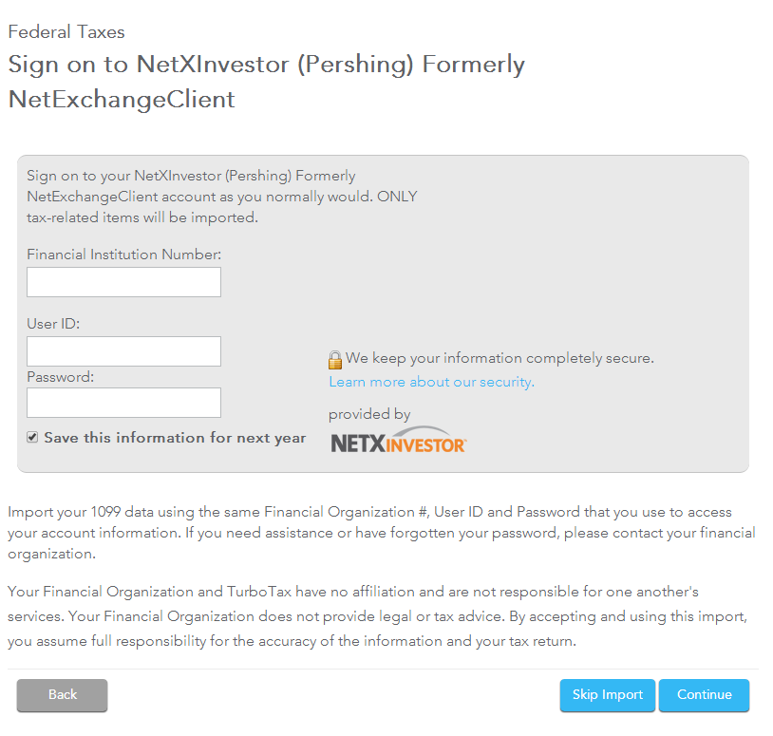

- After clicking Continue, the data from the account will import into your TurboTax system. You are responsible for ensuring the accuracy of the information.

Having Trouble?
Please call our office at 408-963-2874 or
Email Fatima Franco at ffranco@wradvisors.com

