In this week’s recap: the three Wall Street benchmarks advance as investors respond to newly scheduled U.S.-China trade talks and see a silver lining in the latest employment and manufacturing data.
Weekly Economic Update

Presented by Michael J. Levine, September 9, 2019

THE WEEK ON WALL STREET
Stocks rose last week, with help from two developments: the announcement of further U.S.-China trade talks as well as August hiring and manufacturing numbers that seemed to bolster the argument for a rate cut by the Federal Reserve.
The broad U.S. equity market, as represented by the S&P 500, added 1.79% during a 4-day trading week. The Dow Jones Industrial Average improved 1.49%; the Nasdaq Composite, 1.76%. Foreign shares tracked by the MSCI EAFE index gained 1.69%.¹⁻³

Trade Talks Poised to Restart
Trade representatives from the U.S. and China are planning to head back to the negotiating table early next month. This news came Thursday from China’s ministry of commerce, which confirmed a verbal agreement among Secretary of the Treasury Steven Mnuchin, U.S. Trade Representative Robert Lighthizer, and Chinese Vice Premier Liu He.
Formal trade discussions between the U.S. and China last happened in July. China has said that it wants punitive U.S. tariffs on its products removed in the event of a deal.⁴

Weaker Hiring & Manufacturing Data
Payrolls expanded with just 130,000 net new jobs in August, according to the Department of Labor; 25,000 were temp jobs linked to the federal government’s 2020 Census. The main jobless rate stayed at 3.7%. The U-6 rate, which measures both unemployment and underemployment, rose 0.2% to 7.2%.
A key gauge of U.S. factory activity, the Institute for Supply Management’s manufacturing purchasing manager index, fell to 49.1 in August. A number below 50 indicates factory sector contraction. Some investors took these hiring and manufacturing reports as hints of a slowing economy, one which the Federal Reserve could potentially try to stimulate with an interest rate cut.^{5,6}

WHAT’s AHEAD
August inflation data arrives this week, and if looks especially mild, it may amount to another suggestion that the Fed should ease. The European Central Bank concludes a meeting on Thursday, and Fed officials will certainly pay attention to its latest policy statement.⁷

T I P O F T H E W E E K
Some consumers pay $100 or more in ATM fees annually because they make withdrawals from third-party ATMs. If you bank with a major lender, try to make ATM withdrawals strictly from their branches.

THE WEEK AHEAD: KEY ECONOMIC DATA
Thursday: A new Consumer Price Index, tracking both monthly and yearly inflation.
Friday: The August retail sales report from the Census Bureau.
Source: Econoday, September 6, 2019
The content is developed from sources believed to be providing accurate information. The forecasts or forward-looking statements are based on assumptions and may not materialize. The forecasts also are subject to revision. The release of data may be delayed without notice for a variety of reasons.

THE WEEK AHEAD: COMPANIES REPORTING EARNINGS
Thursday: Broadcom (AVGO), Kroger (KR)
Source: Zacks, September 6, 2019
Companies mentioned are for informational purposes only. It should not be considered a solicitation for the purchase or sale of the securities. Any investment should be consistent with your objectives, time frame, and risk tolerance. The return and principal value of investments will fluctuate as market conditions change. When sold, investments may be worth more or less than their original cost. Companies may reschedule when they report earnings without notice.

Q U O T E O F T H E W E E K

“Life is like a ten-speed bicycle. Most of us have gears we never use.”
CHARLES M. SCHULTZ

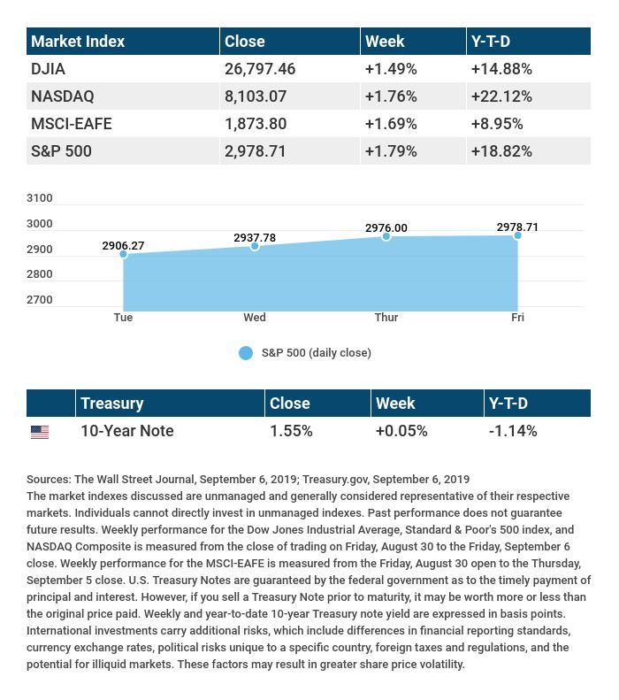

T H E W E E K L Y R I D D L E

It is not alive; it cannot see. Yet it has an eye, and it can make you gasp or cry, if you are not careful. What might it be?

LAST WEEK’S RIDDLE: When I was 2 years old, my brother was half my age. Now I am 100 years old, how old is my brother?
ANSWER: 99. Half of 2 is 1. 2+98=100, and 1+98=99.

Know someone who could use information like this?
Please feel free to send us their contact information via phone or email. (Don’t worry – we’ll request their permission before adding them to our mailing list.)

Securities offered through Kestra Investment Services, LLC (Kestra IS), a member FINRA/SIPC. Investment advisory services offered through Kestra Advisory Services, LLC (Kestra AS), an affiliate of Kestra IS. Levine Group, LLC is not affiliated with Kestra IS or Kestra AS.
CITATIONS:
1 - wsj.com/market-data [9/6/19]
2 - wsj.com/market-data [8/30/19]
3 - quotes.wsj.com/index/XX/990300/historical-prices [9/6/19]
4 - cbsnews.com/news/u-s-china-trade-talks-scheduled-for-october-beijing-says-2019-09-05/ [9/5/19]
5 - bloomberg.com/news/articles/2019-09-06/u-s-payrolls-rise-130-000-boosted-by-25-000-for-census-count [9/6/19]
6 - tradingeconomics.com/united-states/business-confidence [9/3/19]
7 - cnbc.com/2019/09/06/stocks-look-to-reclaim-their-all-time-highs-in-the-week-ahead.html [9/6/19]
CHART CITATIONS:
wsj.com/market-data [9/6/19]
quotes.wsj.com/index/SPX/historical-prices [9/6/19]
treasury.gov/resource-center/data-chart-center/interest-rates/Pages/TextView.aspx?data=yieldYear&year=2019 [9/6/19]
treasury.gov/resource-center/data-chart-center/interest-rates/Pages/TextView.aspx?data=yieldAll [9/6/19]

