In this week’s recap: stocks fall after a Federal Reserve rate cut, new tariffs are planned for Chinese goods, and payrolls see triple-digit monthly growth.
Weekly Economic Update

Presented by Michael J. Levine, August 5, 2019

THE WEEK ON WALL STREET
Last week, the Federal Reserve cut interest rates for the first time in more than a decade, in line with Wall Street’s expectations. Ironically, stocks had their worst week of 2019.
The S&P 500 finished the week 3.10% lower. The Dow Jones Industrial Average and the Nasdaq Composite also posted weekly losses; the blue chips fell 2.60%, while the premier tech benchmark slumped 3.92%. International stocks tracked by MSCI’s EAFE index dipped 1.06%.¹⁻³

Fed Cuts Benchmark Interest Rate
On Wednesday, the central bank reduced the federal funds rate by 0.25%. The latest Fed policy statement noted that “global developments” and “muted inflation” influenced the decision.
Addressing the media, Fed Chairman Jerome Powell described the cut as a “mid-cycle adjustment.” After that comment, Wednesday’s trading session turned volatile on the interpretation that the cut was a “one and done” move, instead of what might be the first in a series.⁴

More Tariffs Planned
Shares also fell Thursday, after a White House tweet indicated that the U.S. would put a 10% tariff on another $300 billion of goods coming from China, effective September 1.
Practically speaking, this would mean a tariff on nearly all Chinese products arriving in America. So far, the announcement has not affected plans for trade delegates from both nations to continue negotiations in September.⁵

The Latest Hiring Data
Payrolls expanded with 164,000 net new jobs in July, according to the Department of Labor. The headline jobless rate stayed at 3.7%; it has now been under 4% for 17 months. The U-6 jobless rate, which counts both underemployed and unemployed Americans, dipped to 7.0%, a level unseen since December 2000.
Monthly job growth has averaged 140,000 over the past three months, compared to 187,000 in 2018.⁶

T I P O F T H E W E E K
You may be inclined to help your adult children financially during your retirement, but think twice about doing so. Providing gifts or a personal loan (or cosigning on a loan they arrange) may put your own financial outlook at risk.

THE WEEK AHEAD: KEY ECONOMIC DATA
Monday: The Institute for Supply Management releases its latest Non-Manufacturing Purchasing Managers Index, its monthly gauge of business activity in America’s service sector.
Source: Econoday / MarketWatch Calendar, August 2, 2019
The content is developed from sources believed to be providing accurate information. The forecasts or forward-looking statements are based on assumptions and may not materialize. The forecasts also are subject to revision. The release of data may be delayed without notice for a variety of reasons.

THE WEEK AHEAD: COMPANIES REPORTING EARNINGS
Monday: Marriott International (MAR), Tyson Foods (TSN)
Tuesday: Walt Disney Co. (DIS)
Wednesday: American International Group (AIG), CVS Health (CVS)
Thursday: Booking Holdings (BKNG), Uber (UBER)
Source: Zacks, August 2, 2019
Companies mentioned are for informational purposes only. It should not be considered a solicitation for the purchase or sale of the securities. Any investment should be consistent with your objectives, time frame, and risk tolerance. The return and principal value of investments will fluctuate as market conditions change. When sold, investments may be worth more or less than their original cost. Companies may reschedule when they report earnings without notice.

Q U O T E O F T H E W E E K

“Learning does not consist only of knowing what we must or we can do, but also of knowing what we could do and perhaps should not do.”
UMBERTO ECO

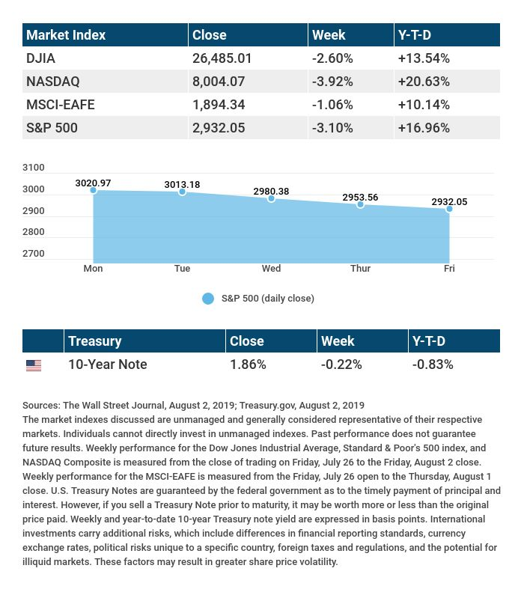

T H E W E E K L Y R I D D L E

What two things will you never be able to eat at dinner?

LAST WEEK’S RIDDLE: Take one letter away from this 8-letter word, and you still have a word. Take another letter away from the seven letters left, and you still have a word. Keep on doing that, each time making a new word, until you have one letter left. What is this word?
ANSWER: The word is starting. Starting, staring, string, sting, sing, sin, in, I.

Know someone who could use information like this?
Please feel free to send us their contact information via phone or email. (Don’t worry – we’ll request their permission before adding them to our mailing list.)

Securities offered through Kestra Investment Services, LLC (Kestra IS), a member FINRA/SIPC. Investment advisory services offered through Kestra Advisory Services, LLC (Kestra AS), an affiliate of Kestra IS. Levine Group, LLC is not affiliated with Kestra IS or Kestra AS.
CITATIONS:
1 - apnews.com/e15c18b9dbc44efab400d2214e2cb6f9 [8/2/19]
2 - wsj.com/market-data [8/2/19]
3 - wsj.com/index/XX/990300/historical-prices [8/2/19]
4 - forbes.com/sites/jjkinahan/2019/07/31/feds-quarter-point-rate-cut-weak-global-growth-trade-tensions-muted-inflation-cited [7/31/19]
5 - cnn.com/2019/08/01/investing/asian-market-latest-trade-war/index.html [8/1/19]
6 - cnn.com/2019/08/02/economy/july-jobs-report/index.html [8/2/19]

CHART CITATIONS:
wsj.com/market-data [8/2/19]
wsj.com/index/SPX/historical-prices [8/2/19]
treasury.gov/resource-center/data-chart-center/interest-rates/Pages/TextView.aspx?data=yieldYear&year=2019 [8/2/19]
treasury.gov/resource-center/data-chart-center/interest-rates/Pages/TextView.aspx?data=yieldAll [8/2/19]

