In this week’s recap: stock indices again set records, the Fed makes its third rate cut of the year, October’s employment report is a nice surprise, and U.S. and Chinese trade negotiators make some progress.
Weekly Economic Update

Presented by Michael J. Levine, November 4, 2019

THE WEEK ON WALL STREET
A better-than-forecast jobs report prompted a stock market rally Friday, two days after traders witnessed another interest rate cut by the Federal Reserve.
Both the S&P 500 and Nasdaq Composite ended the week at historic peaks, while the Dow Jones Industrial Average settled less than 12 points under its all-time record close. The Nasdaq rose 1.74% for the week; the S&P gained 1.47%. The Dow added 1.44%. MSCI’s EAFE benchmark, which measures developed stock market performance outside the U.S. and Canada, improved 0.58%.^{1,2,3}

Economy Adds 128,000 Jobs in October
This net increase far surpassed the gain of 85,000 projected by a Bloomberg poll of economists. These job gains occurred even as last month’s General Motors strike impacted hiring in the manufacturing sector.
Unemployment rose slightly to 3.6% in October, an effect of more people entering the job market. Likewise, the U-6 rate, counting both unemployed and underemployed Americans, ticked up to 7.0%.⁴

The Fed’s Latest Interest Rate Decision
Last week, the central bank made its third quarter-point rate cut since July, leaving the target range for the federal funds rate at 1.50-1.75%.
Something was missing from the latest Fed policy statement. Since June, a passage had noted that the Fed was ready to “act as appropriate to sustain the expansion.” In the latest statement, that language disappeared. At a press conference Wednesday, Fed Chair Jerome Powell commented that Fed officials “see the current stance of monetary policy as likely to remain appropriate.”⁵

Where Trade Talks with China Stand
There were further negotiations between U.S. and Chinese officials Friday, and China’s commerce ministry announced that both sides had “reached consensus on principles” integral to the first phase of a new trade pact. U.S. Trade Representative Robert Lighthizer noted only that the latest round of conversation had brought “progress in a variety of areas.”⁶

T I P O F T H E W E E K
A thorough business plan should also identify your target audience: who wants your service or product, why they are interested in it, and the problem your solution solves. Interviews, research, and surveys can come in handy here.

THE WEEK AHEAD: KEY ECONOMIC DATA
Tuesday: The Institute for Supply Management presents its latest Purchasing Managers Index for the U.S. service sector, gauging business activity and new orders.
Friday: The University of Michigan’s preliminary November Consumer Sentiment Index appears, measuring consumer confidence levels.
Source: Econoday, November 1, 2019
The Econoday economic calendar lists upcoming U.S. economic data releases (including key economic indicators), Federal Reserve policy meetings, and speaking engagements of Federal Reserve officials. The content is developed from sources believed to be providing accurate information. The forecasts or forward-looking statements are based on assumptions and may not materialize. The forecasts also are subject to revision.

THE WEEK AHEAD: COMPANIES REPORTING EARNINGS
Monday: Marriott International (MAR), Sysco (SYY), Uber (UBER)
Tuesday: Allergan (AGN), Toyota (TM)
Wednesday: CVS Health (CVS), Qualcomm (QCOM)
Thursday: Booking Holdings (BKNG), Walt Disney Co. (DIS)
Friday: Duke Energy (DUK), Enbridge (ENB), Honda (HMC)
Source: Zacks, November 1, 2019
Companies mentioned are for informational purposes only. It should not be considered a solicitation for the purchase or sale of the securities. Any investment should be consistent with your objectives, time frame, and risk tolerance. The return and principal value of investments will fluctuate as market conditions change. When sold, investments may be worth more or less than their original cost. Companies may reschedule when they report earnings without notice.

Q U O T E O F T H E W E E K

“We cannot fail to win unless we fail to try.”
TOM CLANCY

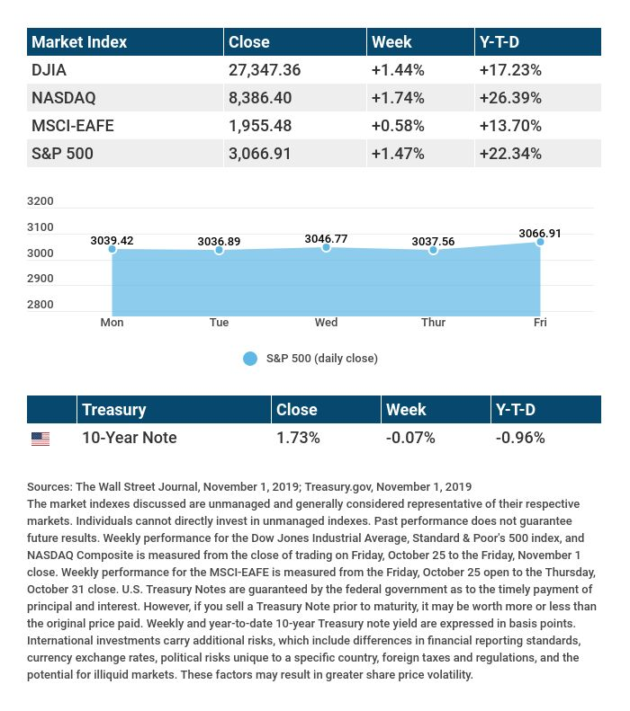

T H E W E E K L Y R I D D L E

Jennifer is 20 years old, yet why has her birthday occurred only five times in her life?

LAST WEEK’S RIDDLE: Round like an apple and deeper than a cup, yet all the king’s horses can’t pull it up. What is it?
ANSWER: A well.

Know someone who could use information like this?
Please feel free to send us their contact information via phone or email. (Don’t worry – we’ll request their permission before adding them to our mailing list.)

Securities offered through Kestra Investment Services, LLC (Kestra IS), a member FINRA/SIPC. Investment advisory services offered through Kestra Advisory Services, LLC (Kestra AS), an affiliate of Kestra IS. Levine Group, LLC is not affiliated with Kestra IS or Kestra AS.
CITATIONS:
1 - reuters.com/article/us-usa-stocks/sp-500-nasdaq-set-records-on-jobs-data-trade-headway-idUSKBN1XB3ZD [11/1/19]
2 - wsj.com/market-data [11/1/19]
3 - quotes.wsj.com/index/XX/990300/historical-prices [11/1/19]
4 - time.com/5716189/us-adds-128000-jobs-october-2019/ [11/1/19]
5 - cnbc.com/2019/10/30/fed-decision-interest-rates-cut.html [10/30/19]
6 - foxbusiness.com/markets/us-china-trade-talks-reach-consensus-on-principles?cmpid=prn_investors [11/1/19]

CHART CITATIONS:
wsj.com/market-data [11/1/19]
quotes.wsj.com/index/XX/990300/historical-prices [11/1/19]
quotes.wsj.com/index/SPX/historical-prices [11/1/19]
treasury.gov/resource-center/data-chart-center/interest-rates/Pages/TextView.aspx?data=yieldYear&year=2019 [11/1/19]
treasury.gov/resource-center/data-chart-center/interest-rates/Pages/TextView.aspx?data=yieldAll [11/1/19]

