

***Monday, April 27th, 2020***

***“Oil Prices Go Negative for First Time”***

Record fiscal and monetary stimulus has many fearful of the potential inflationary ramifications to come. After all, there must be a limit on the amount of money we can print without affecting the purchasing power of each dollar in the money supply.

These are long-term risks to be mindful of, but in the short-term, the more relevant risk is deflation.

The Federal Reserve would much rather deal with the risks of inflation as opposed to deflation. With deflation, declining prices can lead to the deferral of purchases as consumers wait for even lower prices. Long-term deflationary trends such as technological advancements can be a net benefit to the economy, but there are certain deflationary signals that symbolize a more severe contraction in the economy.

Last week we saw one of these deflationary signals as oil prices in the front month futures contract went negative for the first time in history. Due to the limited ability to store supply, May futures contract holders were having to pay to close out their contracts, at one point at prices near ***negative*** $40 per barrel.

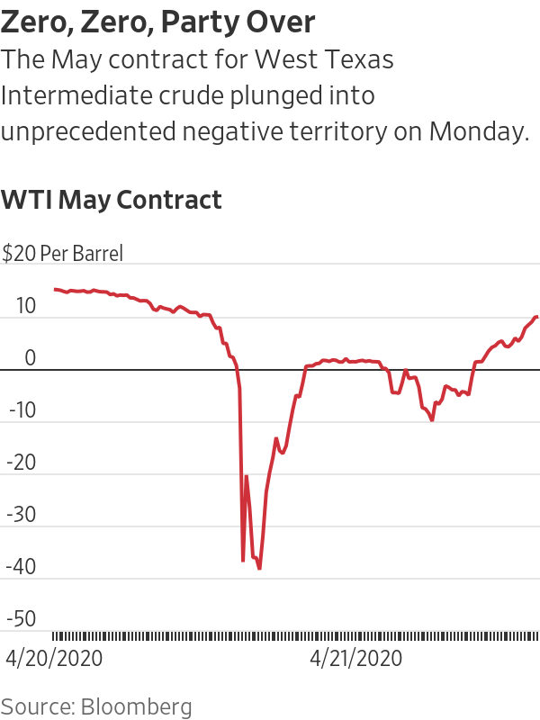

The rest of the oil futures market traded down as well, just not nearly as bad as the front month futures contract which dealt with the logistical oversupply issue. Even if prices went negative for technical reasons, it is remarkable that investors had to pay to have oil taken from them.

Despite this historic event, energy stocks ended the week slightly up. The news was potentially less meaningful because the rest of the futures curve did not decline as much as the May contract and because energy stocks have suffered such severe losses over the past few months already.

Oil remains an integral part of the economy, but less meaningful for the overall stock market. Energy companies represented nearly 15% of the S&P 500 as recently as 2008, but now account for less than 3% of the index. They are a much higher percentage of the credit markets due to their large outstanding debts.

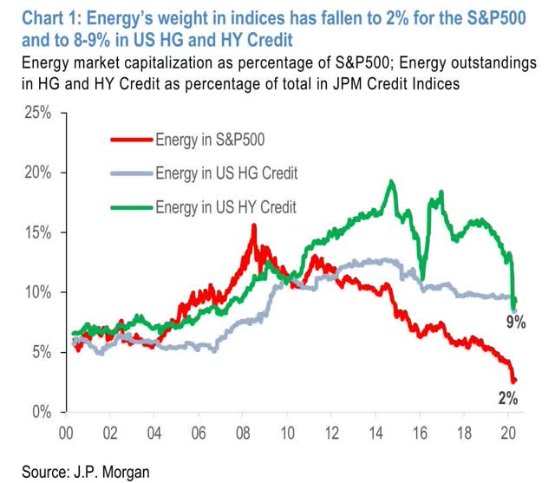

So, the impact of energy stocks means less today than it did in the past, but plummeting oil demand is just another sign of how the economy has ground to a halt over the past two months.

Once again, the stock market brushed off the news, with the S&P 500 and Dow down just 1.3% and 1.9%, respectively for the week. The S&P 500 is within 16% of all-time highs despite 26 million Americans having lost their jobs over the past 5 weeks.

While the market often has its biggest gains when the news goes from awful to less bad, it is still a bit surprising how fast of an economic recovery that seems to be implied by the recent move in stocks. The stock market is now higher than it was a year ago when the economy was in a healthy environment, insinuating a fairly quick recovery from this historic collapse. For those who have lost their jobs or businesses, we can only hope this ends up translating from forecast into reality.

**Jack Holmes, CFA®**

***WealthPLANPartners***

*The opinions voiced in this material are for general information only and are not intended to provide specific advice or recommendations for any individual. To determine which Investment(s) may be appropriate for you, consult your financial advisor prior to investing. Information is based on sources believed to be reliable, however, their accuracy or completeness cannot be guaranteed. Statements of forecast and trends are for informational purposes, and are not guaranteed to occur in the future.*

*All indices are unmanaged and may not be invested into directly. Advisory services offered through Feltz WealthPLAN, DBA of WealthPLAN Partners. Securities offered through Securities America, Inc., Member FINRA/SIPC. Feltz WealthPLAN and Securities America are separate entities.*