- Upon initial login of your account, you will be required to complete the Identity Verification Setup. Once you add the phone number and/or email address, click ‘add phone number/add email address’ as shown by the arrows below. We recommend using the email option. Please be sure to enter in an email nickname.

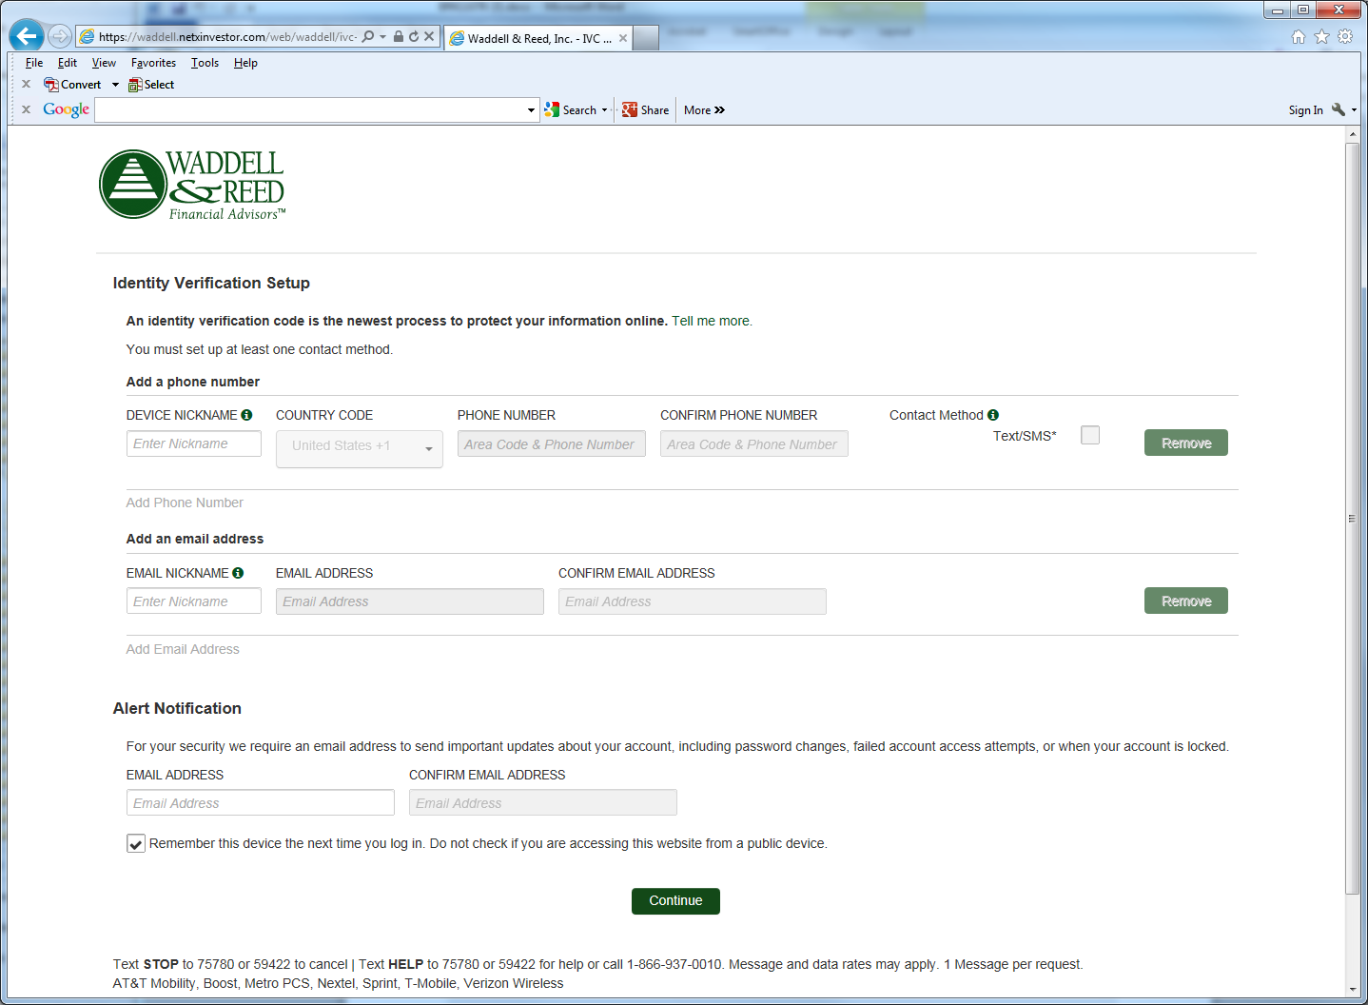

By clicking this box, the system will
remember your device and not ask for a
verification code each time you log in.

- When a phone number is added, you will be asked to activate your device. Enter the six-digit code as provided to you via a text message in the ‘Activate your device’ box as shown below.

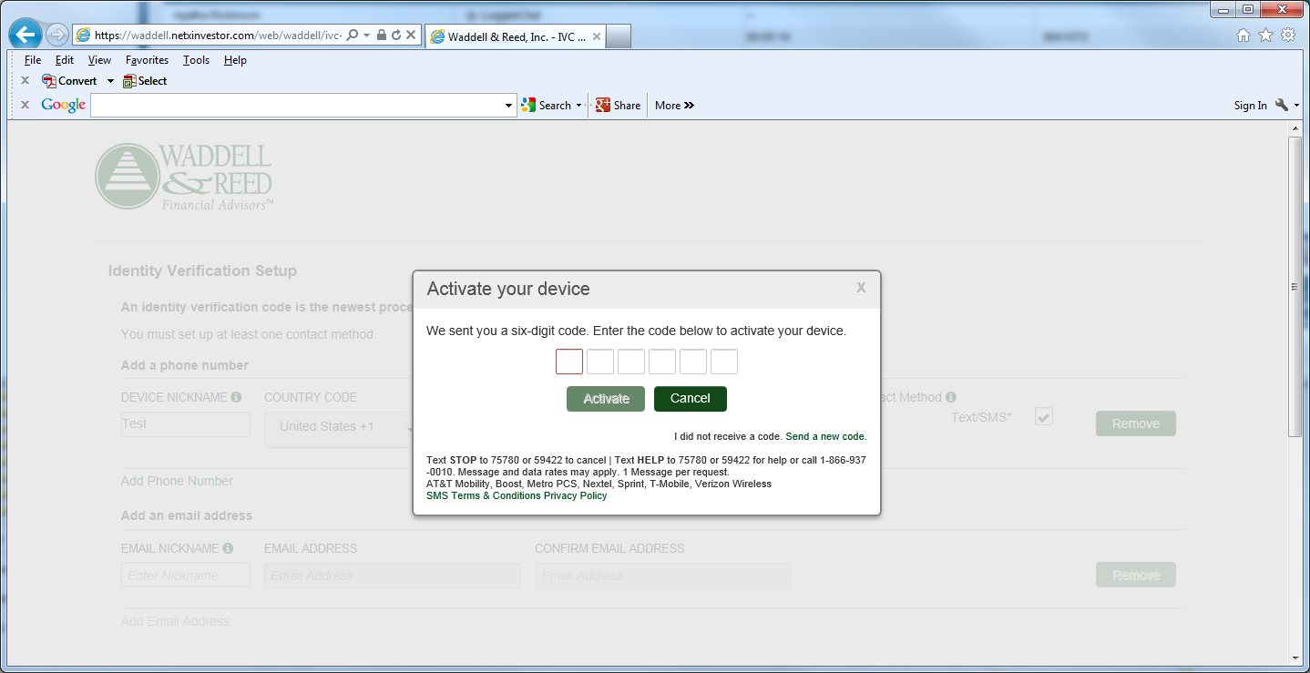

- Confirmation that you have successfully activated your device. Click Close to continue with the setup process.

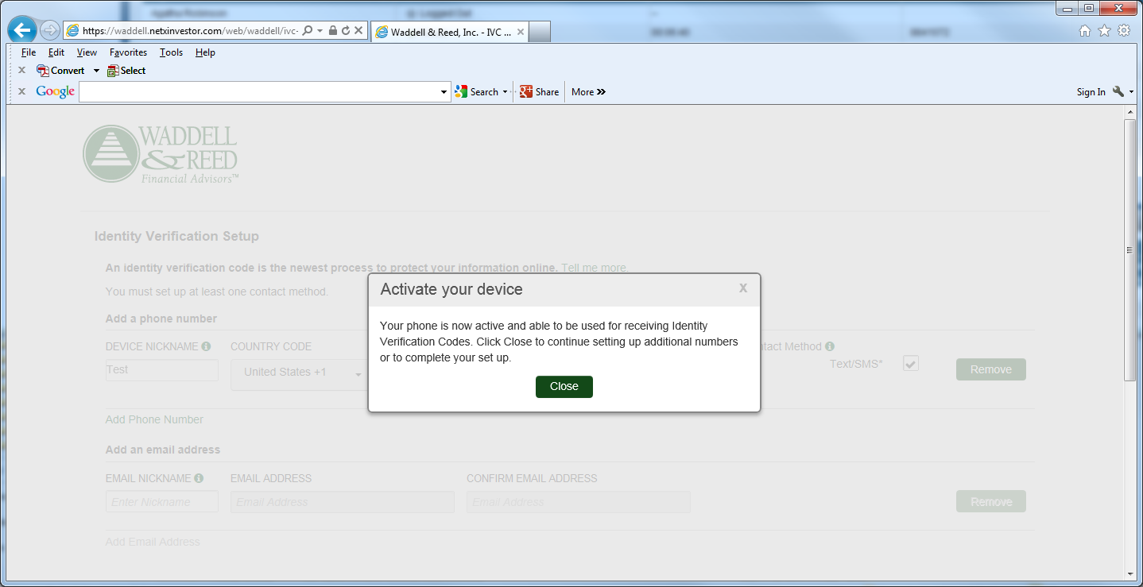

- Complete your Alert Notification and click Continue.

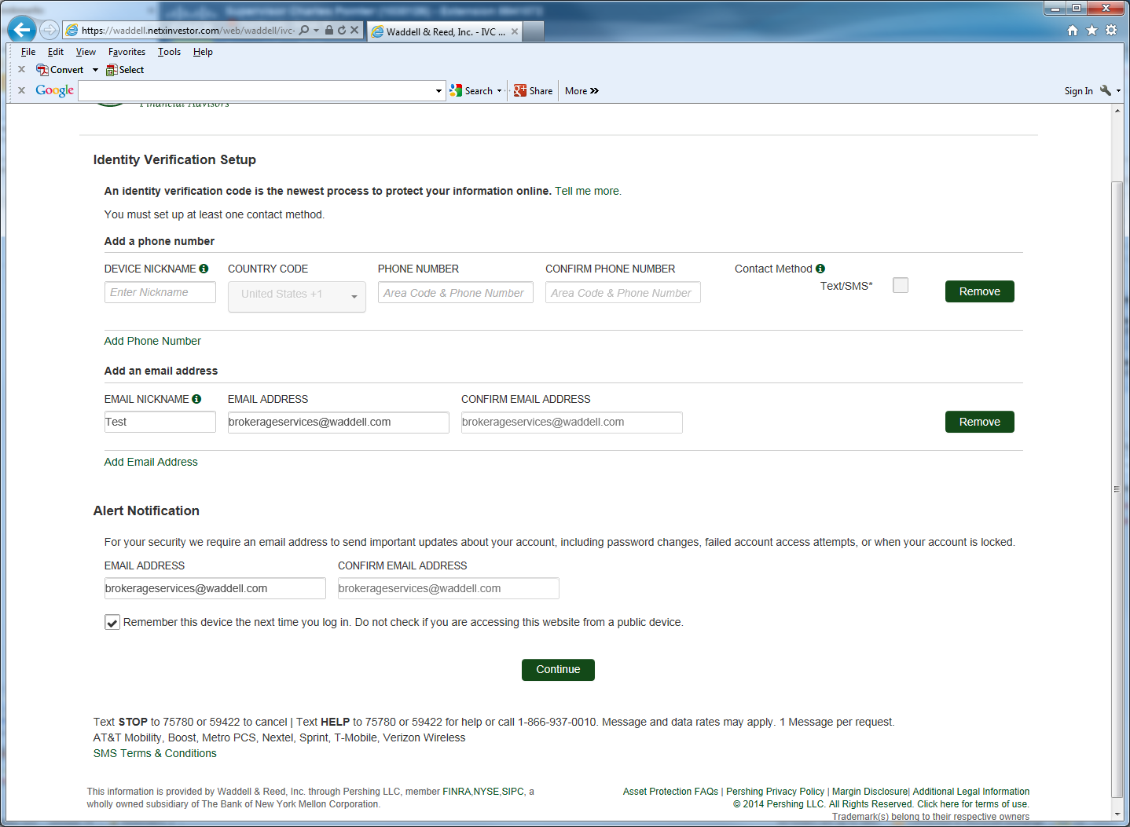

By clicking this box, the system will
remember your device and not ask for a
verification code each time you log in.

- Review the information entered and click Save.

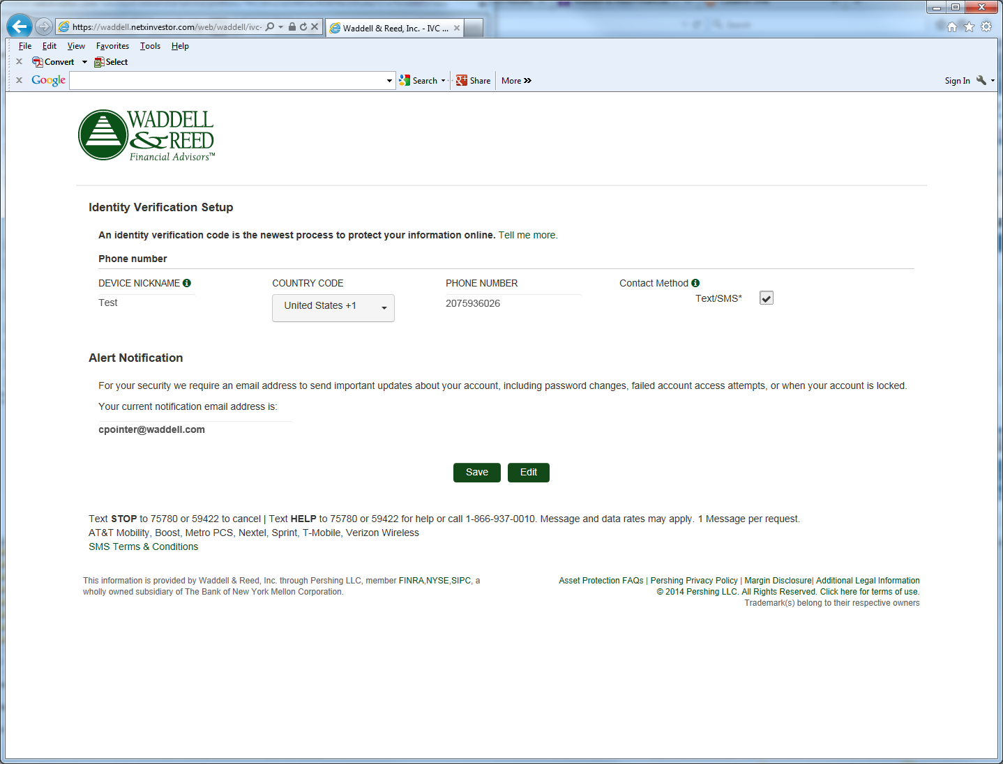

- Update your Security Image and Phrase. Click “Select” below the image.

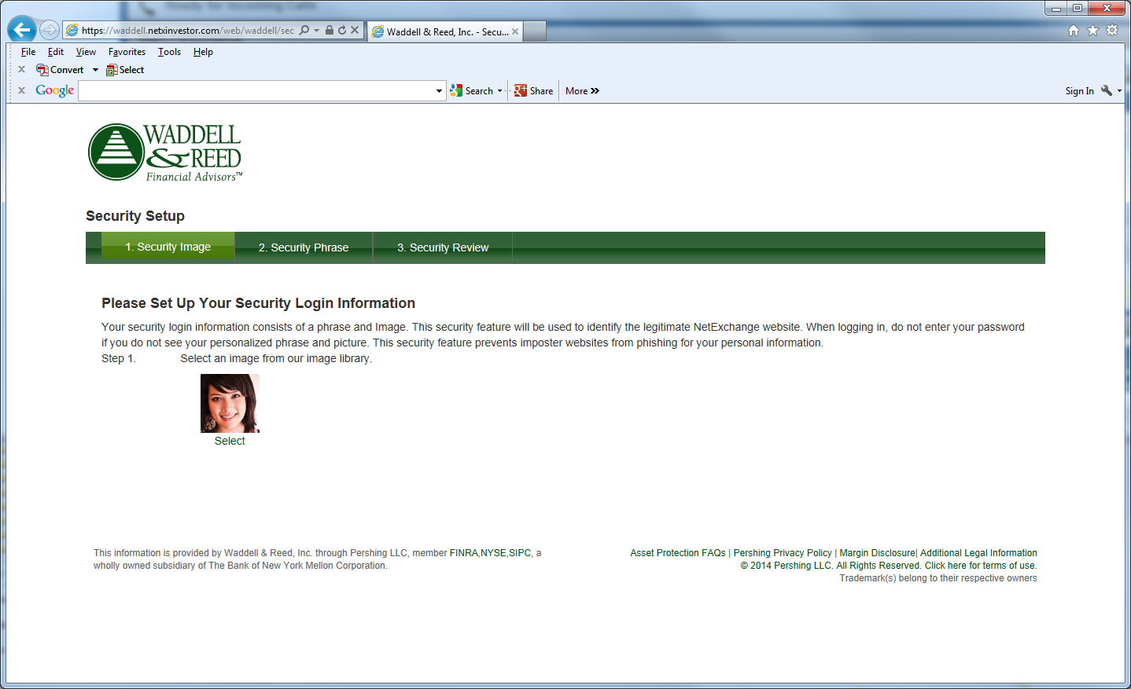

- Select Your Security Image. You must choose a new image.

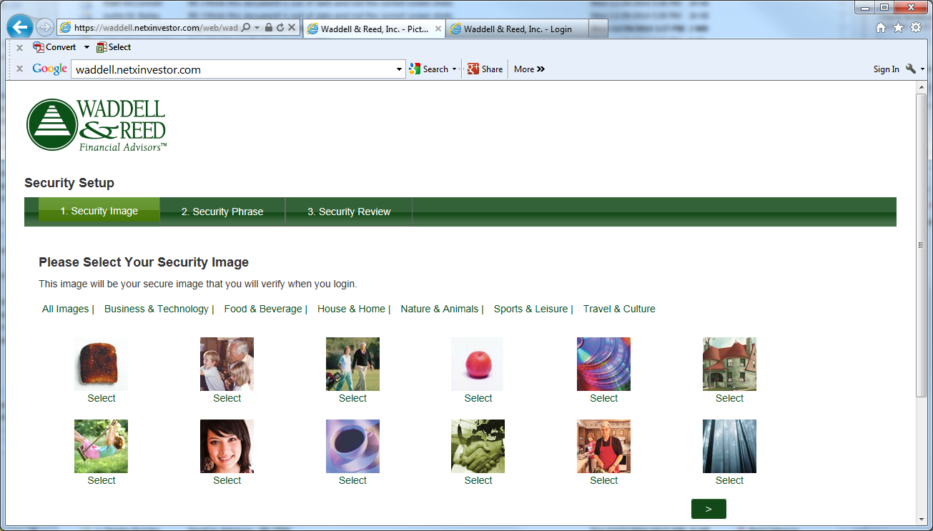

- Enter your personalized security phrase. If you had already created a phrase, you do not have to change it. Click Continue.

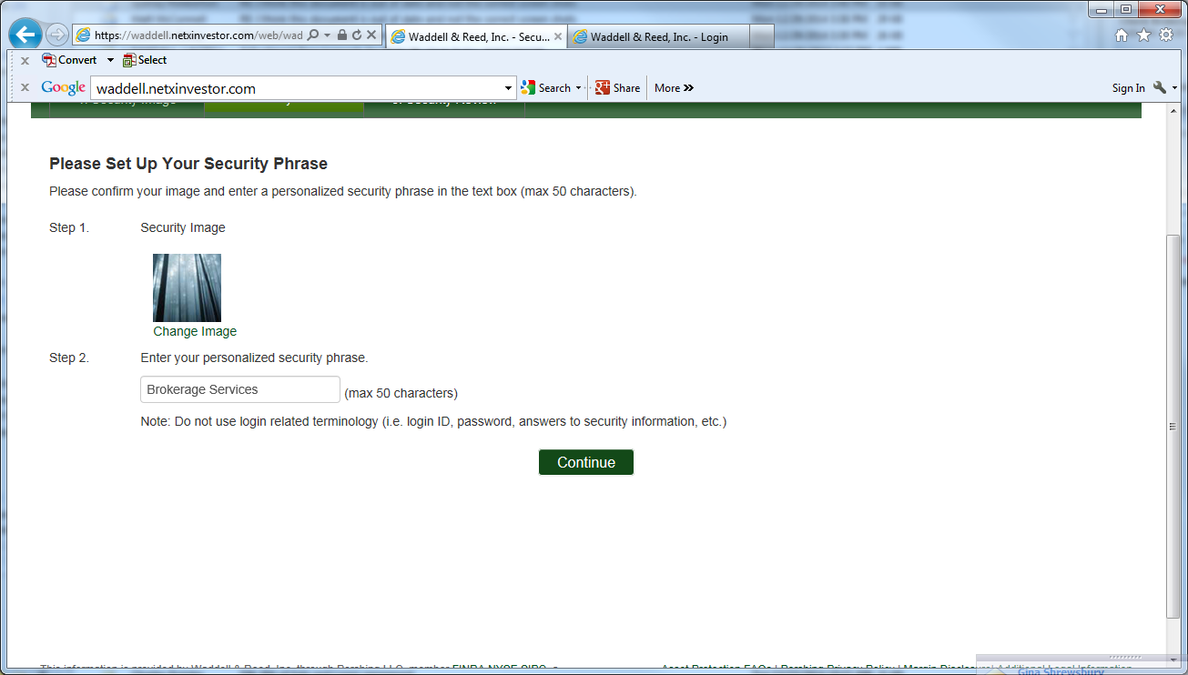

- Verify the information and click Continue.

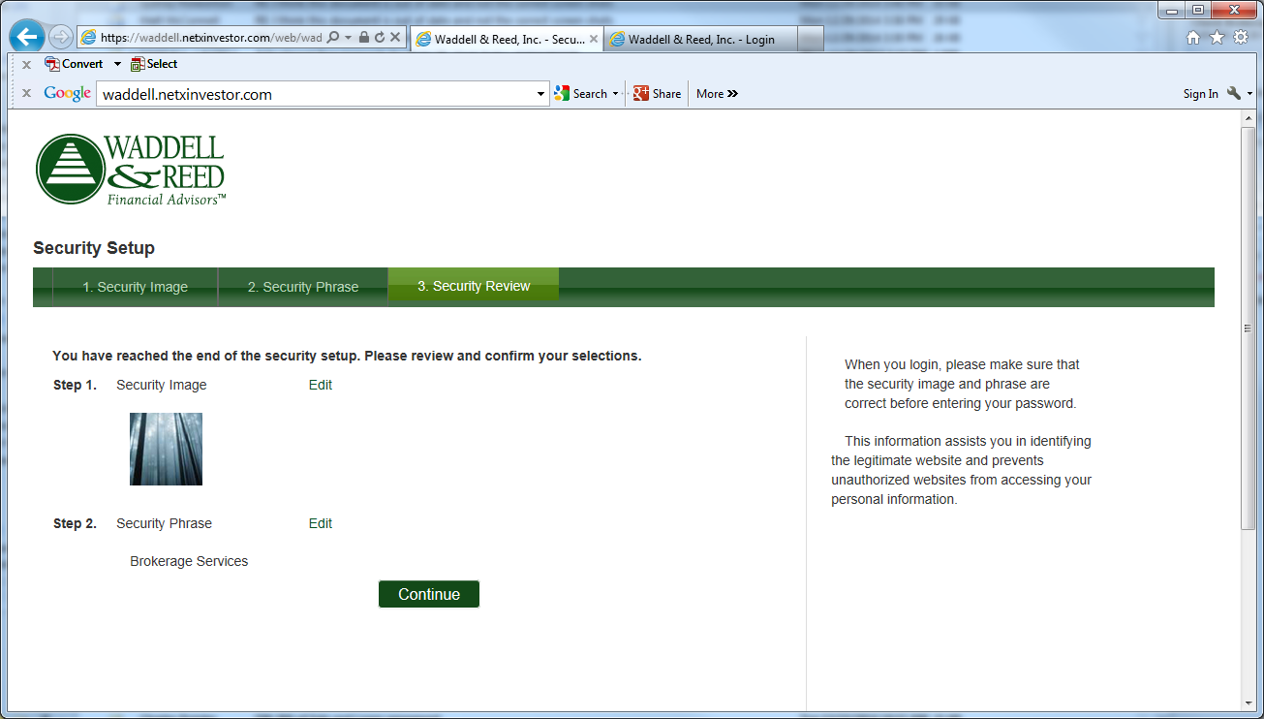

- Upon 3 failed attempts, Unrecognized Device verification, or the “Forgot Password” is selected, you will be required to select one of your predetermined delivery methods (email/text message). Once determined, click “Send Code”.

Below is an example of an Unrecognized Device verification:
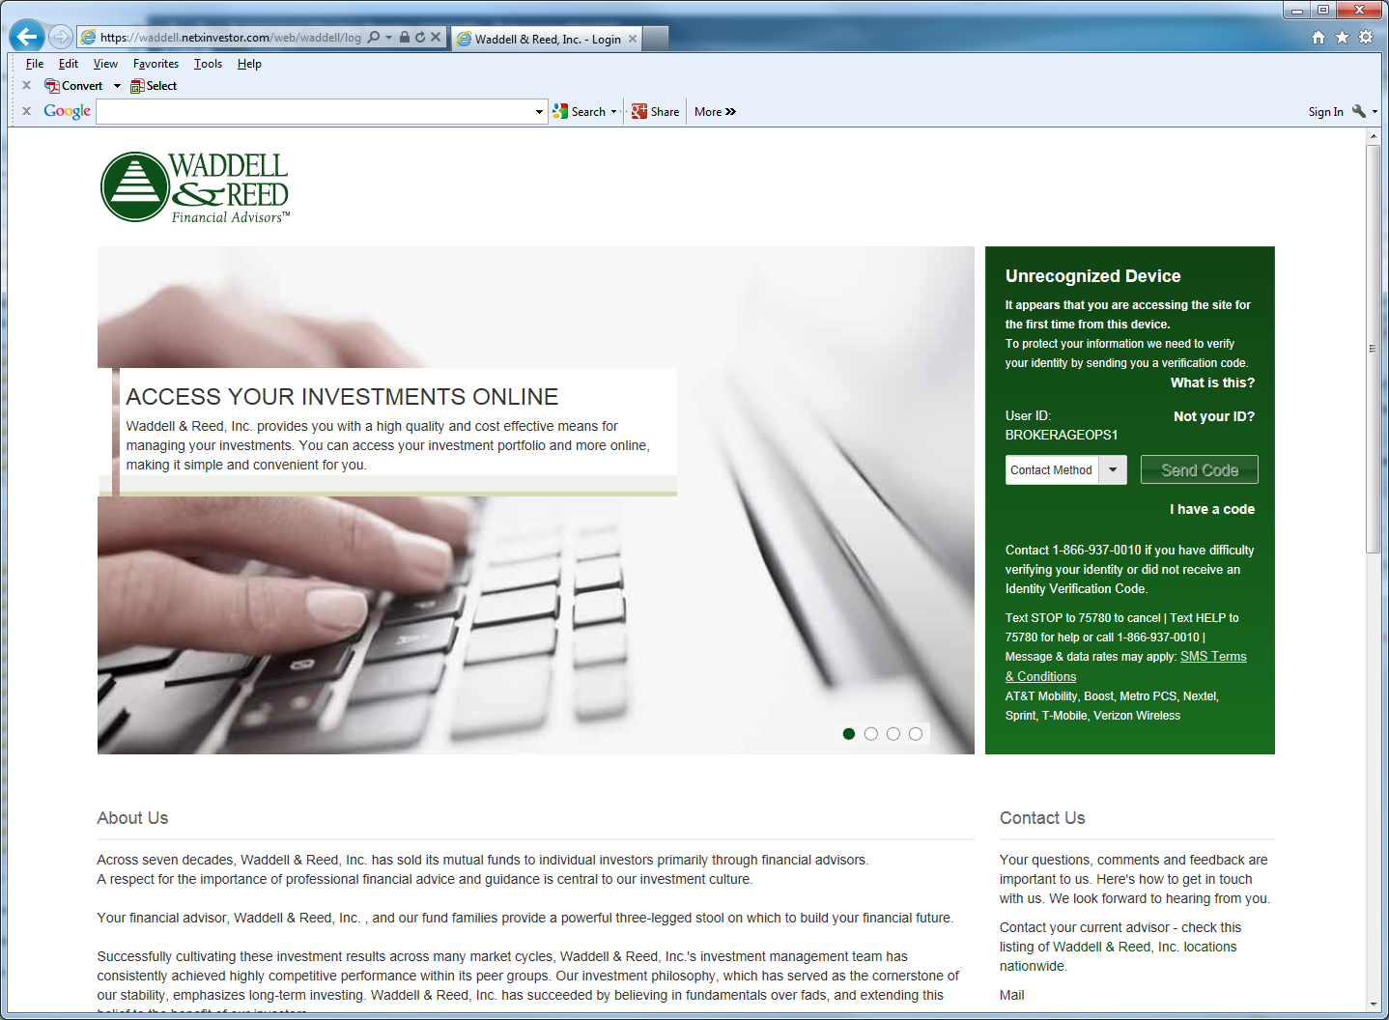

- Enter your code and click “Verify Identity”.
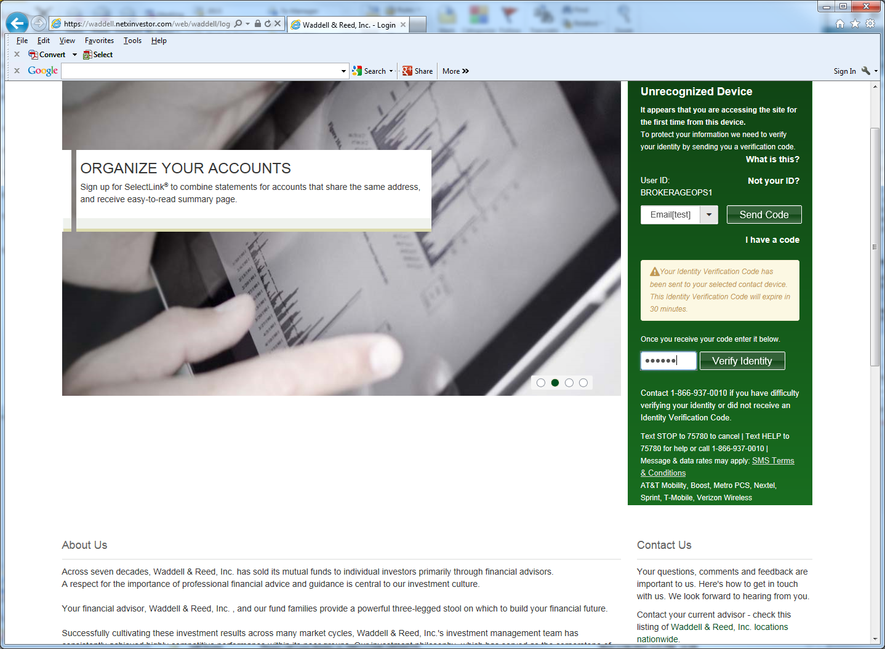

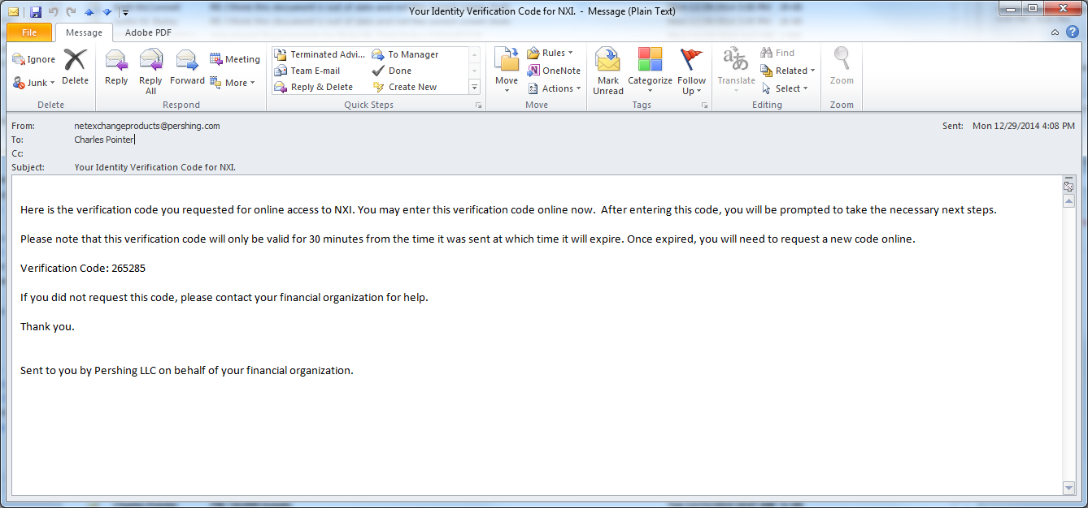

- Enter Password. Hit Continue to access account. Note: You have the option to ‘Remember this device next time’.

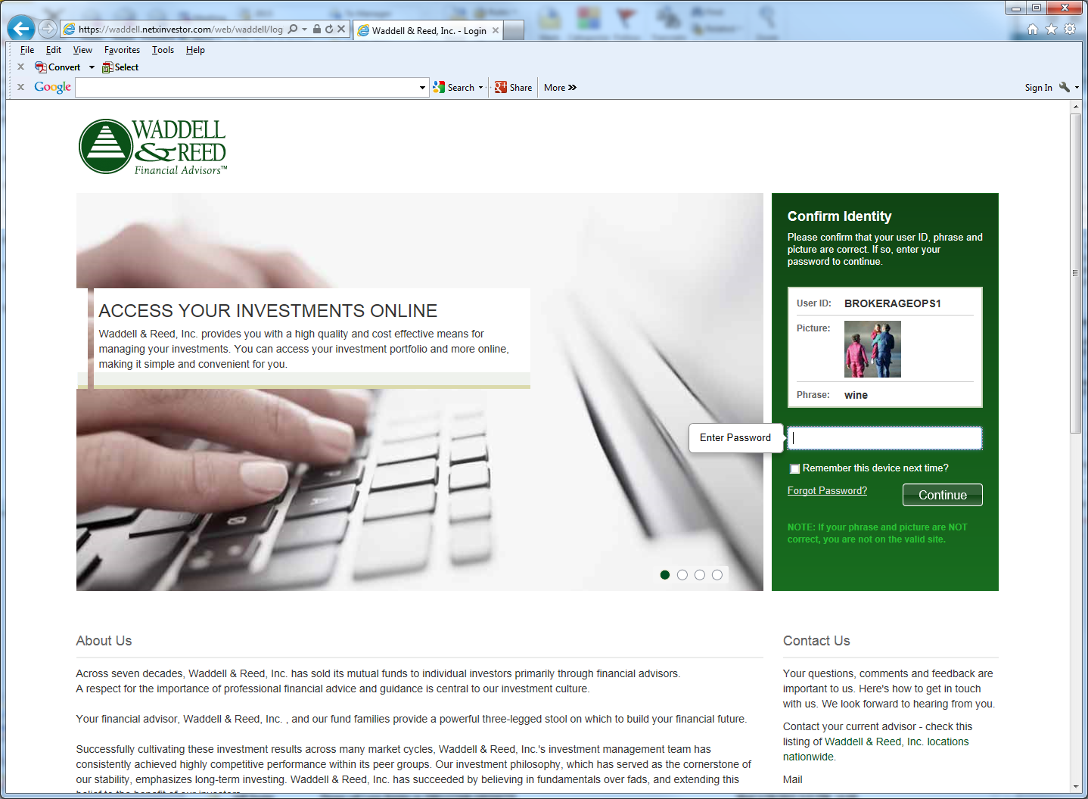
By clicking this box, the system will
remember your device and not ask for a
verification code each time you log in.

Having Trouble?
Please call our office at 408-963-2874 or
Email Fatima Franco at ffranco@wradvisors.com

