In this week’s recap: a shortened trading week sees additional gains for the major stock benchmarks, as optimism about a new trade pact with China outweighs doubts; household spending rises, but confidence declines.
Weekly Economic Update

Presented by Michael J. Levine, December 2, 2019

THE WEEK ON WALL STREET
As November wrapped up, U.S. equity benchmarks advanced. Stocks were again aided by a sense of optimism that a preliminary U.S.-China trade deal could be near.
For the week, the Nasdaq Composite added 1.87%; the S&P 500, 1.21%; the Dow Jones Industrial Average, 1.03%. The MSCI EAFE index, which measures the performance of developed stock markets outside North America, gained 0.89%.^{1,2}

Markets Wait for News of a Trade Pact
Wednesday, a senior White House official told Politico that the U.S. was “millimeters away” from a phase-one trade agreement with China, a deal that might involve the removal of certain tariffs.
Still, friction remains within the Sino-American relationship. Last week, President Trump signed two bills into law backing pro-democracy demonstrators in Hong Kong. China’s Ministry of Foreign Affairs quickly reacted, stating that American lawmakers had “sinister intentions” and adding that China would take “strong counter-measures” in return.^{3,4}

The Latest on Consumer Spending and Consumer Confidence
Personal spending was up 0.3% in October, according to the Department of Commerce. This happened even with no gain in household incomes.
The Conference Board said that its Consumer Confidence Index came in at 125.5 for November. Even though it has declined for four straight months, the index remains well above levels seen during the first half of the decade.^{5,6}

T I P O F T H E W E E K
In business travel, a little thriftiness is a plus. Plan your business trips as if you are paying for them out of pocket.

THE WEEK AHEAD: KEY ECONOMIC DATA
Monday: The Institute for Supply Management provides its latest monthly index of U.S. manufacturing activity (November).
Wednesday: The ISM presents its November Non-Manufacturing Index, and Automatic Data Processing (ADP) publishes its November payrolls report.
Friday: November hiring data arrives from the Department of Labor, and the University of Michigan’s preliminary December Consumer Sentiment Index appears.
Source: Econoday, November 29, 2019
The Econoday economic calendar lists upcoming U.S. economic data releases (including key economic indicators), Federal Reserve policy meetings, and speaking engagements of Federal Reserve officials. The content is developed from sources believed to be providing accurate information. The forecasts or forward-looking statements are based on assumptions and may not materialize. The forecasts also are subject to revision.

THE WEEK AHEAD: COMPANIES REPORTING EARNINGS
Tuesday: Salesforce (CRM), Workday (WDAY)
Wednesday: RBC (RY)
Thursday: Dollar General (DG), TD Bank (TD)
Source: Zacks.com, November 29, 2019
Companies mentioned are for informational purposes only. It should not be considered a solicitation for the purchase or sale of the securities. Any investment should be consistent with your objectives, time frame, and risk tolerance. The return and principal value of investments will fluctuate as market conditions change. When sold, investments may be worth more or less than their original cost. Companies may reschedule when they report earnings without notice.

Q U O T E O F T H E W E E K

“I look to the future because that’s where I’m going to spend the rest of my life.”
GEORGE BURNS

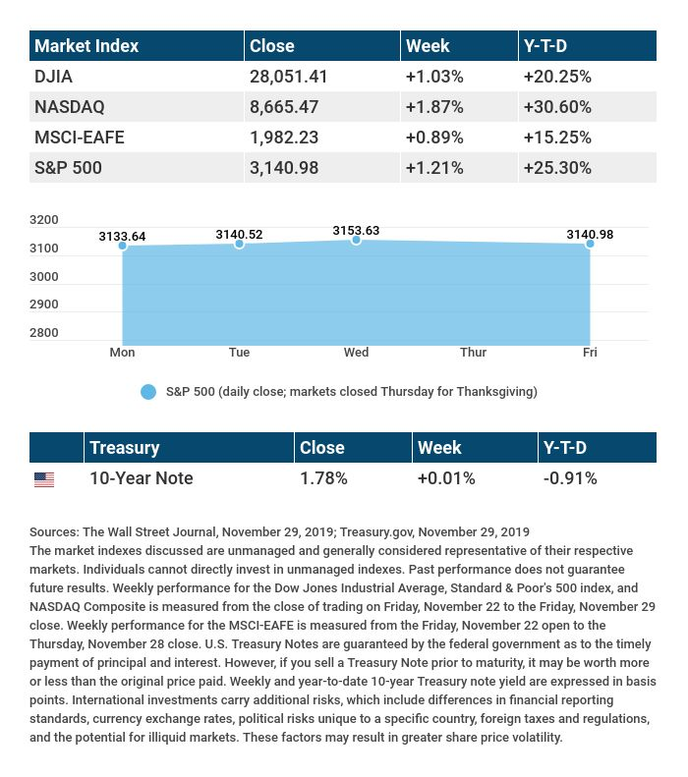

T H E W E E K L Y R I D D L E

I follow and lead as you pass. Dress yourself in black, my darkness lasts. I flee the light, but without the sun, your view of me would be gone. Now tell me, what am I?

LAST WEEK’S RIDDLE: Two children are born in the same hospital, on the same year, on the same day, and have the same father and mother … but they are not twins. How is this possible?
ANSWER: They are triplets (or quadruplets, etc.).

Know someone who could use information like this?
Please feel free to send us their contact information via phone or email. (Don’t worry – we’ll request their permission before adding them to our mailing list.)

Securities offered through Kestra Investment Services, LLC (Kestra IS), a member FINRA/SIPC. Investment advisory services offered through Kestra Advisory Services, LLC (Kestra AS), an affiliate of Kestra IS. Levine Group, LLC is not affiliated with Kestra IS or Kestra AS.
CITATIONS:
1 - wsj.com/market-data [11/29/19]
2 - quotes.wsj.com/index/XX/990300/historical-prices [11/29/19]
3 - politico.com/news/2019/11/27/us-trade-deal-china-074230 [11/27/19]
4 - cnbc.com/2019/11/29/dow-futures-black-friday-thanksgiving-holiday.html [11/29/19]
5 - bit.ly/37M0yl7 [11/27/19]
6 - bit.ly/2XYGdEM [11/26/19]

CHART CITATIONS:
wsj.com/market-data [11/29/19]
quotes.wsj.com/index/XX/990300/historical-prices [11/29/19]
quotes.wsj.com/index/SPX/historical-prices [11/29/19]
treasury.gov/resource-center/data-chart-center/interest-rates/Pages/TextView.aspx?data=yield [11/29/19]
treasury.gov/resource-center/data-chart-center/interest-rates/Pages/TextView.aspx?data=yieldAll [11/29/19]

